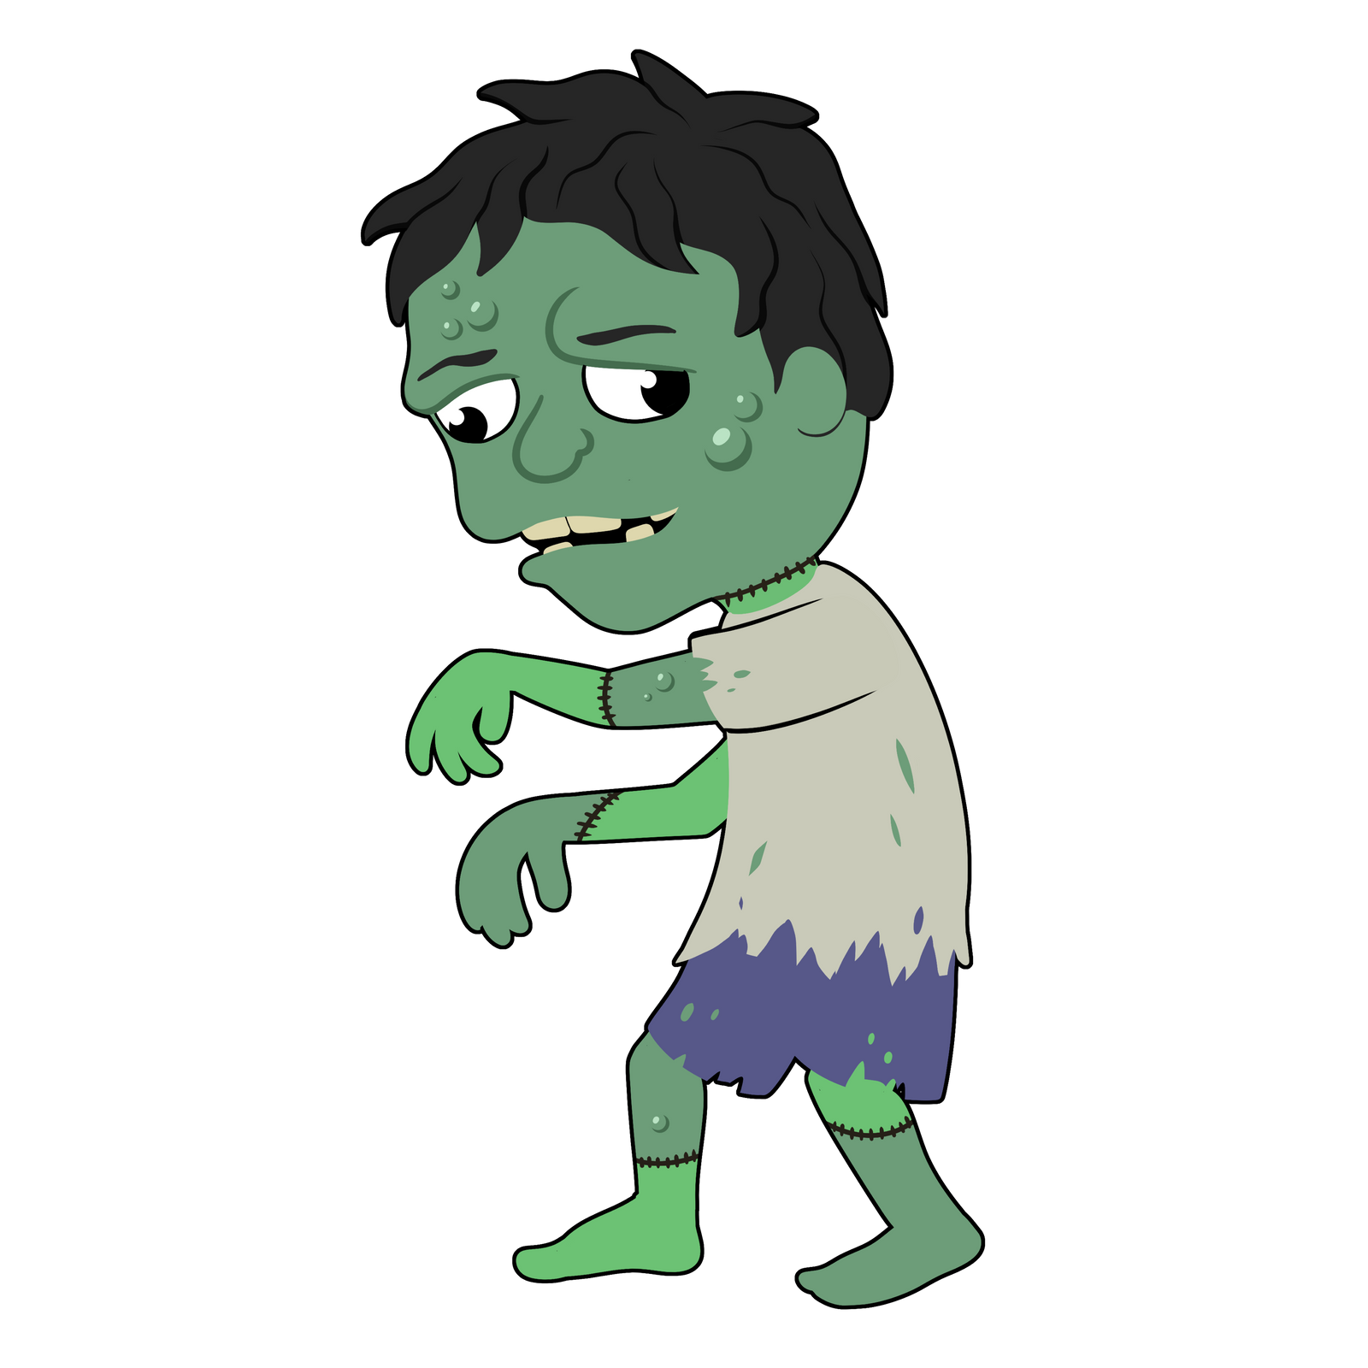
Gaa-nibo’aadizid

Gaa-nibo’aadizid
Zombie

nibo
s/he is dead

ozhaawashkozi
s/he is green

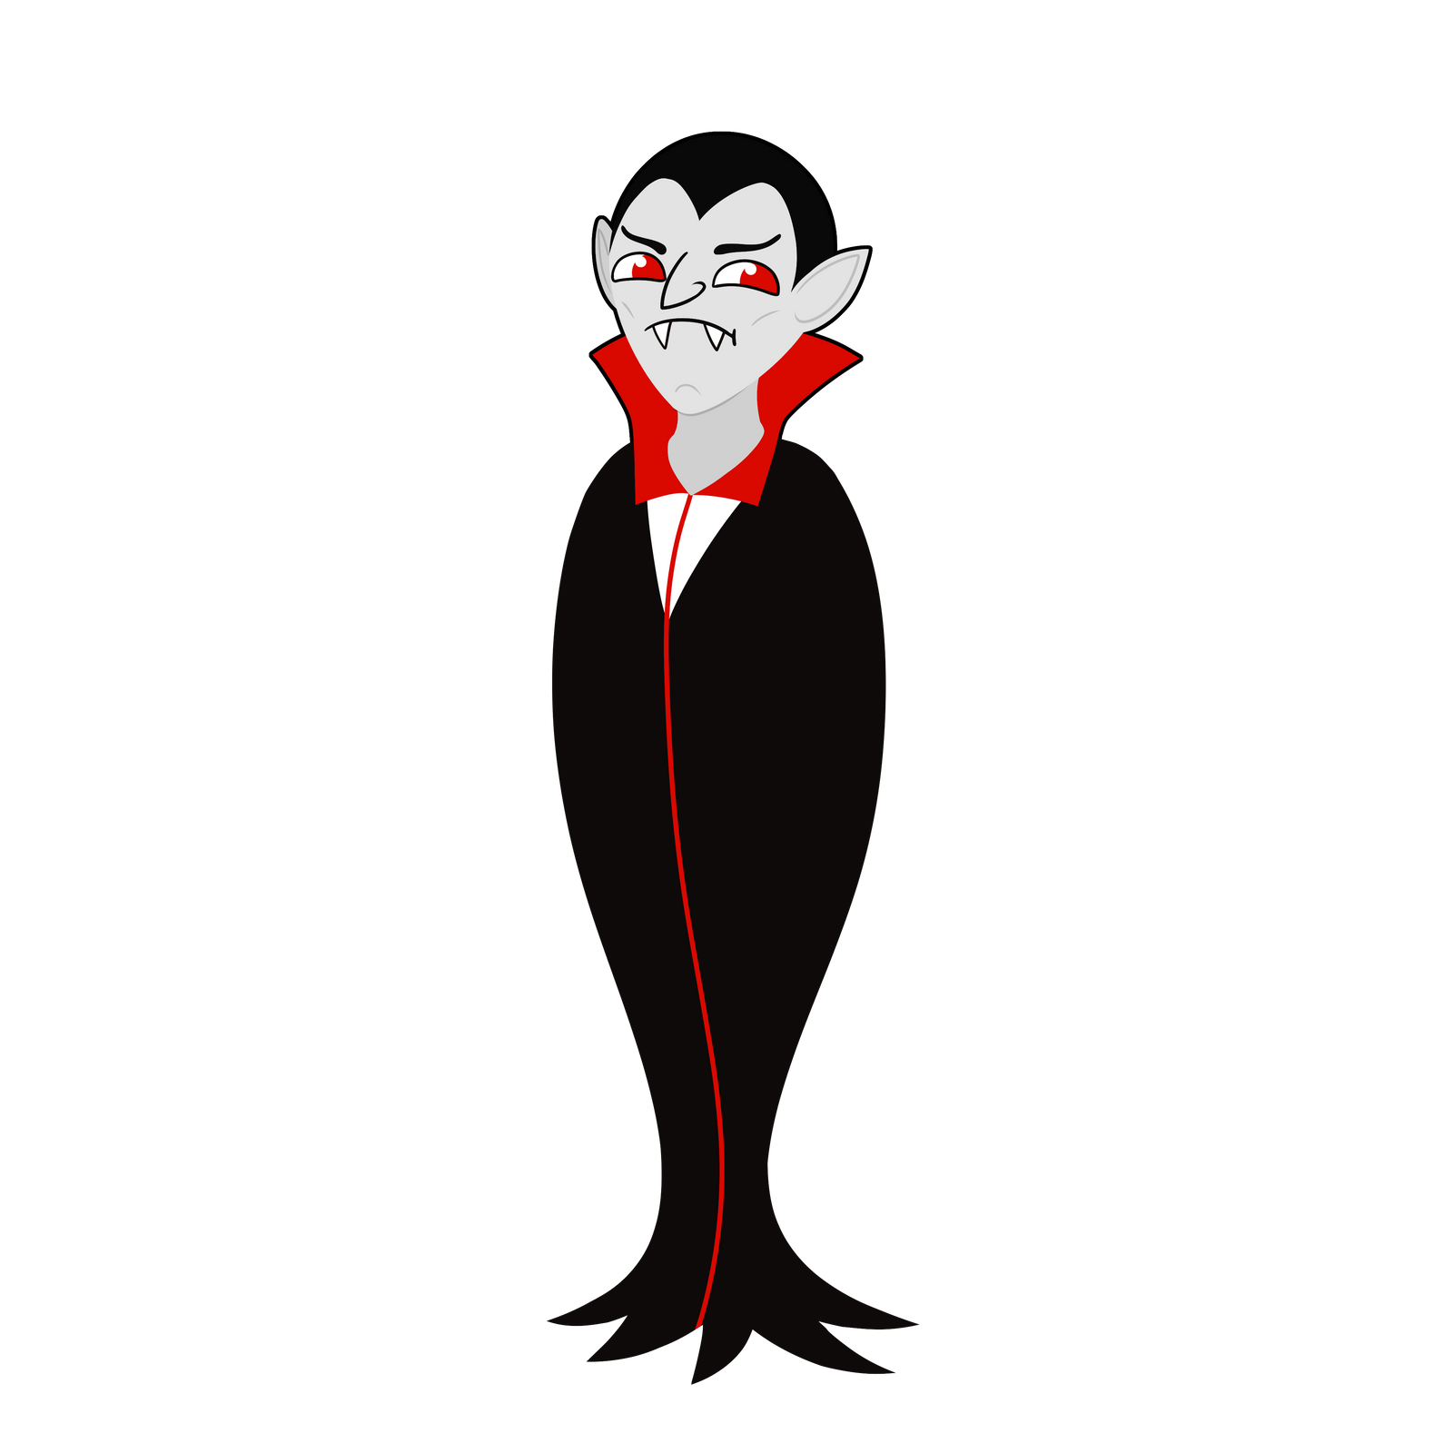

Miskwi Gaa-minikwed

Miskwi Gaa-minikwed
Vampire

miskwi
blood

gaashkaabide
s/he has sharp teeth

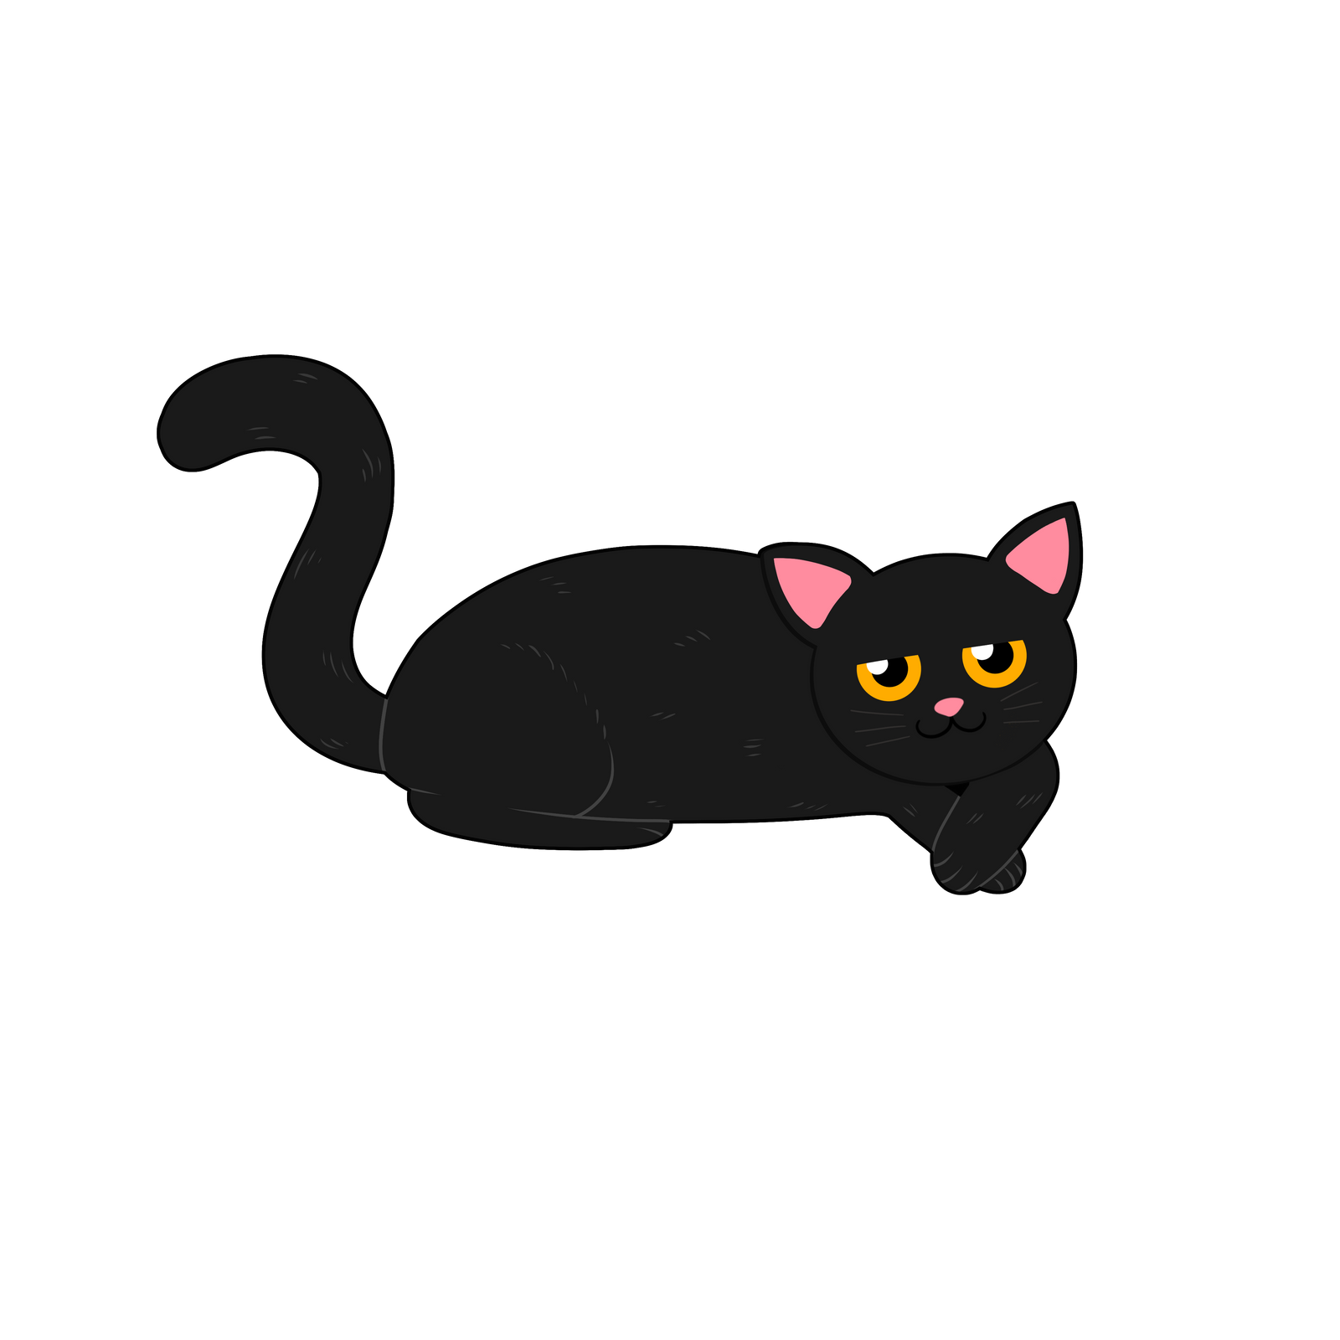
Makade-gaazhagens

Makade-gaazhagens
Black Cat

niiyogaade
s/he has 4 legs

Aaniin enwed? What does s/he sound like?

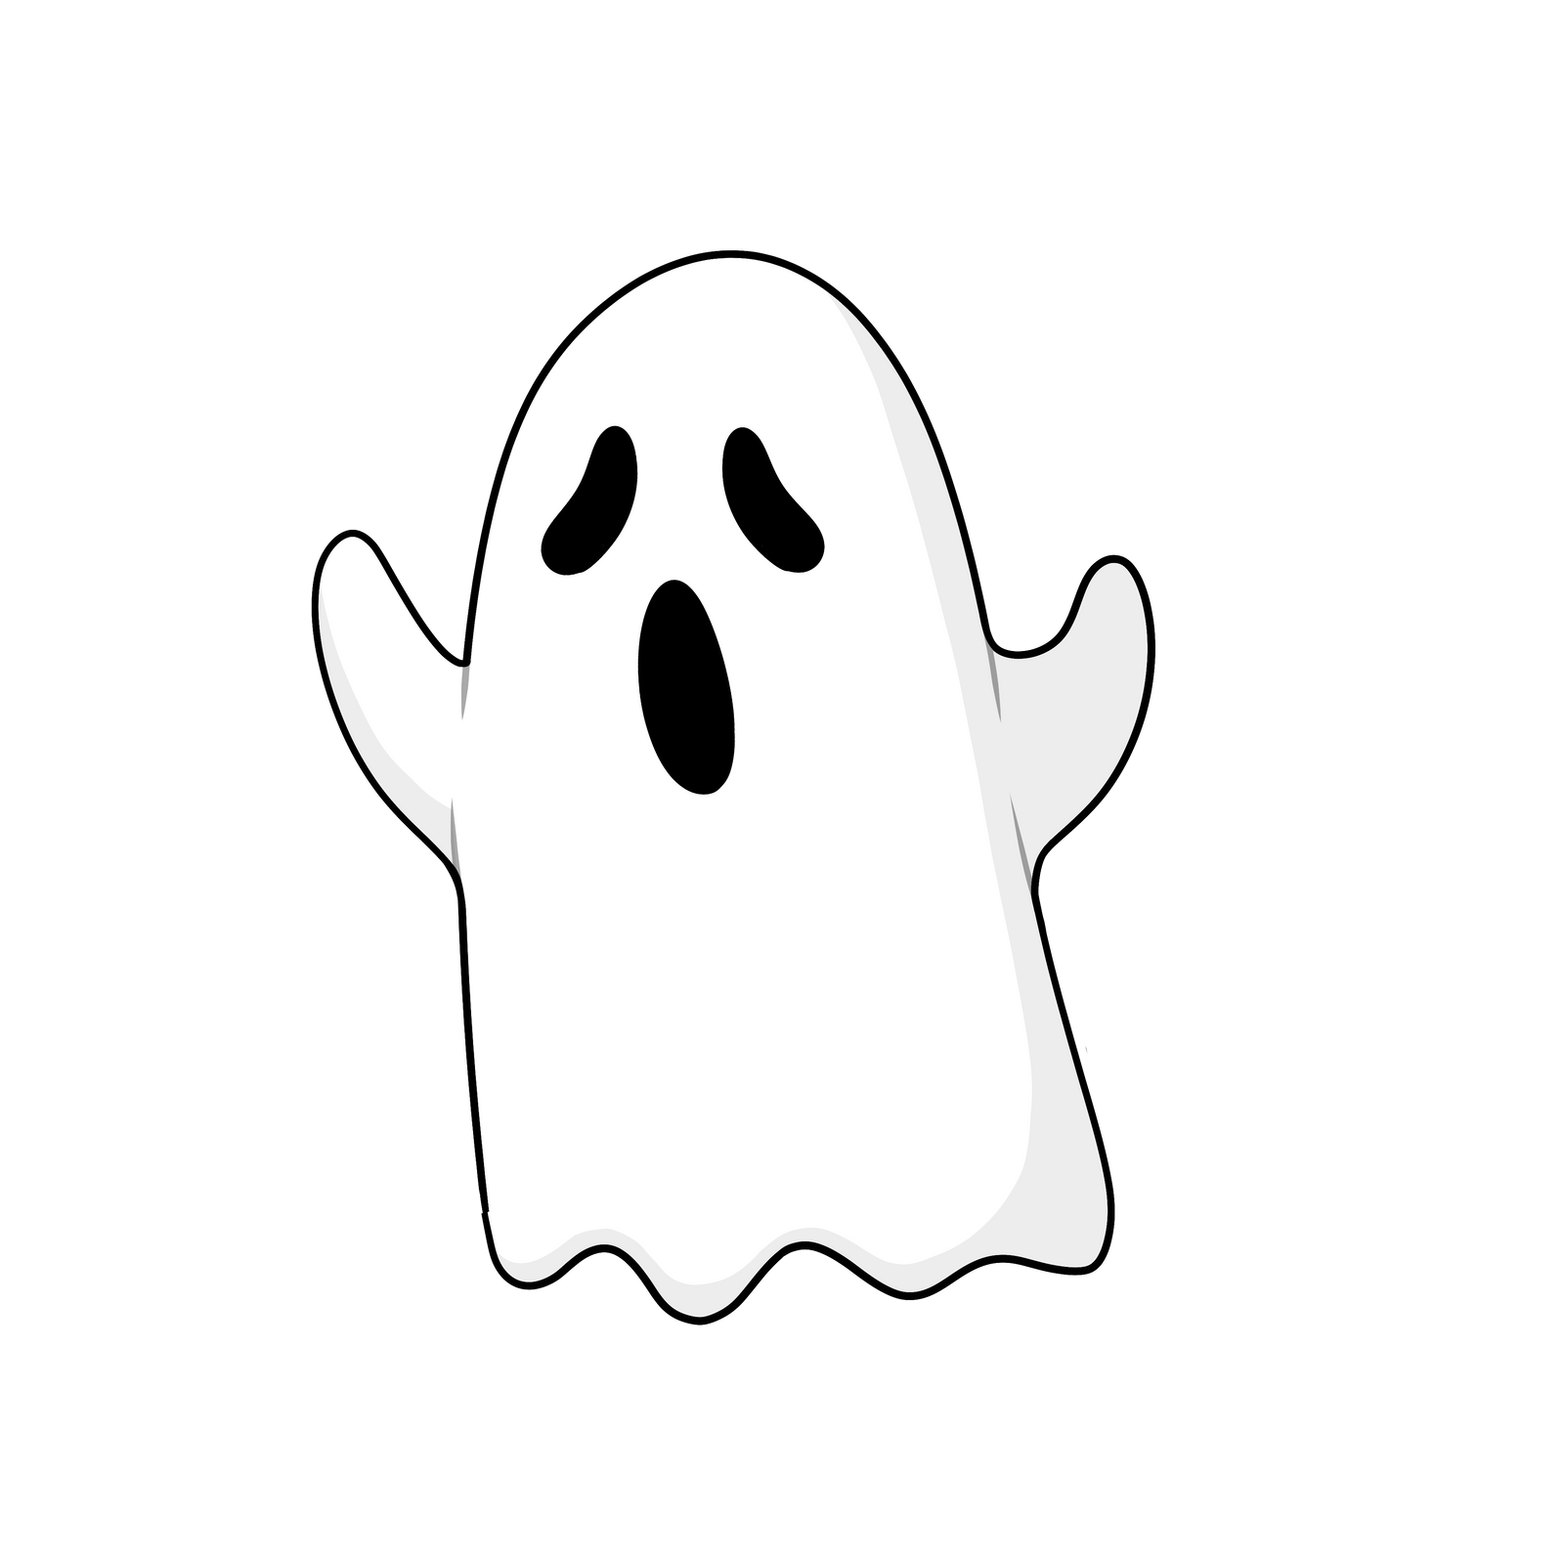
Jiibay

Jiibay
Ghost

Jiibayag
Ghosts (pl)

waabishkizi
s/he is white

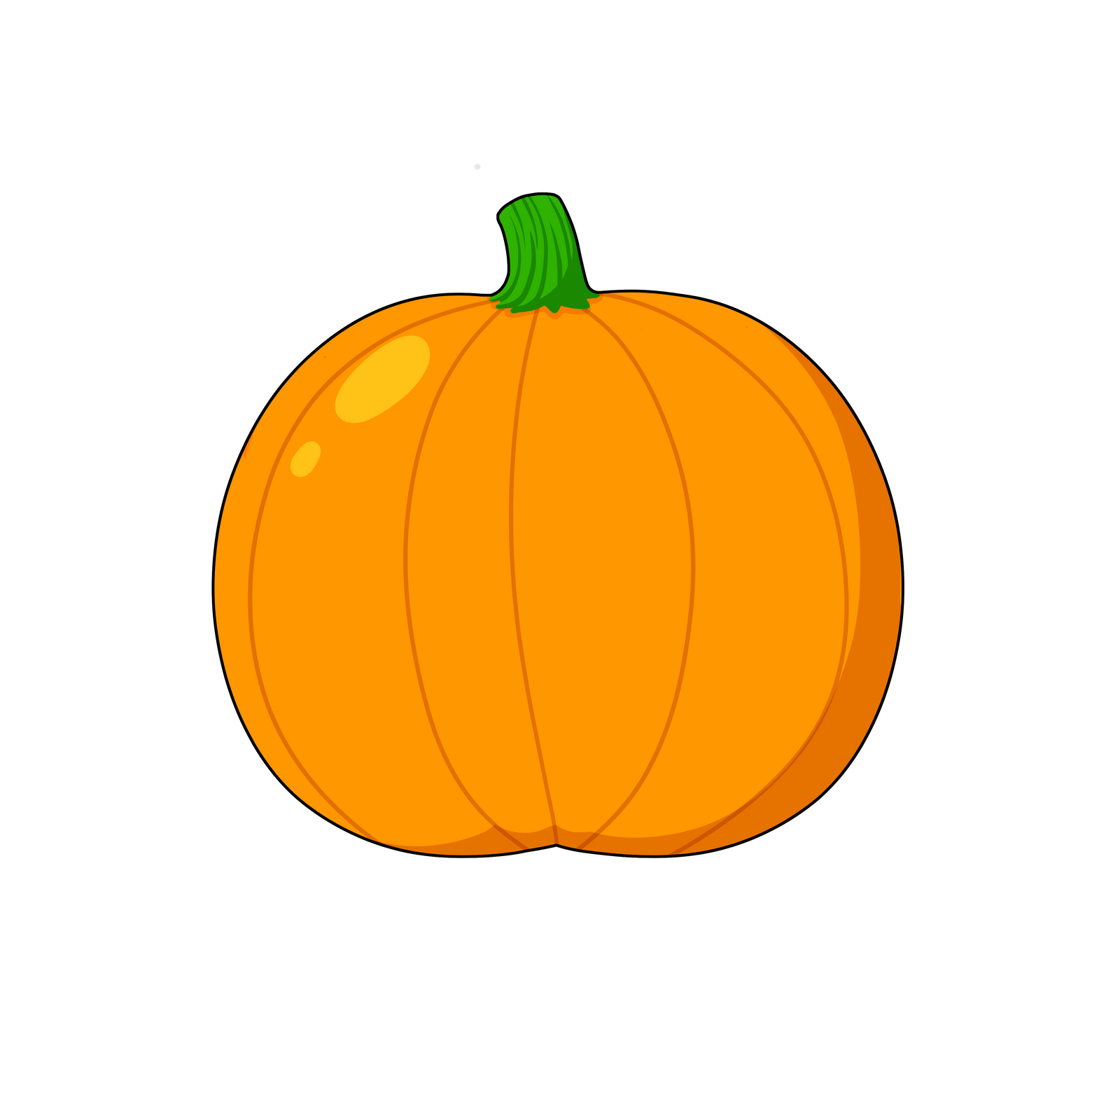
Okosimaan

Okosimaan
Pumpkin

ozaawaa
it is orange

waawiyeyaa
it is round

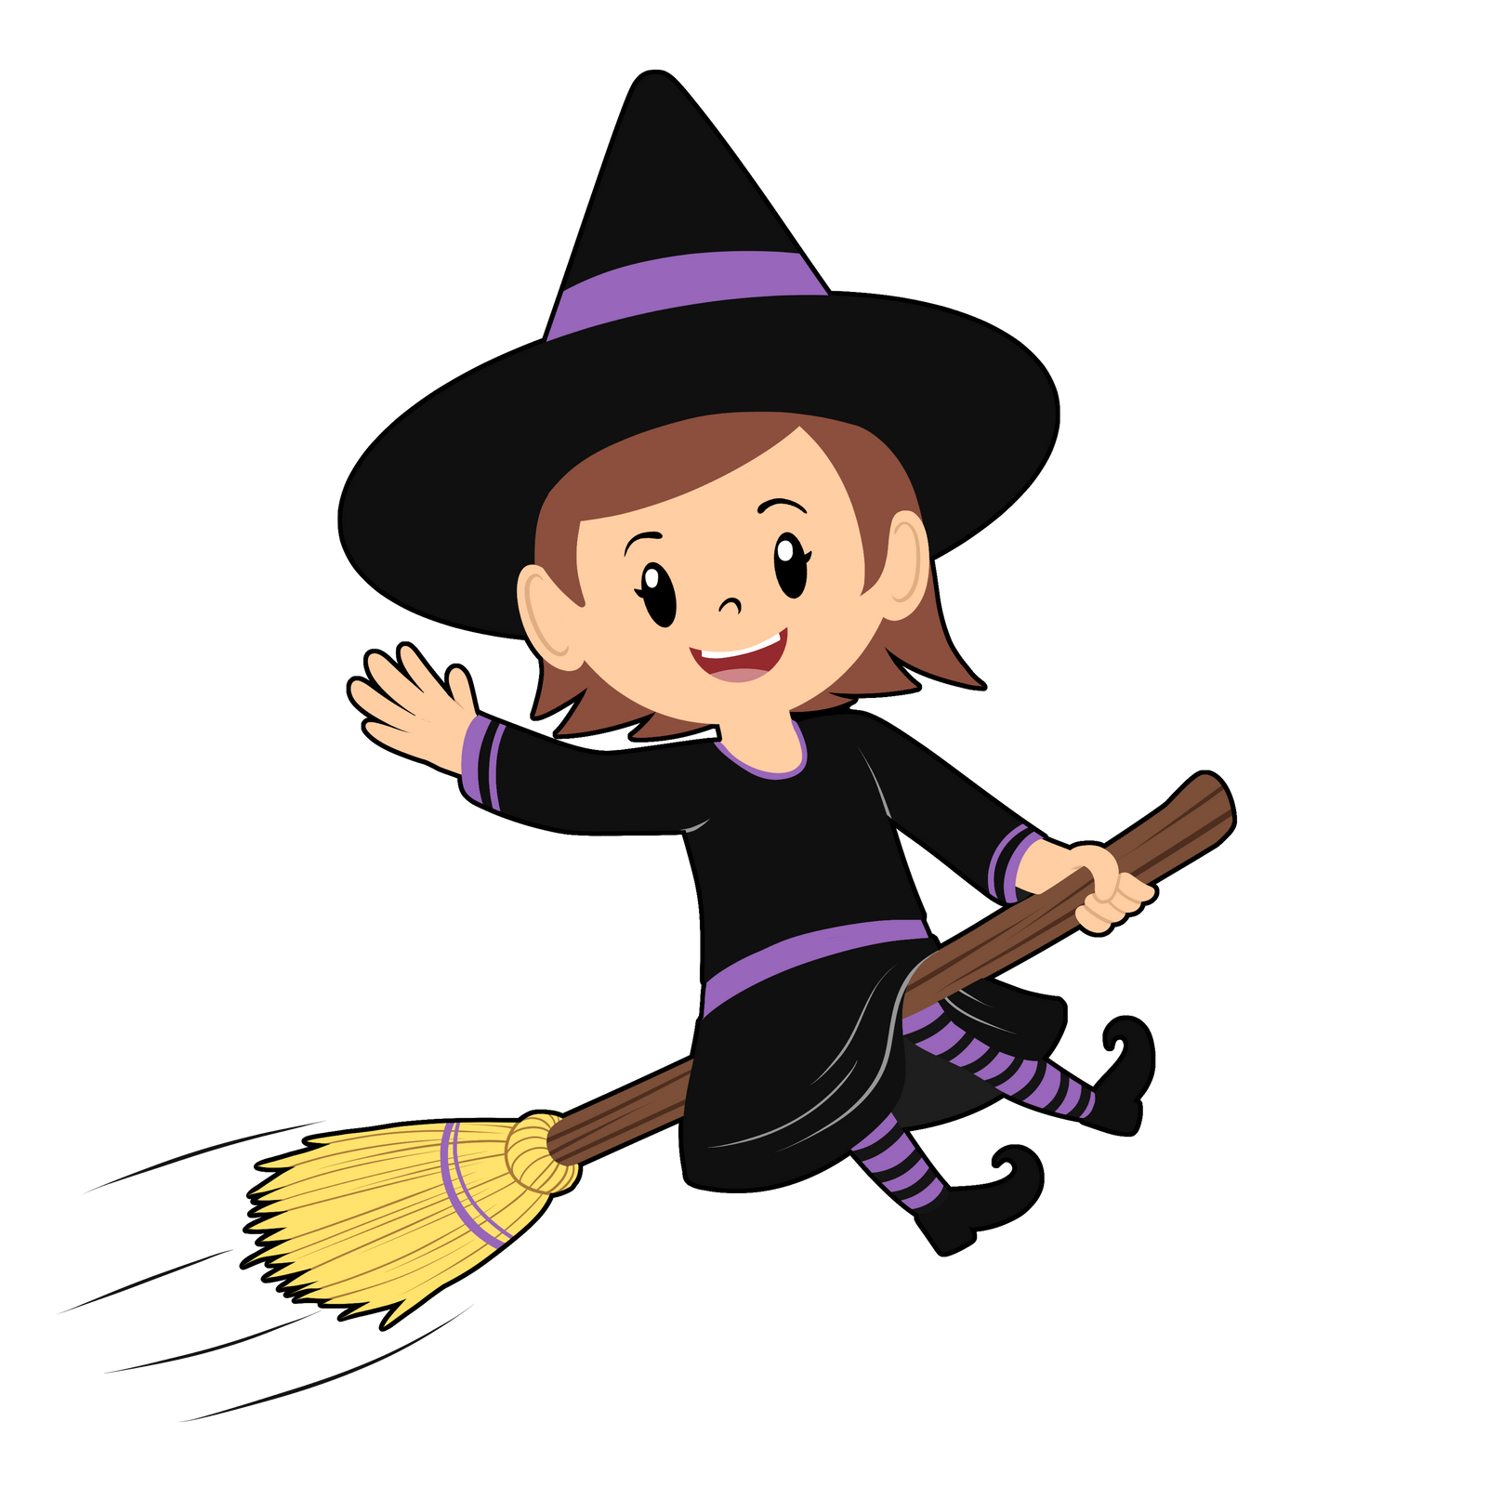
Gaa-majaadizid

Gaa-majaadizid
Witch

jiishada'igan
a broom

babaamise
s/he flies about

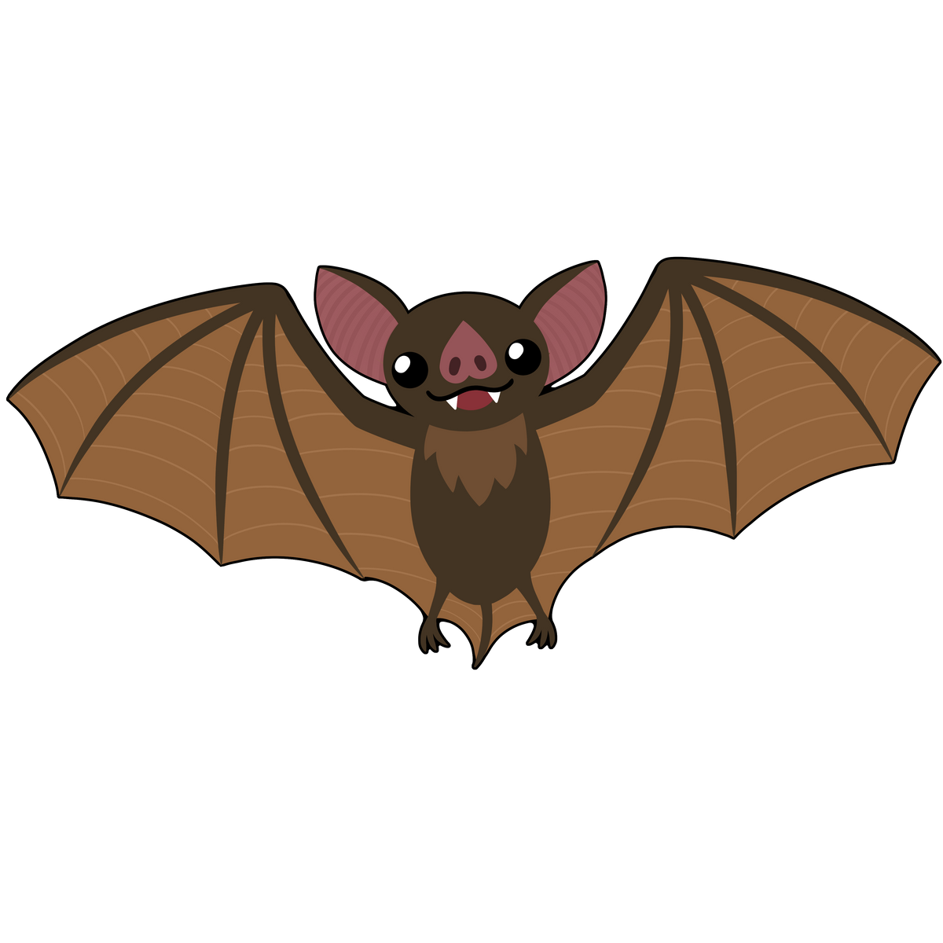
Apakwaanaajii

Apakwaanaajii
Bat

makade-ozaawizi
s/he is brown

babaamise
s/he flies about

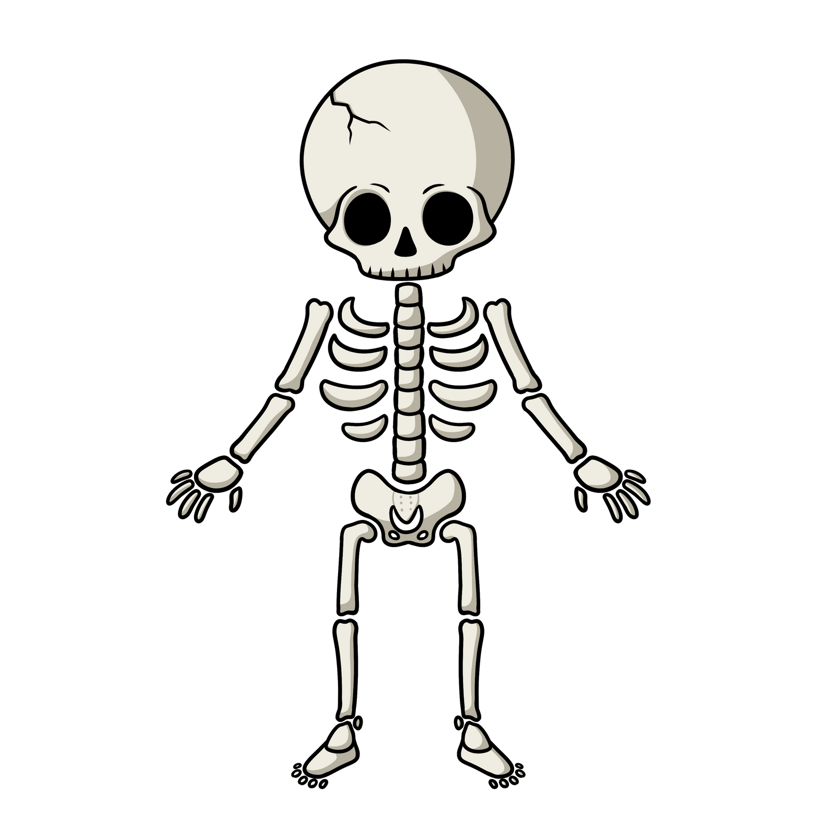
bizhishigokogane

Bizhishigokogane
Skeleton

waabishkaa
It is white

nibo
s/he is dead

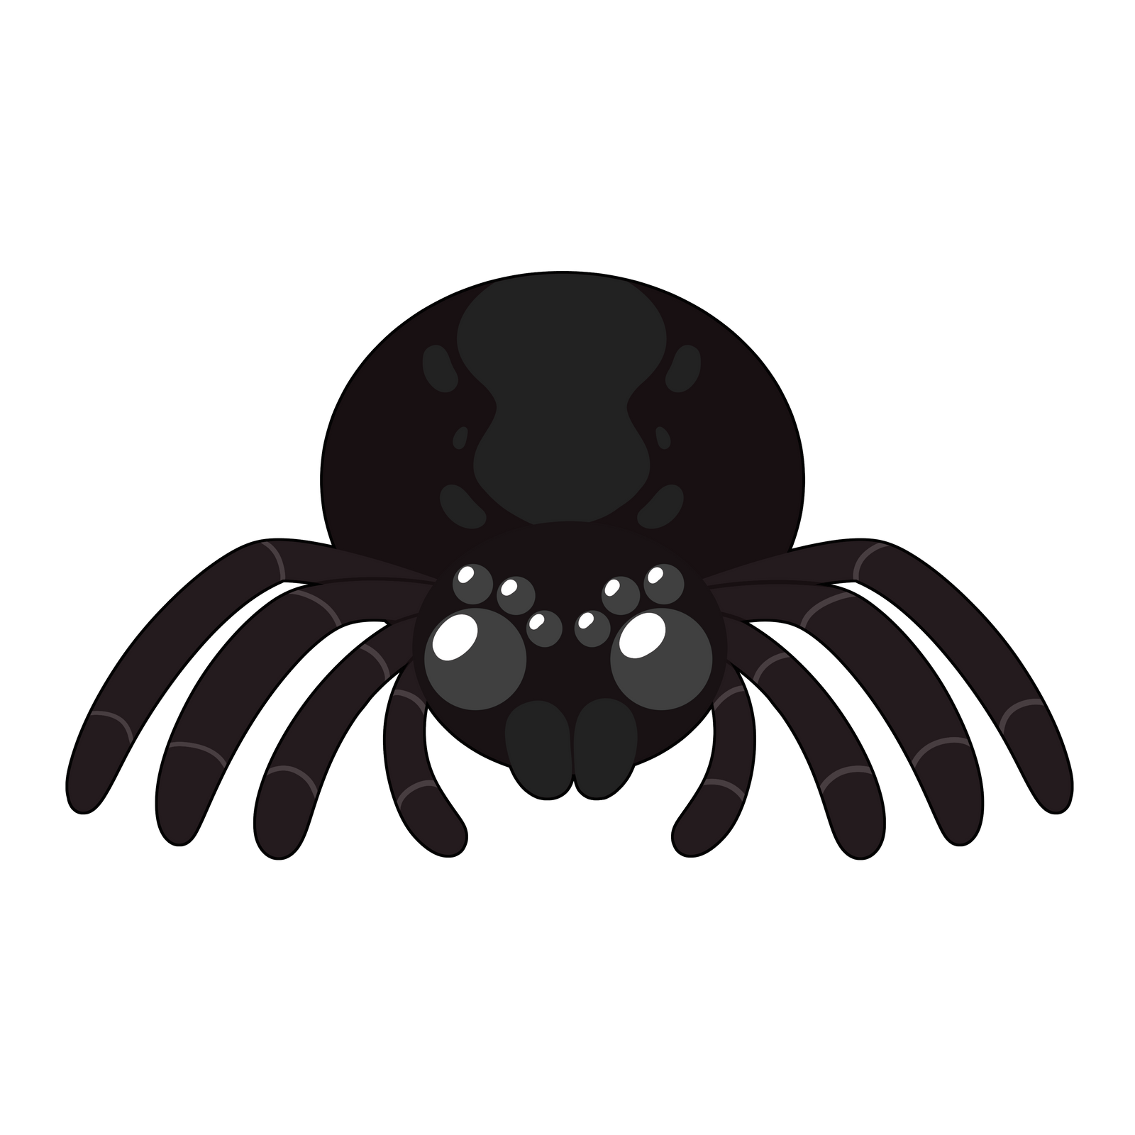
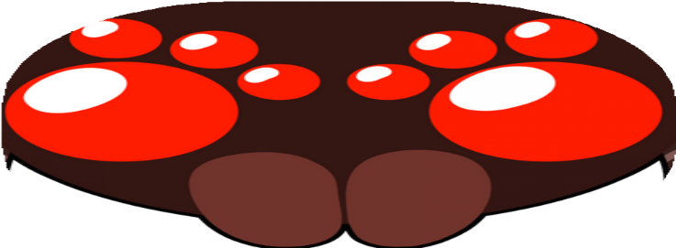
Asabikeshiinh

Asabikeshiinh
Spider

nishwaasogaade
s/he has 8 legs

makadewizi
s/he is black

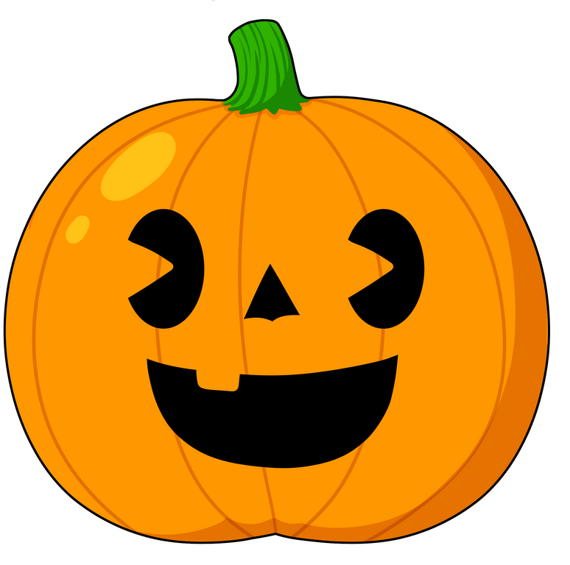
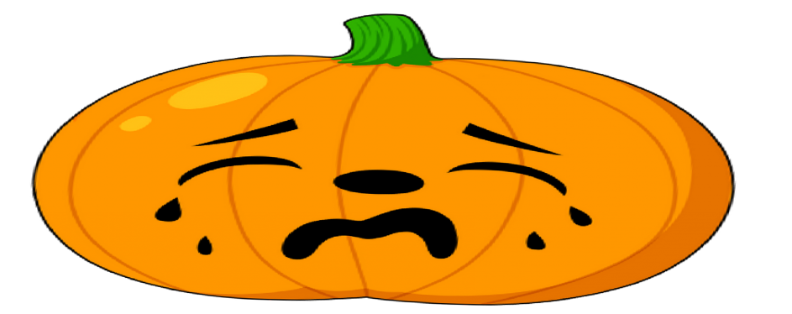

Gaa-mazinikozod Okosimaanan

Gaa-mazinikozod Okosimaanan Carved Pumpkins

mookodan
carve it

ozhaashijiiyaa
it is slimy

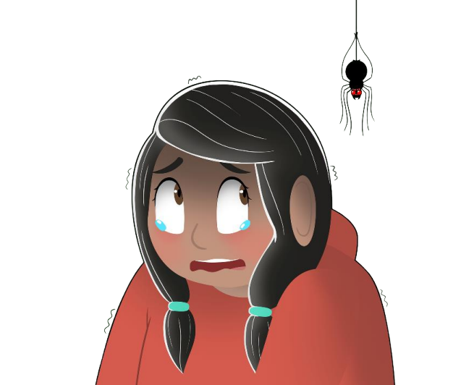
Zegizi

Zegizi
s/he is scared
gichi-biibaagi
s/he screams
zegendaagozi
s/he is scary
zegaatese
it is a scary movie

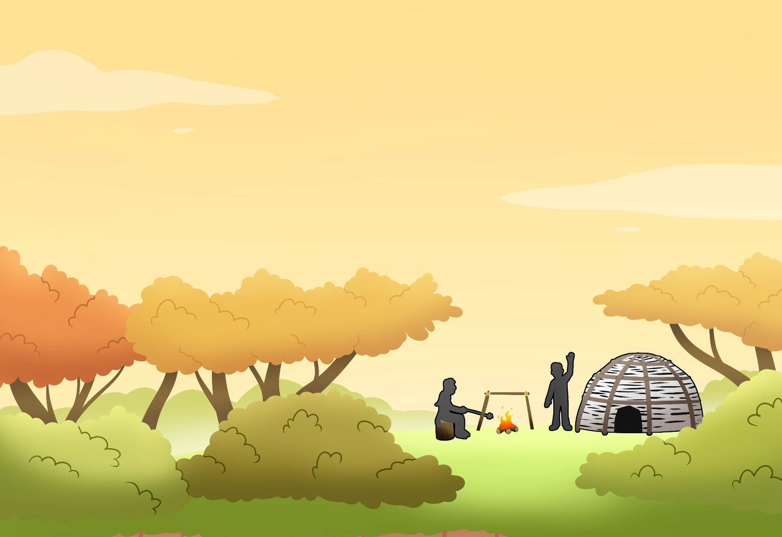

Dagwaagin

Dagwaagin
It is Autumn

ani-gisinaa
it is becoming cold

gaaskibagaasin
leaves rustle in the wind

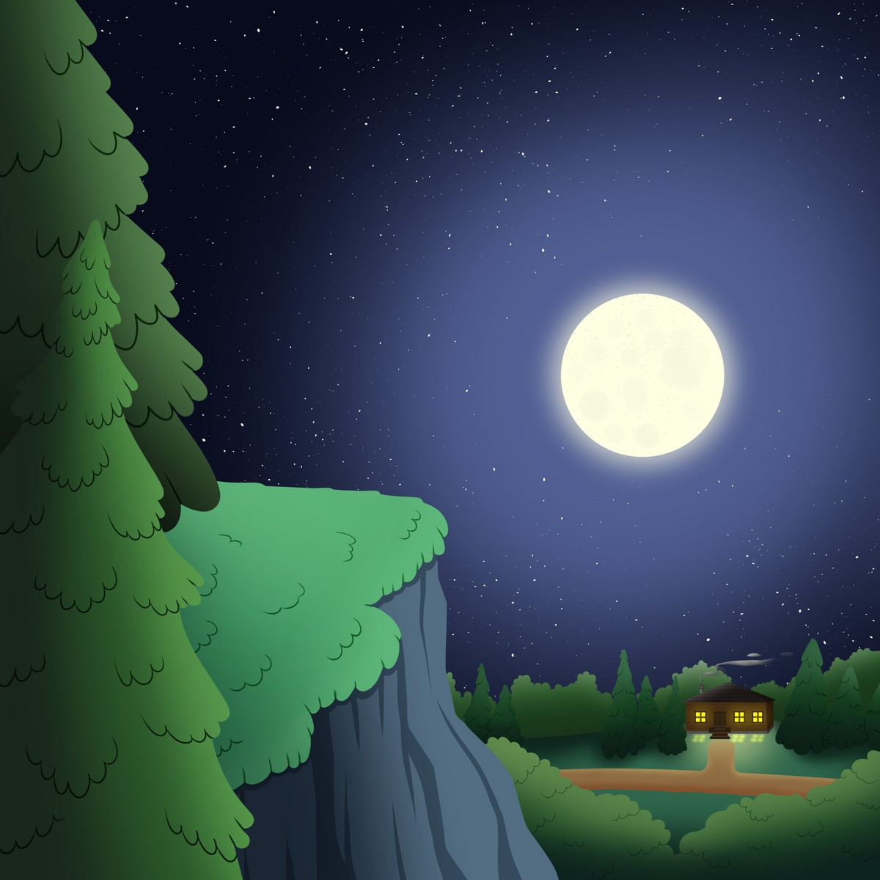
Dibikad

Dibikad
It is night

gashkii-dibikad
it is a dark night

dibiki-giizis
moon


Ziinzibaakwadoonsan
Candies

ziinzibaakwadoonsan
candies

ziinzibaakwadoons
piece of candy

waawe’izh-izhi’on
costume

