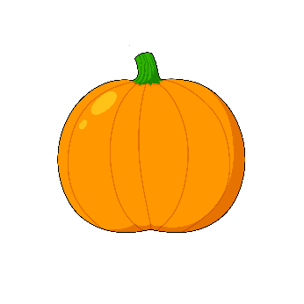
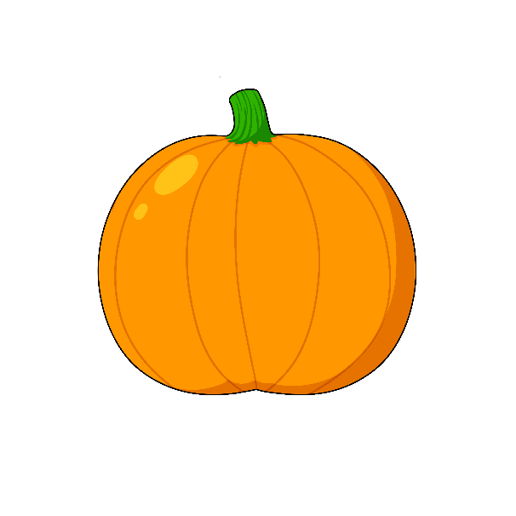
agaasin
michaa

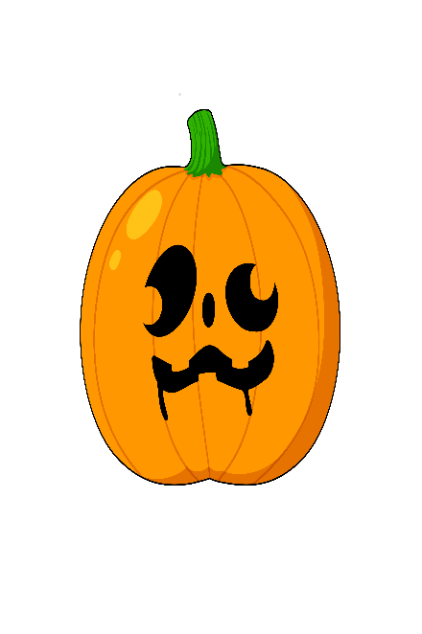
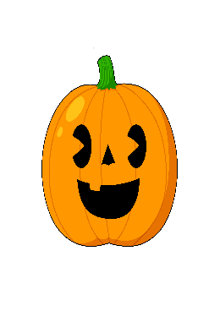
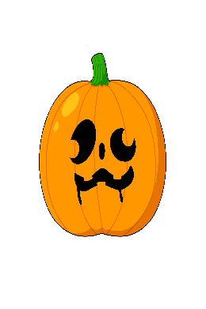
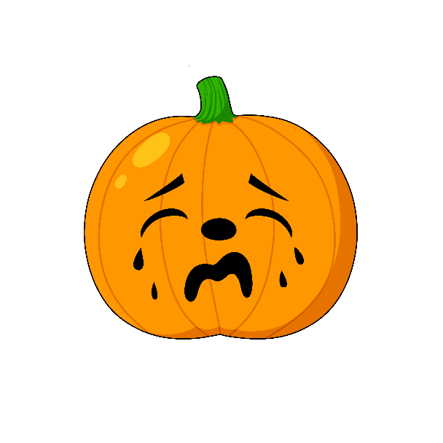

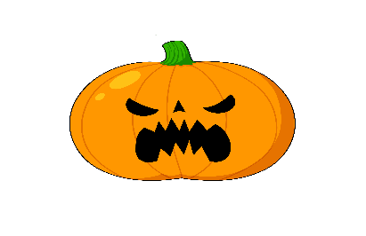
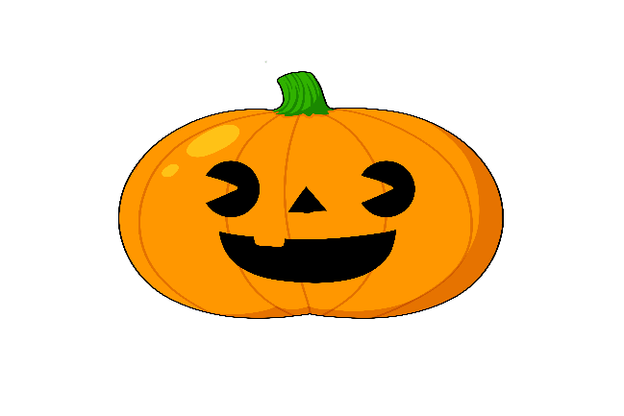
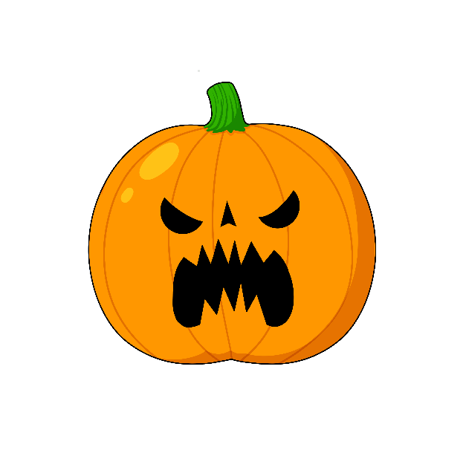
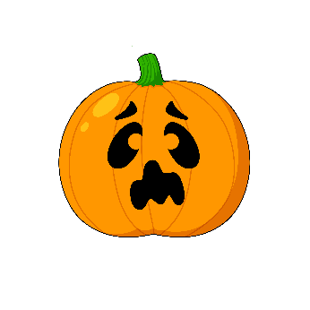
Ikidowinan
Okosimaan(an) pumpkin(s) [NI]
Michaa it is big [VII]
Agaasin it is small [VII]
Michaa ina okosimaan? Is the pumpkin big?
Agaasin ina okosimaan? Is the pumpkin small?
Giishkizhan Cut it [VTI]
Agokiwasan Glue it [VTI]
Gojitoon miinawaa! Try again!
Gegaa go! Almost!

