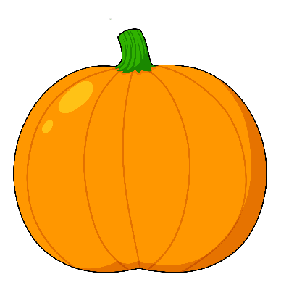
2  niizh | 8  nishwaaswi | 1  bezhig

9  zhaangaswi | 2  niizh | 4  niiwin
3  niswi | 5  naanan | 7  niizhwaaswi

10  midaaswi | 4  niiwin | 6  ningodwaaswi

4  niiwin | 9  zhaangaswi | 5  naanan

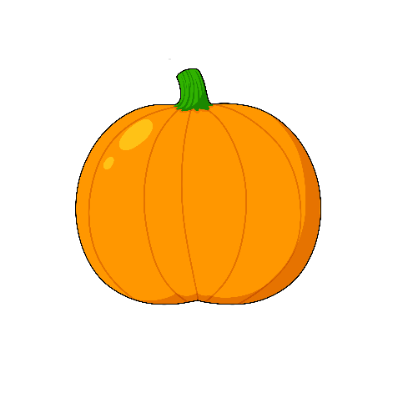
3  niswi | 6  ningodwaaswi | 1  bezhig

7  niizhwaaswi | 10  midaaswi | 8  nishwaaswi

3  niswi | 6  ningodwaaswi | 8  nishwaaswi

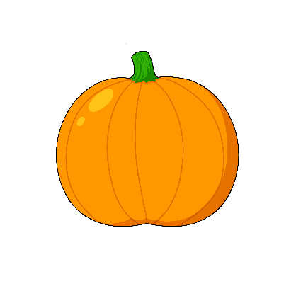
9  zhaangaswi | 2  niizh | 7  niizhwaaswi
6  ningodwaaswi | 10  midaaswi | 5  naanan

Vocabulary

Aaniin minik okosimaanan? How many pumpkins?

Agindaason! Count!

Bezhig one
Niizh two
Niswi three
Niiwin four
Naanan five
Ningodwaaswi six
Niizhwaaswi seven
Nishwaaswi eight
Zhaangaswi nine
Midaaswi ten

