Aandi waa-izhaayan?
Where are you going?
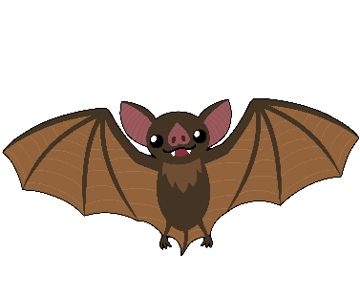
This early pre-writing activity is great for young ones practicing their fine motor skills.
Trace the lines or cut each section separately and have young ones cut on the lines!
apakwanaajiinhs
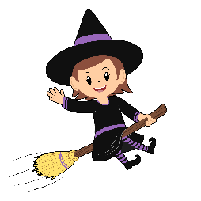
gaa-majaadizid
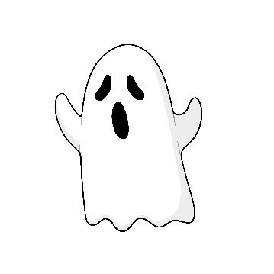

jiibay
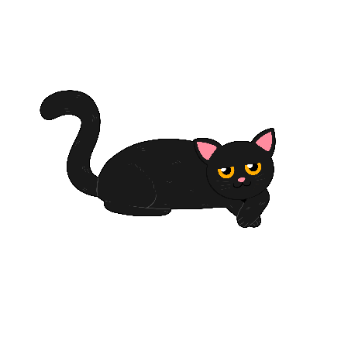

makade-gaazhagens

