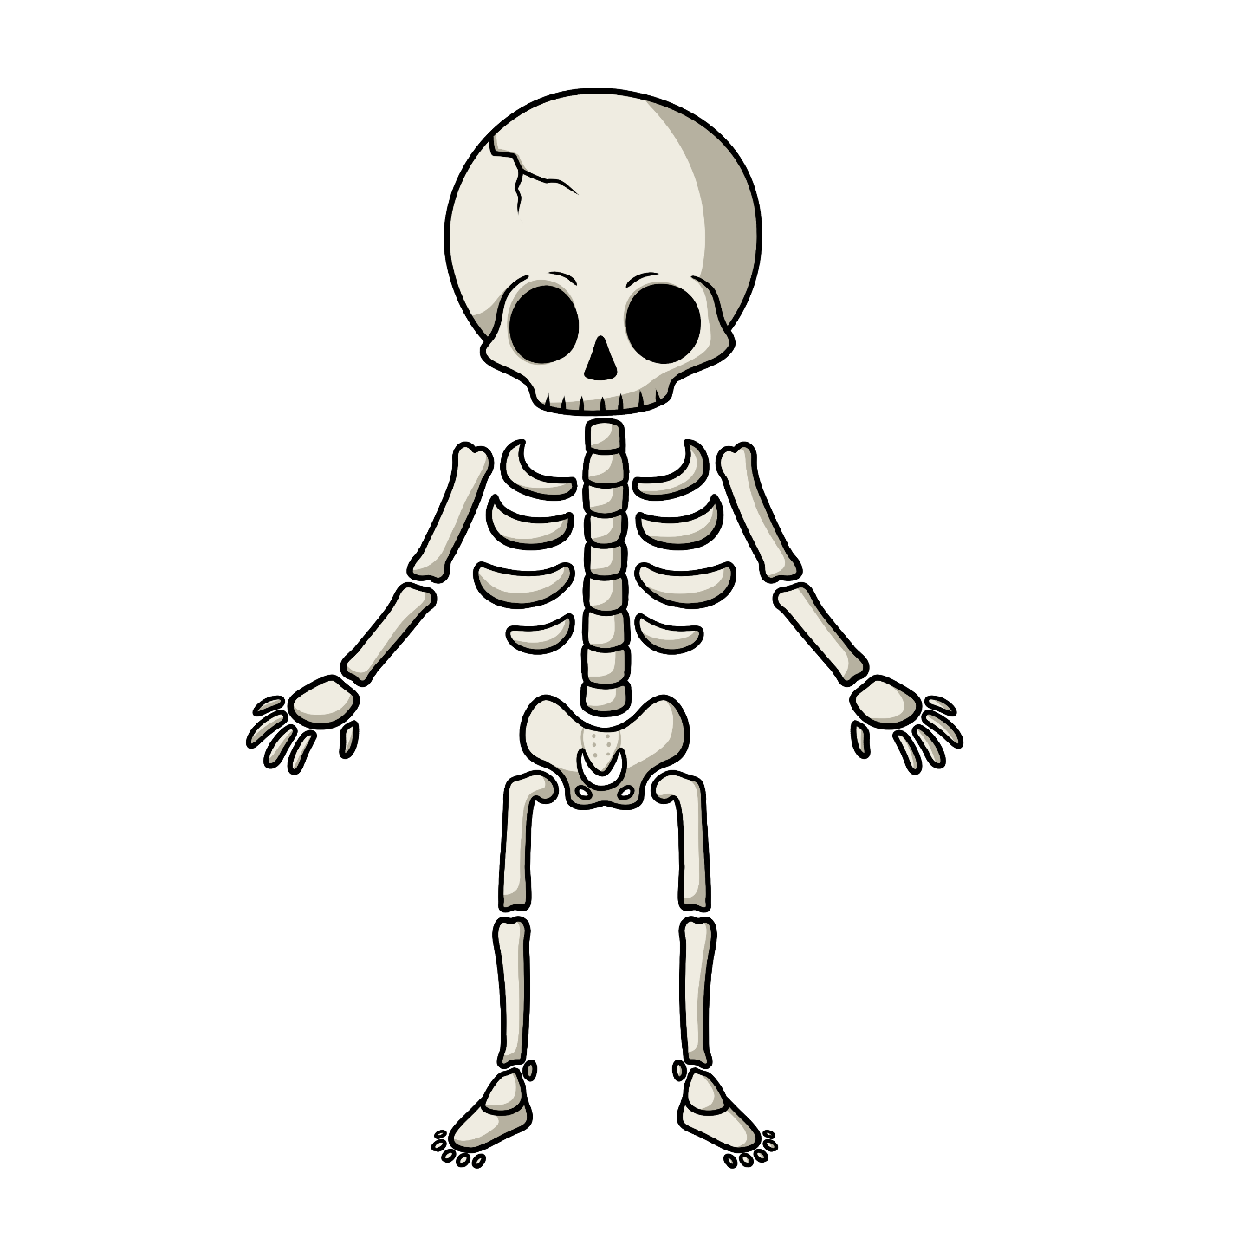

Bizhishigokogane

Bizhishigokogane
Skeleton

Waabishkizi
It is white

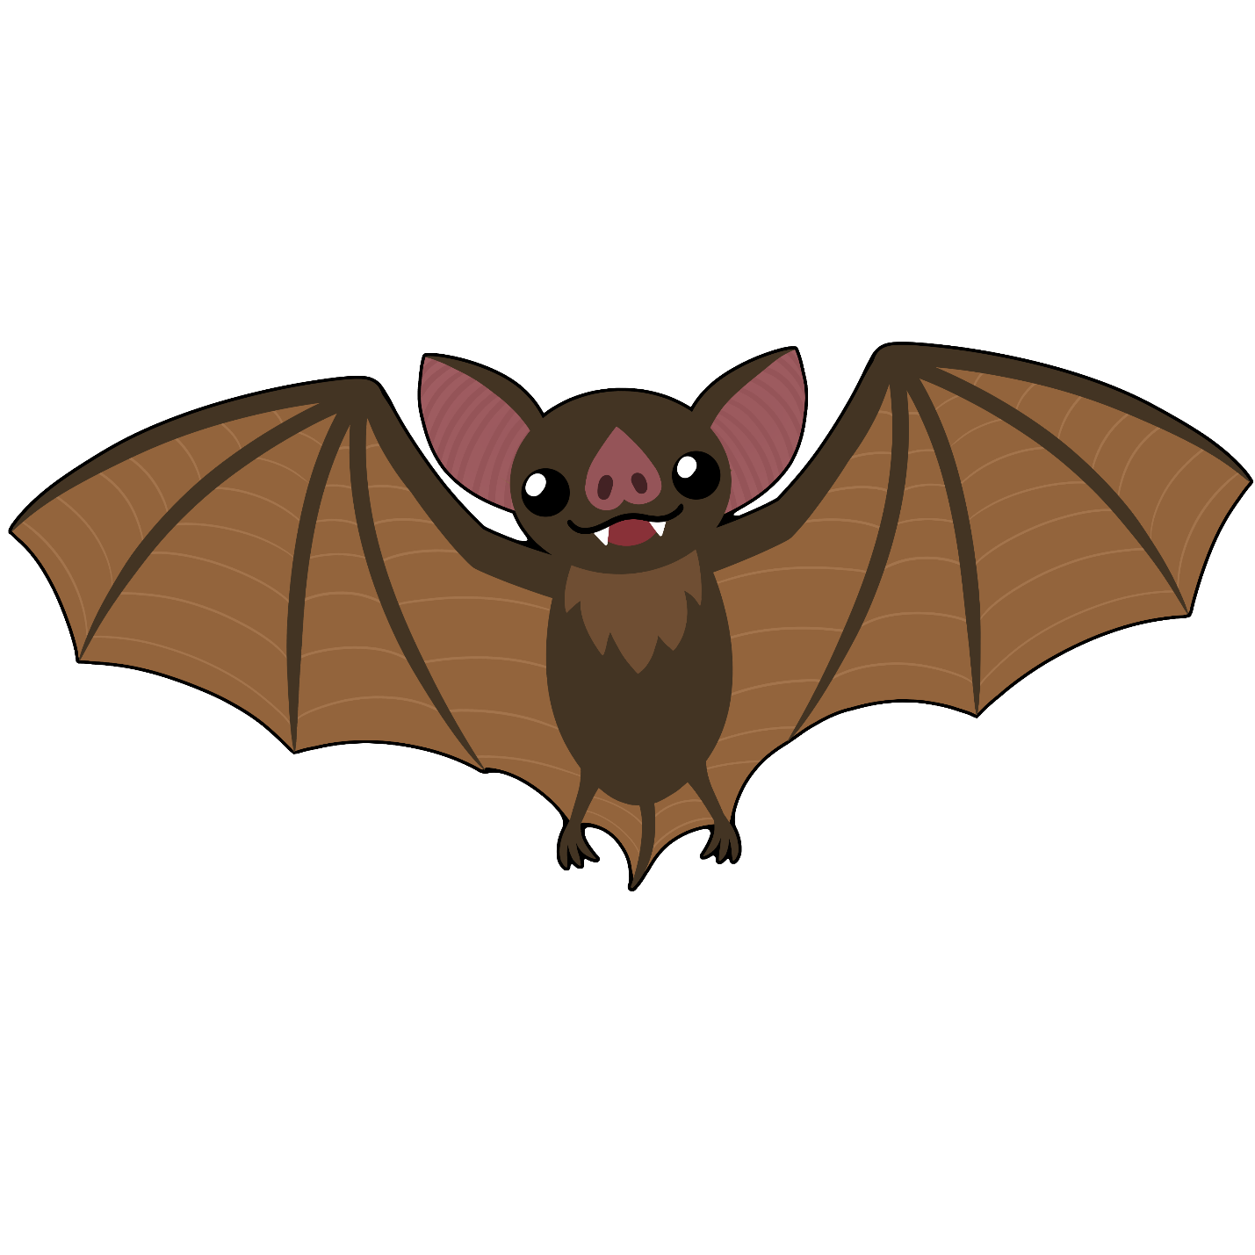

Apakwaanaajii

Apakwaanaajii
Bat

Apakwaanaajiiyag
Bat (pl)

Makade-ozaawizi
S/he is brown

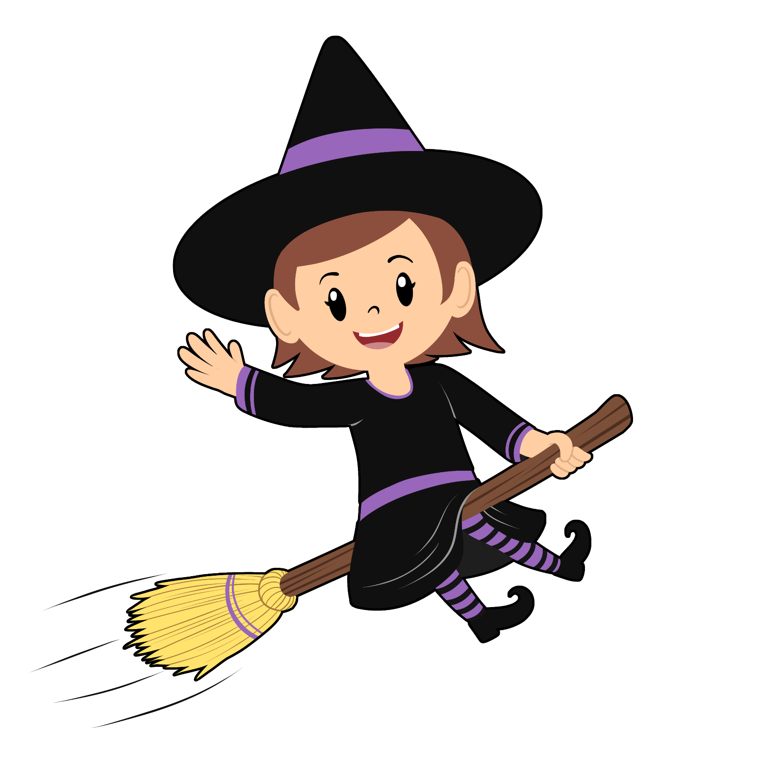

Gaa-majaadizid

Gaa-majaadizid
Witch

jiishada'igan
a broom

babaamise
s/he flies about

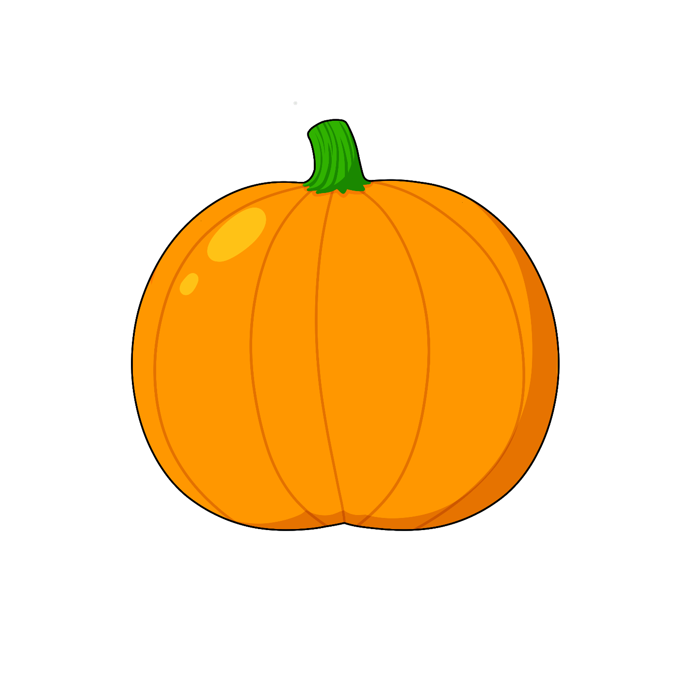Okosimaan
Okosimaan
Pumpkin

Ozaawaa
It is orange

Waawiyeyaa
It is round

Jiibay

Jiibay
Ghost

Jiibayag
Ghosts (pl)

Waabishkizi
s/he is white

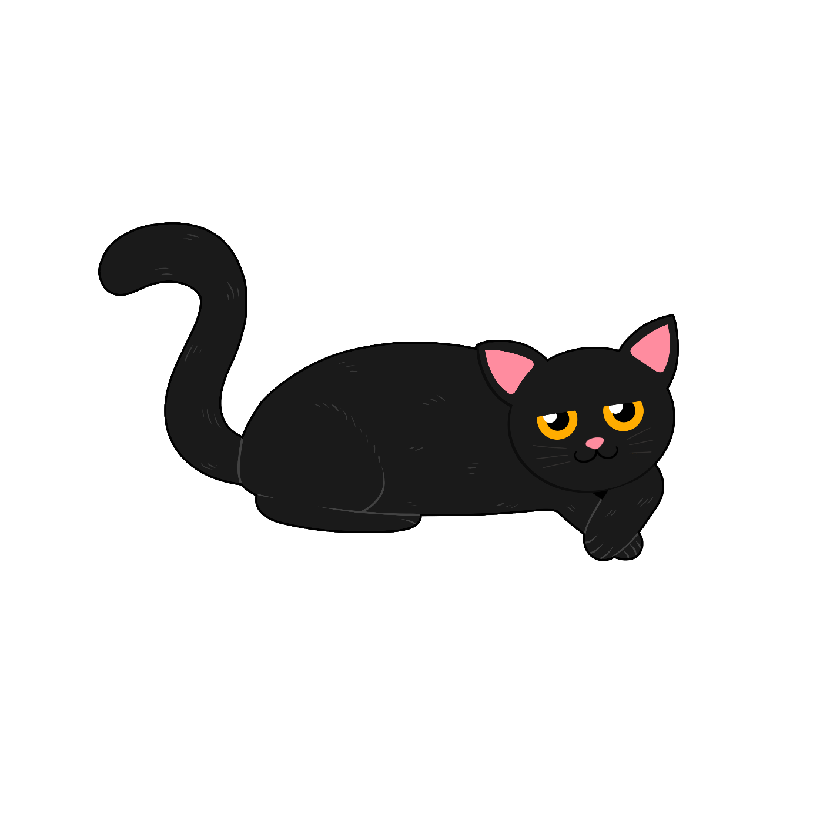

Makade-gaazhagens

Makade-gaazhagens
Black cat

Niiyogaade
s/he has 4 legs

Aaniin enwed?
What does s/he sound like?

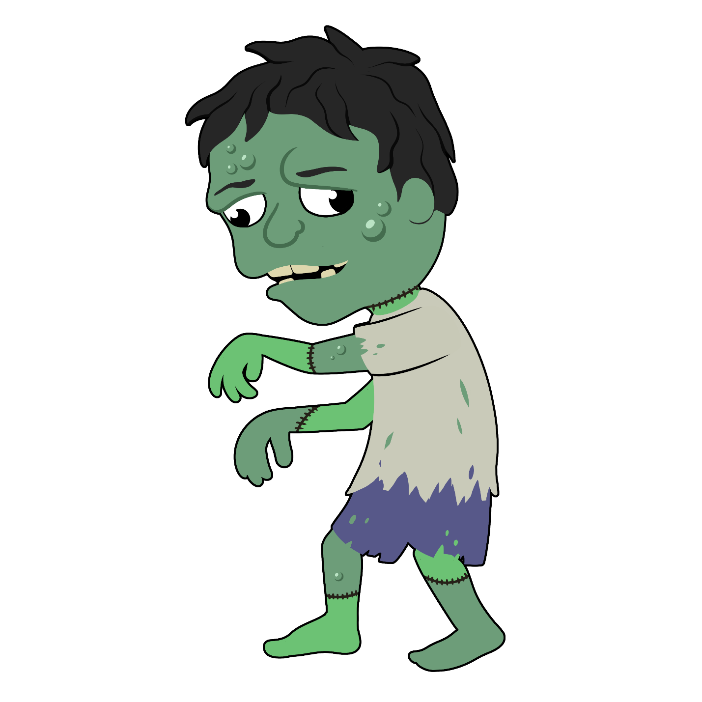

Gaa-nibo’aadizid

Gaa-nibo’aadizid
Zombie

Nibo
s/he is dead

Ozhaawashkozi
s/he is green
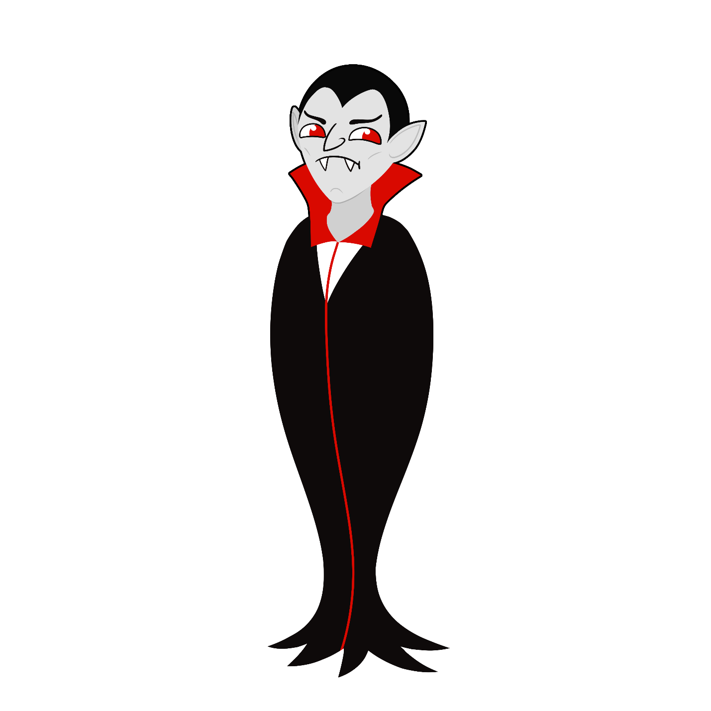

Miskwi Gaa-minikwed

Miskwi Gaa-minikwed
Vampire

Miskwi
Blood

Gaashkaabide
s/he has sharp teeth

