Odedewi-giizhigad
Miigiwe-mazina’igan

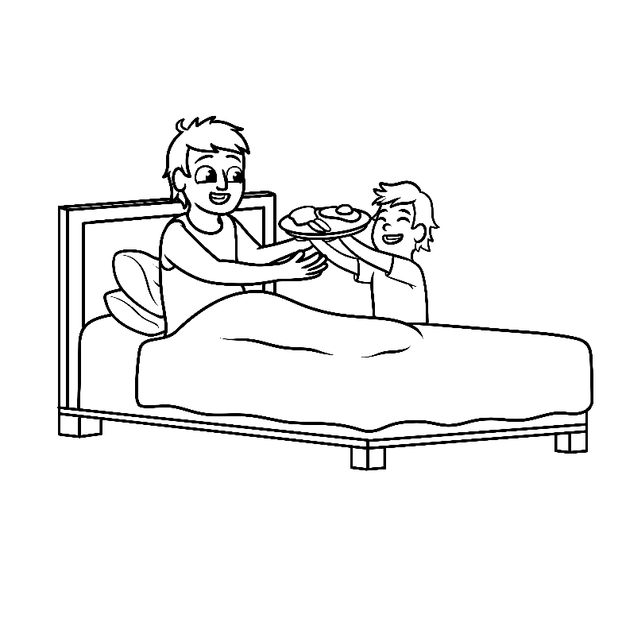

Miiwan ono ge-onjiigin:
Ga-gizhebaa-ashandiwin megwaa nibewining zhingishinan.

Miiwan ono ge-onjiigin:
da-biinad ninigewigamigoons.

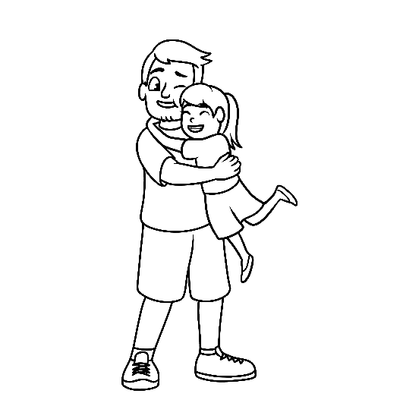

Miiwan ono ge-onjiigin: bezhig gaakinjigwein apiitendaagod.

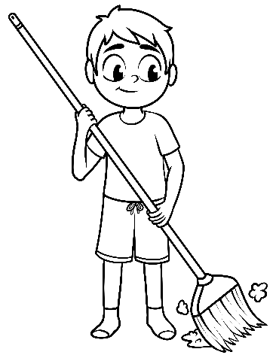
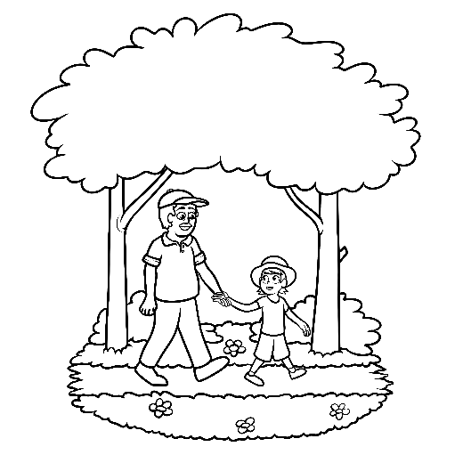
Aanikanootamaawinan/Translations
Miiwan ono ge-onjiigin: aabiting noopiming
giga-babaa-wiida’atoomin.
Miiwan ono ge-onjiigin: bezhig zhiishata’igewin.

- Coupon Book
- This coupon is good for one breakfast in bed.
- This coupon is good for one clean bedroom.
- This coupon is good for one big hug.
- This coupon is good for one sweep of the kitchen.
- This coupon is good for one walk in the bush.

