Wiiyaw
His/Her Body
On each sheet you will find a different animal with lines indicating various body parts.
Along the bottom of each page is a selection of words describing their body parts.
Learners can cut these out and paste them onto the correct line for each body part labelled.
If they know more than what is offered, they can write and draw a line for additional labels as well!
Below is a list of body parts to learn.
Anishinaabemowin | English |  | Anishinaabemowin | English
emikwaan | shell |  | ozow | animal tail
onaga'ay | scales |  | oningwiigana' | wings
oninjiganan | fins |  | omiishidoonaanan | whiskers
ozhigwan | fish tail |  | okoozh | beak
ozhaga'e | skin |  | odeshkana' | antlers
oshkiinzhigoon | eyes |  | ogaawiwa' | quills
otawagan | ears |  | ozhkanzhii' | claws
ojaan | nose |  | oganzhiin | hooves
odoon | mouth |  | obiiway | fur
wiibidan | teeth |  | omiigwana’ | feathers
oshtigwaan/otigwaan | head |  | okaadan | legs
ozidan | feet

These are the most basic words for describing body parts of animals. Some animals, like a bear, have specialized words
i.e. makwaninj – bear’s front paw & makozid – bear’s hind paw.
Notice how the word parts for the body part is included in these specialized words as well i.e. ninj – hand, zid – foot.
We encourage you to find these specialized words by speaking to your community language keepers,
or by searching for them in dictionaries.

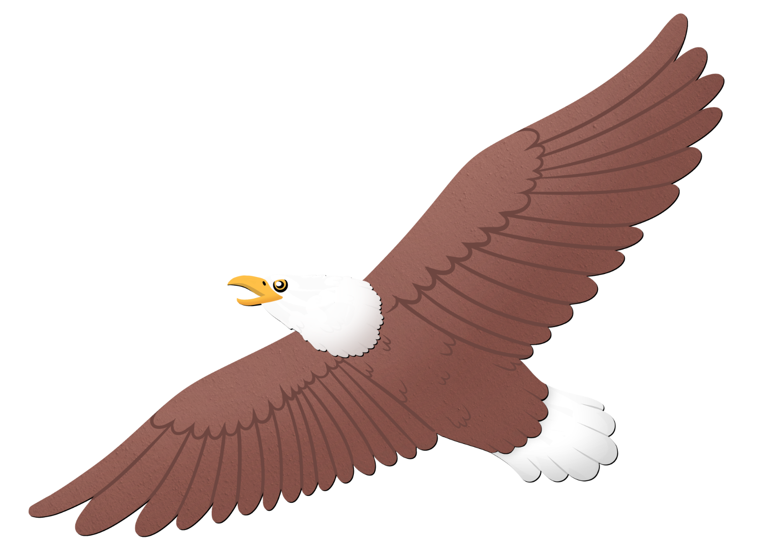

okoozh | ozow | oningwiigana' | omiigwana'

oshkiinzhigoon | ozhigwan | onaga'ay | oninjiganan

otawagan | okaadan | odoon | obiiway
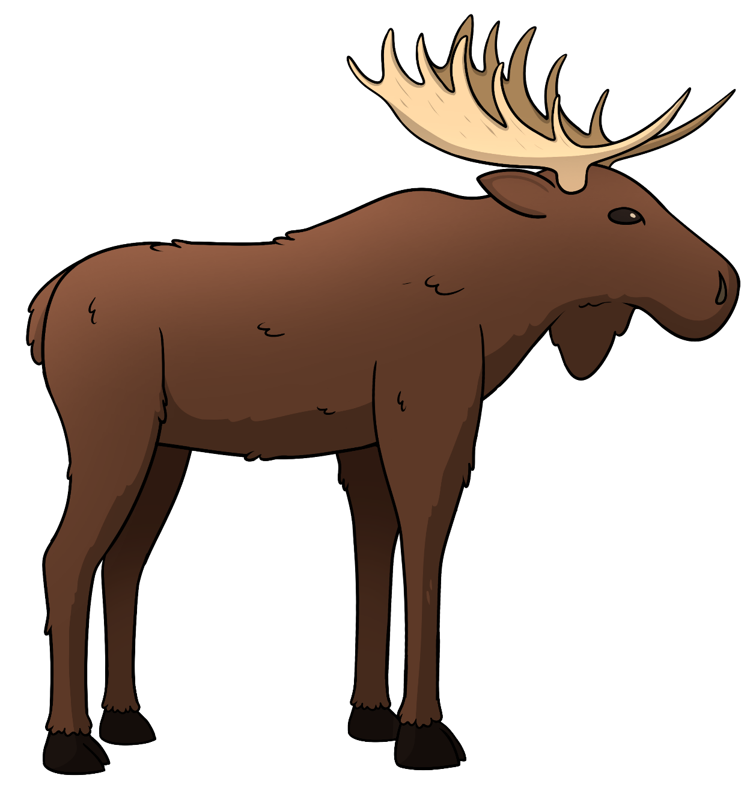

oganzhiin | odeshkana' | ojaan | oshtigwaan

emikwaan | oshkanzhii' | oshkiinzhigoon | ojaan

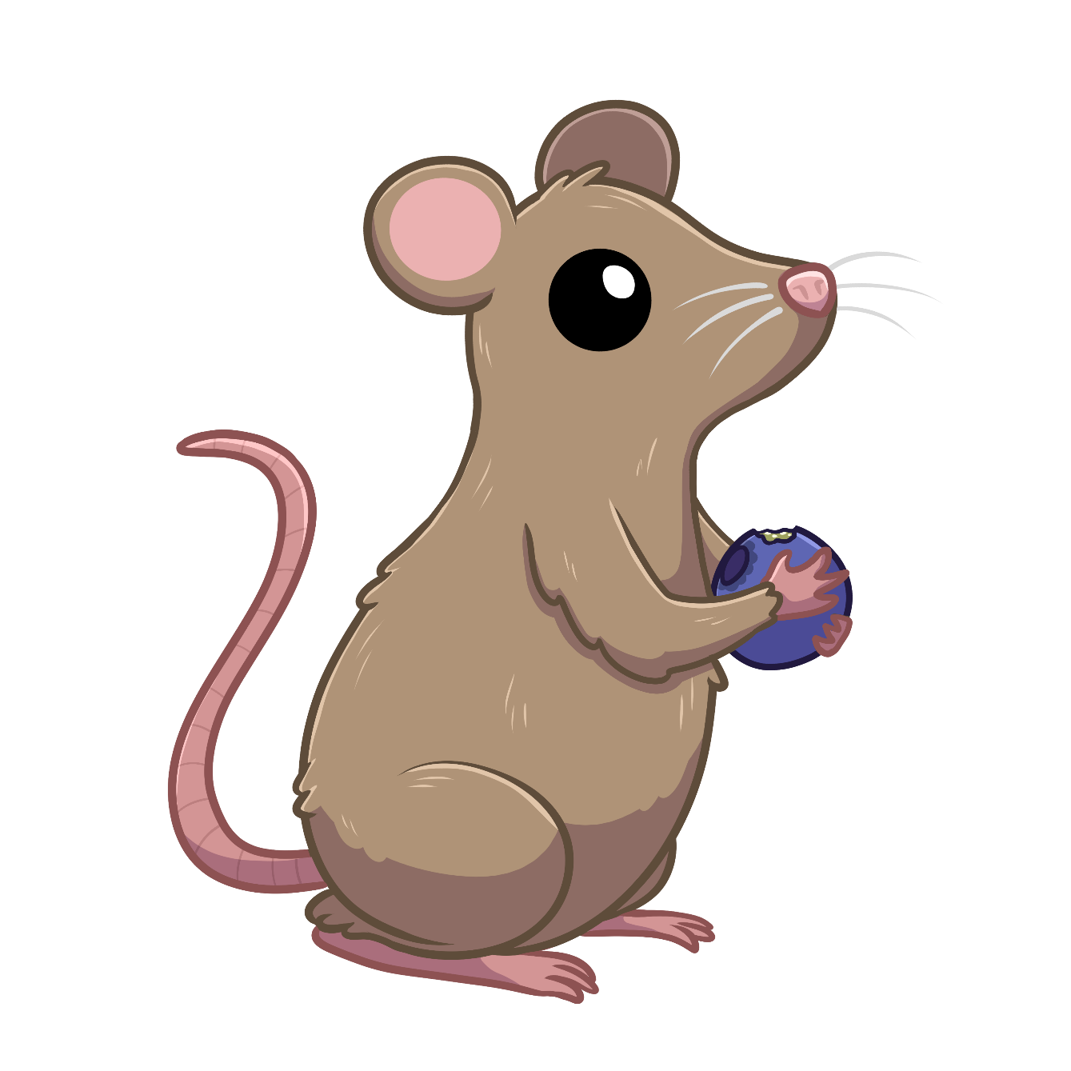

ozidan | omiishidoonaanan | otawagan | ozow

ozidan | omiishidoonaanan | ogaawiwa' | ozow

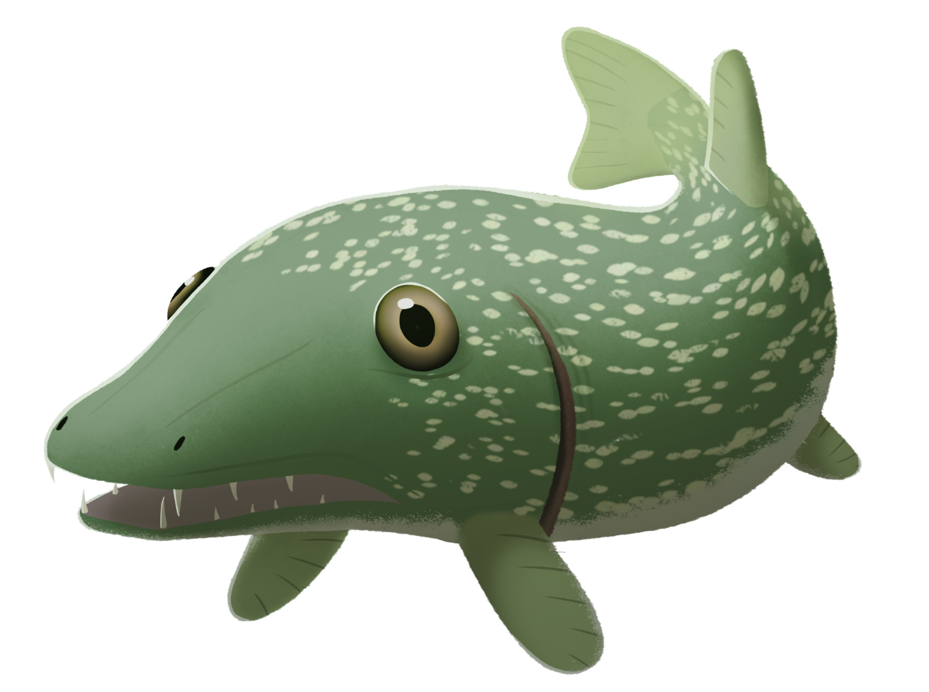

oninjiganan | ozhigwan | wiibidan | onaga'ay

