**Omaamaawi-giizhigad**Vocabulary & Phrases

**Awenen? Who?**

Nimaamaa my mother

Nookomis my grandmother

Nizigos my auntie (father’s sister)

Ninoshenh my auntie (mother’s sister)

Nimise my older sister



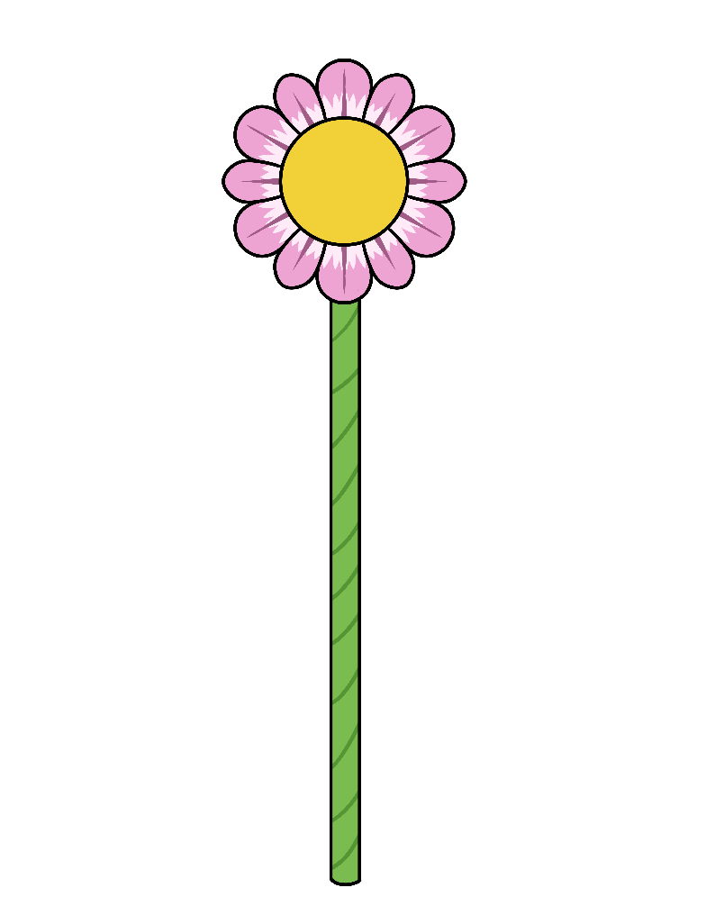

**Nice Things to Say About Her**

S/he is beautiful. Miikawaadizi.

S/he is kind. Gizhewaadizi.

S/he is smart. Gikendaaso.

S/he is funny. Wawiyadendaagozi.

S/he has a good/kind heart. Minode’e.

S/he is strong. Mashkawizii.

**Nice Things to Say to Her**

I love you. Gizhawenimin.

I am thankful for you. Gimiigwechiwenimin.

You are beautiful. Gimiikawaadiz.

You are kind. Gigizhewaadiz.

You are smart. Gigikendaas.

You are funny. Giwawiyadendaagoz.

You have a good/kind heart. Giminode’e.

You are strong. Gimashkawizii.