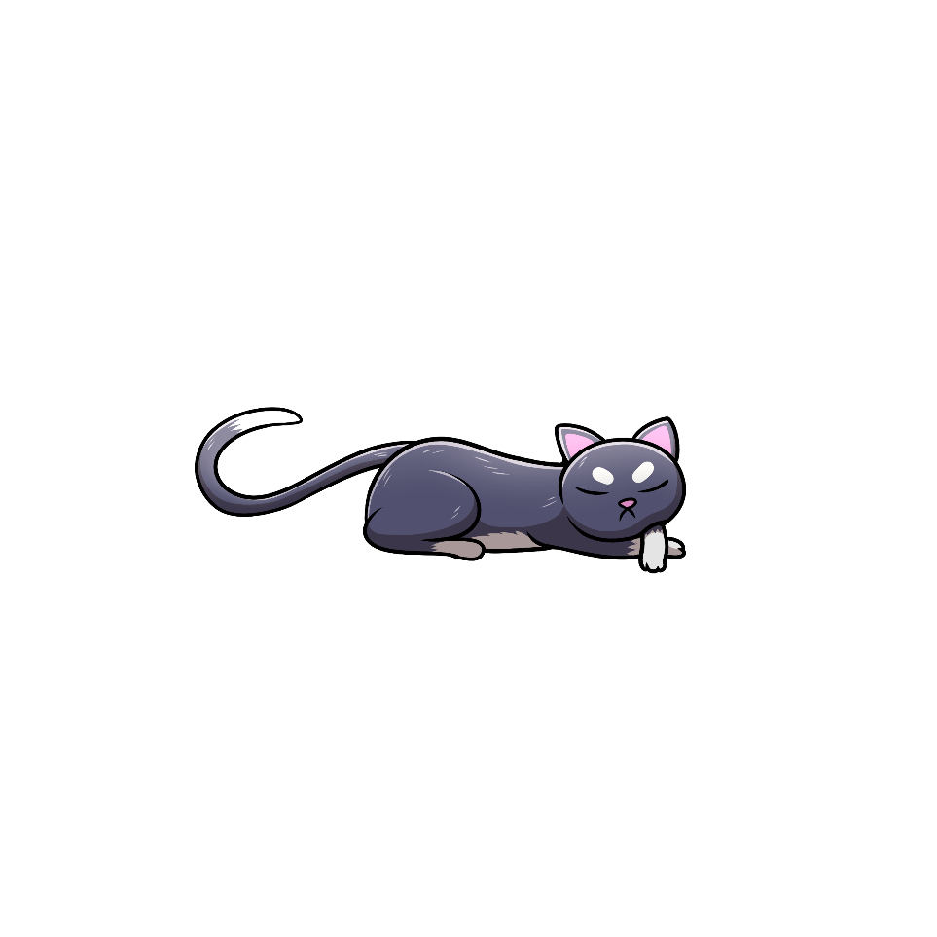

**Inga-doodam!**Words & Phrases for Potty Training

**Nouns**

aanziyaan diaper

miizii-onaagaan toilet bowl

zaagaa’amoowigamig bathroom

miiziiwigamig bathroom

giziindime’on toilet paper

giziininjii-onaagan sink

giziibiiga’igan soap

gaasiininjii’on towel

giziingwe’onens towel

moo poop

zhigiwin urine

boogid fart

**Awenen? Who?**

Biibii infant

Abinoojiiyens child

Ikwezens girl

Gwiiwizens boy

Niniijaanis my child

Nindaanis my daughter

Ningozis my son

**Questions to Ask**

Gizhiigwaabaawe na? Is your diaper wet?

Ginoonde-zaaga’am ina? Do you need to go to the bathroom?

Ginoonde-zhiishiig ina? Do you need to go pee?

Ginoonde-miizii na? Do you need to go poop?

Gigii-zhiishiig ina? Did you go pee?

Gigii-miizii na? Did you go poop?

Gigii-naazhibidoon ina? Did you flush the toilet?

Gigii-giziininjii ina? Did you wash your hands?

Gigii-gaasiininjiw ina? Did you dry your hands?

**Commands for Adults Helping Children Learn to Use the Toilet**

Naazhibizh gidaas. Pull down your pants.

Giijidaasen. Take off your pants.

Ishpiigibidoon gigoodaas. Lift up your dress/skirt.

Naazhibizh gidaasens. Pull down your underwear.

Namadabin omaa. Sit here.

Niibawin omaa. Stand here.

Ombibidoon. Put it up (the toilet seat).

Zhiishiigin. Go pee.

Naanaagadawendan nibi. Think of water.

Miiziin. Go poop.

Giziindime’on. Wipe your bottom.

Niibawin. Stand up.

Naazhibiiwebinan. Flush the toilet.

Giziininjiin. Wash your hands.

Gaasiininjii’on. Dry your hands.

Ishpibizh gidaasens. Pull up your underwear.

Ishpibizh gidaas. Pull up your pants.

Naazhibidoon gigoodaas. Put your dress/skirt down.

**Encouraging Phrases**

Mii go maanoo *hug them* gaawiin gegoo iwe.  
It’s ok, everyone has accidents.

Gego ojaanimendangen.  
Don’t worry.

Gego mawiken.  
Don’t cry

Giminochige! Howa!  
Good job!

Gigiidoodam!  
You did it!