Ikwezens Gii-babaamose
The Girl Was Walking About

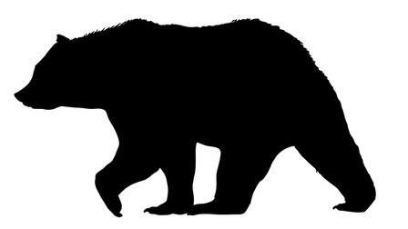
Ikwezens gii-babaamose, ikwezens gii-babaamose, ikwezens gii-babaamose,
The girl was walking about, the girl was walking about, the girl was walking about,
makwan ogii-waabamaan.
when she saw a bear.
Makwa inwe “ROAR!”, Makwa inwe “ROAR!”,
Makwa inwe “ROAR ROAR, ROAR ROAR, ROAR ROAR!”
The bear sounds like “ROAR!”, the bear sounds like “ROAR!”,
the bear sounds like “ROAR ROAR, ROAR ROAR, ROAR ROAR!”

Ikwezens gii-babaamose, ikwezens gii-babaamose, ikwezens gii-babaamose,
The girl was walking about, the girl was walking about, the girl was walking about,
animosh ogii-waabamaan.
when she saw a dog.
Animosh inwe “WOOF!”, Animosh inwe “WOOF!”,
Animosh inwe “WOOF WOOF, WOOF WOOF, WOOF WOOF!”
The dog sounds like “WOOF!”, the dog sounds like “WOOF!”,
the dog sounds like “WOOF WOOF, WOOF WOOF, WOOF WOOF!”

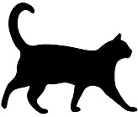
Ikwezens gii-babaamose, ikwezens gii-babaamose, ikwezens gii-babaamose,
The girl was walking about, the girl was walking about, the girl was walking about,
gaazhagan ogii-waabamaan.
when she saw a cat.
Gaazhag inwe “MEOW!”, Gaazhag inwe “MEOW!”,
Gaazhag inwe “MEOW MEOW, MEOW MEOW, MEOW MEOW!”
The cat sounds like “MEOW!”, the cat sounds like “MEOW!”,
the cat sounds like “MEOW MEOW, MEOW MEOW, MEOW MEOW!”

Ikwezens gii-babaamose, ikwezens gii-babaamose, ikwezens gii-babaamose,
The girl was walking about, the girl was walking about, the girl was walking about,
gwiiwizens ogii-waabamaan.
when she saw a boy.
Gwiiwizens ikido“AANII!”, Gwiiwizens ikido “AANII!”,
Gwiiwizens ikido “AA-NII, AA-NII, AA-NII!”
The boy says “HELLO!”, the boy says “HELLO!”,
the boy says “HELLO, HELLO, HELLO!”

Mazinaakizan!
Scan the QR to hear the song

The animals/characters in the song can be changed to suit the animals/characters that you would like to teach to the learners. They must be in 4th person form (aka Obviative form) ex. Makwan.
Here are the steps to put the animal/character into 4th person form:
- Choose animal Bineshiinh
- Pluralize the word Bineshiinyag
- Change the last letter to an “n” Bineshiinyan
- You are done, you now have a word that is in 4th person form.

