Giziibiigininjiin Nagamon
Wash Your Hands Song
Sung to the tune of “Frere Jacques”
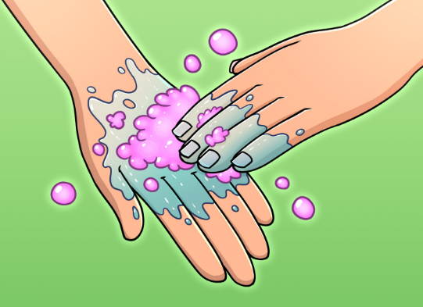

Giziibiigininjiin, Giziibiigininjiin
Wash your hands, Wash your hands

Aabajitoon nibi, Aabajitoon nibi
Use water, Use water

Giminochige, Giminochige
Good job, Good job

Gibiinininjii, Gibiinininjii
You have clean hands, You have clean hands

Mazinaakizan!
Scan the QR to hear the song

