Biminizho’ Iwidi Endanaadizid
Follow Them Home
This early pre-writing activity is great for young ones practicing their fine motor skills.
Trace the lines to follow the animals to their homes! Or, cut each section separately and have young ones cut on the lines!
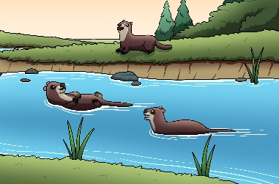
nigig ziibiing
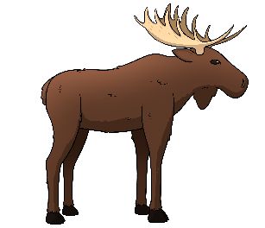
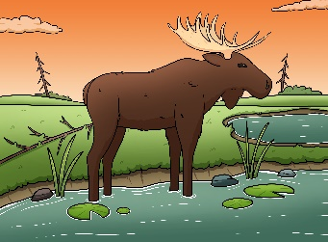
mooz mashkiigong
makwa waazhing
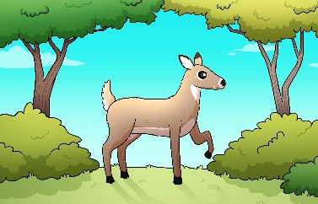
waawaashkeshi noopiming

