|  |  |  |
| --- | --- | --- |
|  | | |
|  | | |
|  |  |  |

|  |  |  |
| --- | --- | --- |
|  | | |
|  | | |
|  |  |  |
|  | | |
|  | | |
|  |  |  |

|  |  |  |
| --- | --- | --- |
|  | | |
|  | | |
|  |  |  |

|  |  |  |
| --- | --- | --- |
|  | | |
|  | | |
|  |  |  |

|  |  |  |
| --- | --- | --- |
|  | | |
|  | | |
|  |  |  |

|  |  |  |
| --- | --- | --- |
|  | | |
|  | | |
|  |  |  |

**Vocabulary**

Awenen gaa-bimikawaanan? Whose tracks are these?

____________ iwe bimikawaanan. Those are ___________ tracks.

i.e. Makwa iwe bimikawaanan. Those are bear tracks.

Makwa bear

Ma’iingan wolf

Aginjibagwesi goldfinch

Gaag porcupine

Waabooz rabbit

Nigig otter

Waawaashkeshi deer

**Answer Key**

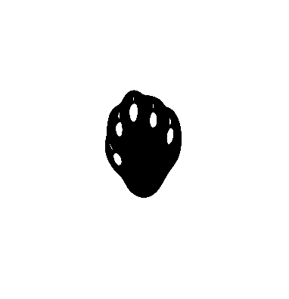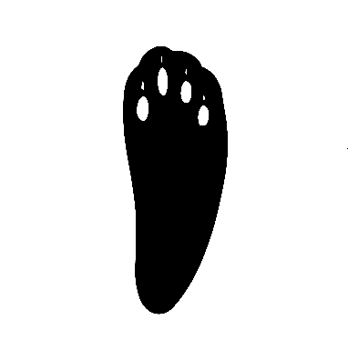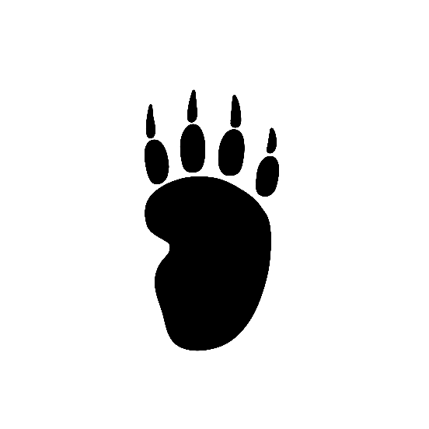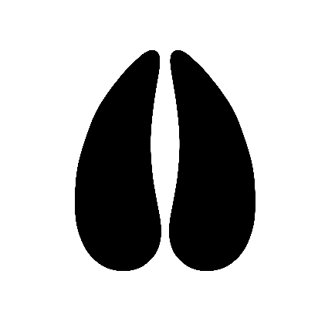

**waawaashkeshi**

**waabooz**

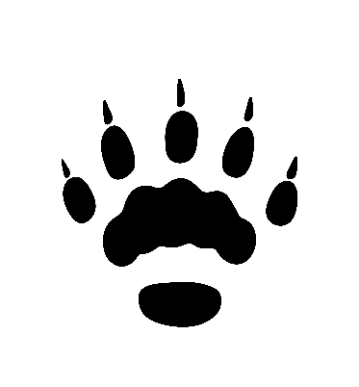

**nigig**

**gaag**

**aginjibagwesi**

**ma'iingan**

**makwa**

