Ajidamoo Odaminowin
2-5 players
Rules
- Cut out the squirrel pieces and laminate separately. Each player gets their own different coloured squirrel.
- Place all pieces on the Maajiitaadaa square to begin.
- Roll one die to move from the Maajiitaadaa square.
- Move the number of spaces rolled to advance in the game.
- There are three animals on the board. If you land on one, each one has their own rule for you to follow:
  - Gaag – Oh no! Slow down and miss a turn.
  - Waabooz – The path is clear! Hop ahead 2 spaces.
  - Amik – There is a tree in your way! Move back 3 spaces.
- The first person to reach the tree home of the squirrel wins the game, however, they must roll the exact number to land on the tree i.e. if they are one space away they need to roll a one to land on the tree and win
Vocabulary
ozhaawashkwaa
miskwaa
Wiiji’ ajidamoo ji-giiwed. Help the squirrel get home.
Ditibiwebin gaa-gakakizid. Roll the die.
Aanjishim awe gijidamoom. Move your squirrel.
Niinitam. My turn.
waabishkaa
Giinitam. Your turn.
waabijiiyaa
Wiinitam. His/her turn.
Ishe! Bezikaan, baamaa giin miinawaa. Oh no! Slow down and miss a turn.
Dawi’ayaa imaa! Niizhing gaanjishkaan. The path is clear! Hop ahead 2 spaces.
Mitig imaa gigibishkaag! Nising azheshkaan. There is a tree in your way! Move back 3 spaces.
Gegaa go! Almost!
ozaawaa
Gibakinaage! You win!
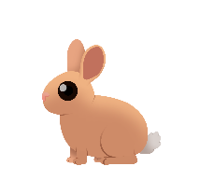
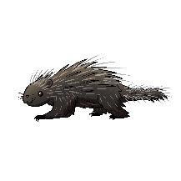
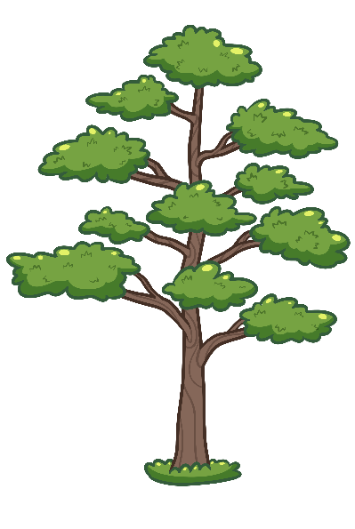
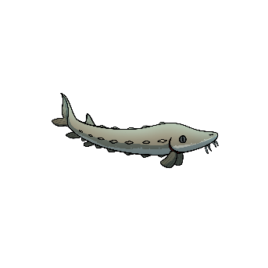
GIBAKINAAGE!
MAAJIITAADAA!

