**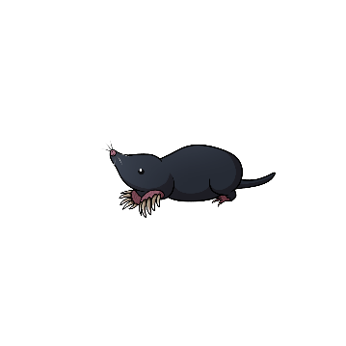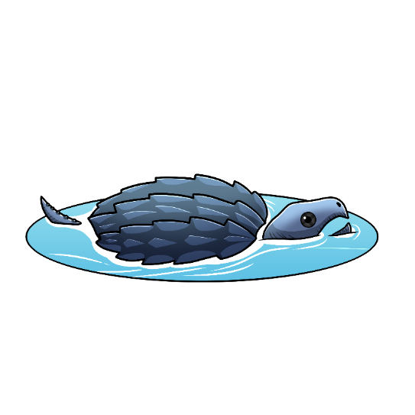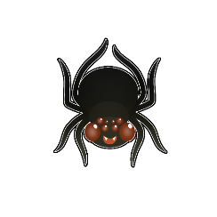

**Aandi endaawaad awesiinhyag?**