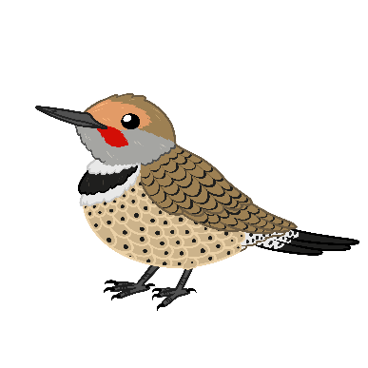
______________________________nindizhinikaaz
Ziigwan Odaminowin

Using the Tiny Tap game, listen carefully to the words as you click each object, and spell them using the double vowel system to the best of your ability.
https://www.tinytap.com/activities/g51s2/play/aandi
Anishinaabemowin | English
 | bee
 | flower
 | leaf
 | dragonfly
 | goldfinch (bird)
 | cloud
 | mushroom
 | puddle
 | snail
 | birch tree
 | snapping turtle
 | there are plenty of raspberries
 | stump
 | branch/twig/stick
Answer Key & Morphology (Word Parts)
Anishinaabemowin | English
amoo | bee
waabigwan | flower
(a)niibiish | leaf
aboodiskwaanashiinh (also; oboodaskwaanashiinh) | dragonfly
Aginjibigwesii (also aginjibagwesiinh) aginj- count, big- leaf,  wesii-insect/animal like | goldfinch (bird)
aanakwat (also; aanakwad) aanakw- cloud; -at- it is in a state | cloud
wazhashkwedoons | mushroom
gaa-waanabiiyaag gaa+VERB+g- the thing that is…, waan-fog,mist,  bii-liquid, aa-state or condition | puddle
bimishkoodesii bim- along in space or time; -shkaa- s/he or it (animate) moves, goes, oode- s/he crawls, sii- insect/animal like | snail
wiigwaaswaatig (also; wiigwaasaatig) wiigwaas- birchbark,  aatigw- (deciduous) tree, stick | birch tree
mikinaak | snapping turtle
miskominikaa misko- red, min-small and globular; berry,  kaa- it is present, is abundant | there are plenty of raspberries
giishkanakad giishk- cut off, severed, sheared off; an- do action to it; ak- wood, organic solid; ad- state or condition | stump
mitigwaanens (also; mitigoons) | branch/twig/stick

