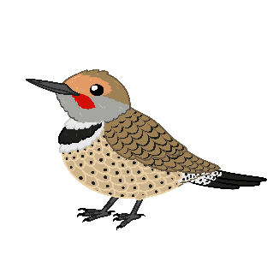
Mikan!
Find it!
Use this vocabulary list to explore your area and have a fun scavenger hunt with your learners. Based on their age you can have them simply find and point out the items, collect the items, or take pictures of the items. Make sure your learners have a copy of the visual list for their search. You can laminate and reuse these with erasable markers for learners to check off what they’ve found as well.
Mikan (inanimate) | Mikaw (animate)
Waabigwan - Flower | Asin - Rock
Aniibiish - Leaf | Manidoosh - Bug
Mitigwanens - Twig | Mitig - Tree
Aanakwad - Cloud | Bineshiinh - Bird
Gaa-waanibiiyaag - Puddle

Other Vocabulary & Phrases

Babaamosedaa! Let’s walk about!
Aandi ______? Where is ______?
Aandi aanakwad? Where is a cloud?
Ishpiming. In the sky.
Akiing. On the ground.
Mitigoong. On/In the tree.
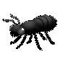

Giwaabandaan ina? Do you see it?
(inanimate)
Giwaabamaa na? Do you see it?
(animate)
Gigii-mikaan! You found it! (inanimate)
Gigii-mikawaa! You found it! (animate)

Mikan!
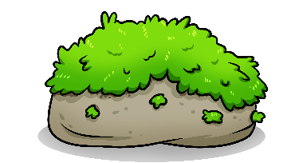
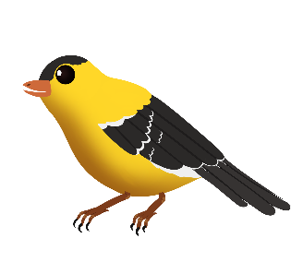

Bineshiinh Asin Aniibiish
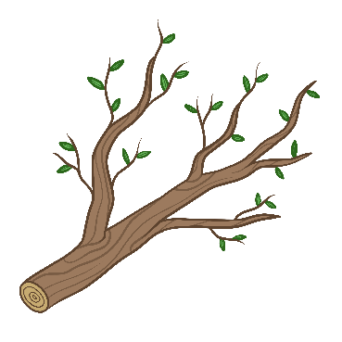
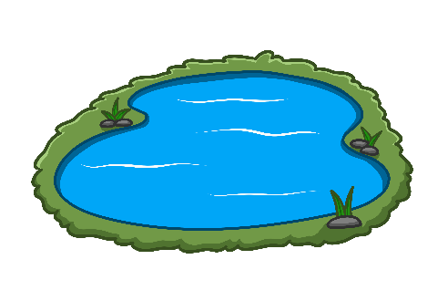

Mitigwanens Gaa-wanibiiyaag Waabigwan

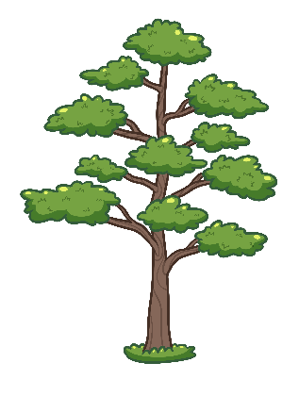

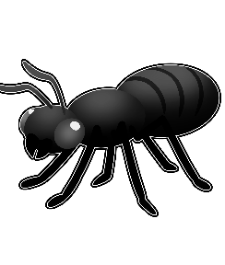

Aanakwad Mitig Manidoosh

