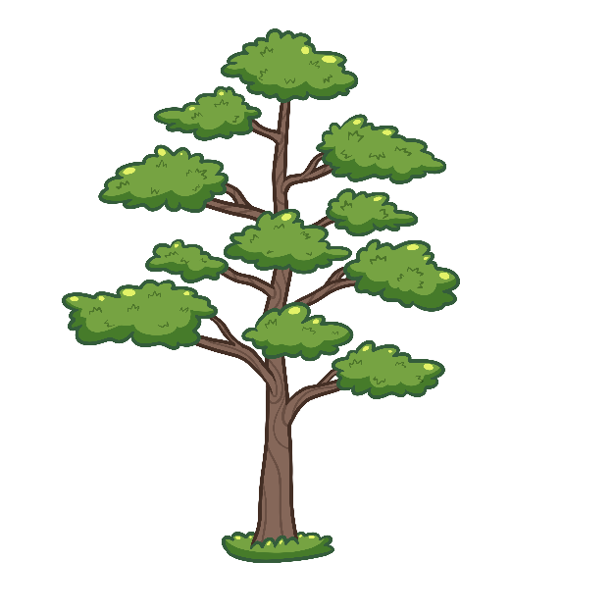
Ininaatig igaye Manijooshag
The Maple Tree and the Bugs

Mewinzha niibowa manijooshag gii-biindigewaad owe Ininaatig.
A long time ago, a lot of bugs went into the maple tree.
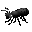
Ogii-ginagishkaago’ onzaam imaa gii-izhi-biindigewoodewa’ owanagekong.
They made maple tree too itchy when they crawled into the tree’s bark.

Ogii-giiwinaachi’igoo’ a’awe Ininaatig.
He was going crazy that maple tree.

Ogii-paanetoon ji-chichigiid misawaa go ani-gii-ayaad otikwaanensan ini idash igaye ojiibikaanan.
He was not able to scratch even though he had those branches and his roots.

Odandomaa’ owiijiiyaagana’ iwe awesiinyag.
He called for his friends, the animals.

“Gonage awiiya nindaa-bi-wiiji’ig, ji-ishkwaa-ginagiziyaan,” ikido.
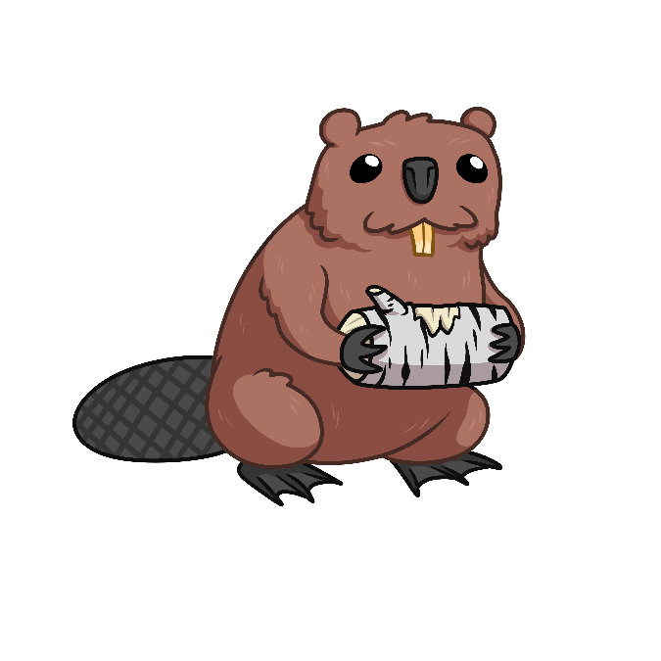
“I wonder if somebody can come help me stop being itchy,” s/he says.

Amik imaa gii-pi-izhaa ininaatigoong.
The beaver came to the maple tree.

Gichi-maang-gaabide amik.
The beaver has really big teeth.
“Gidaa-wiiji’in igo, giishpin dash jiichiigwandamaan giwanagek gidaa-wiisage-ayaawin,” ikido amik.
“I could help you, but if I chew on your bark I could hurt you,” said amik.

Miinawaa waawaabiganoojii omaa gii-pi-izhaad ininaatigoong.
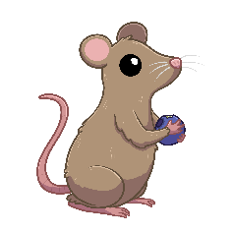
And a mouse came here to the maple tree.

“Ininaatig, nindaa-dawaanike go iwidi gijiibikaaning.”
“Maple Tree, I could dig there at your roots.”

“Ogowe dash ge waawaabiganoojiiyag daa-wiiji’itwaawag,”
“These mice should be able to help out,”

“O-maagizhaa ji go ge’e gidaa-wiisagibinigoo,” ikido waawaabaginoojii.
“Perhaps they might hurt you,” says mouse
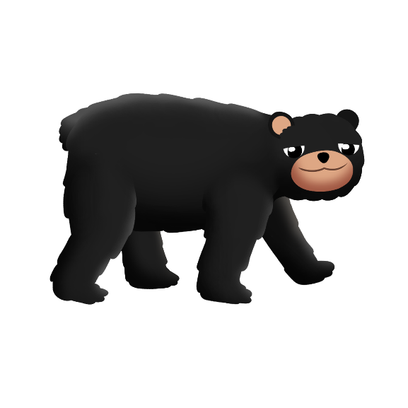
Miinawaa go makwa omaa go gii-pi-izhaad, gichi-oshkanzhii odayaawaa makwa.
And a bear came here, the bear has big claws.

“Gidaa-wiiji’in igo, maagizhaa dash gaakaashgibitoyaan
iwe giwanagek gidaa-wiisagibinin,” ikido makwa.
“I could help you, but maybe while I’m scratching your bark I could hurt you,” said the bear.

Aanind ani-naanaagadawendamoog aaniiin ge-izhichigeyaad.
Some of them were trying figuring out what they can do.

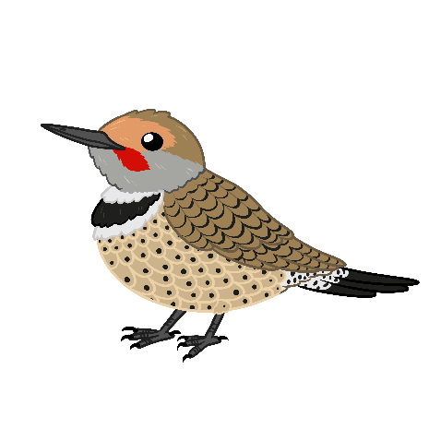
Bineshiiyag imaa bimise’o, bezhig idash bineshii aya’aa awe mooningwane
Birds flew by, but that one bird is a flicker.

“Ininaatig, nindayaawaa omaa nindinawemaagan,
ogaashaani iw okoonzh.”
“Maple tree, I have my relative here, his beak is sharp.”
“Gidaa-andawaanikaanig, gaawiin gidaa-wiisagibinigsii,” ikido moonigwane.
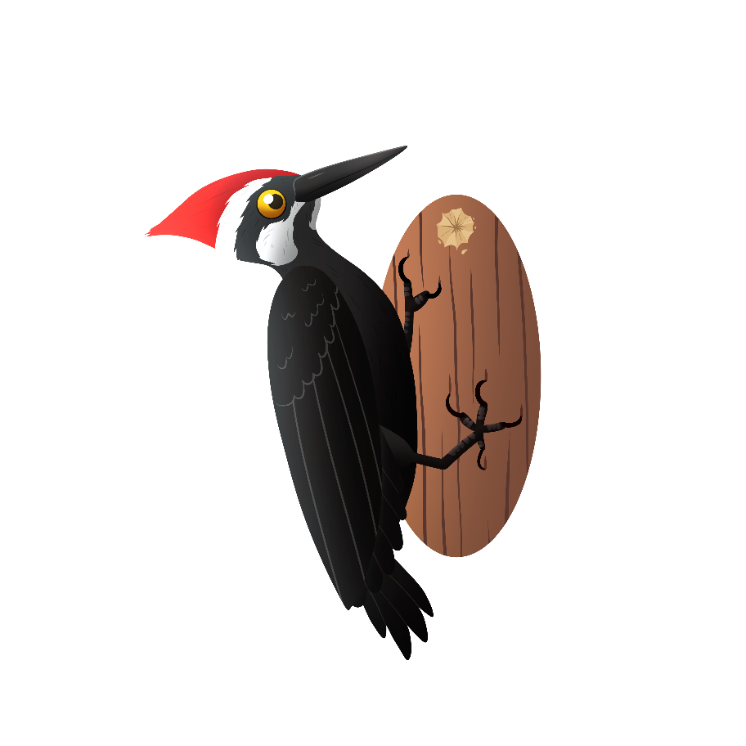
“S/he could dig at you, s/he won’t hurt you,” says moonigwane.
Gaa-pi-izhi-izhaad baapaase omaa ininaatigoong.
Woodpecker came here to the maple tree.

Ani-izhi-maajii-bakiite’aa ininaatigoong.
S/he starts to peck at the Maple Tree.

Gaa-izhichigeyaad gakina Manijooshag.
That is what s/he did to all the bugs.

Wiinge jiikendam awe ininaatig.
The maple tree is very happy.

Gabe-ayi’ii gegoo gii-ani-minose, gezika dash gaawiin gii-ayaasinoon gimiwanaaboo.
Things were going well for a long time, then suddenly there was no rain water.

Wiinge gii-baate iw aki, dash igaye go awensiinyag gii-noonde’aabaagwewag.
The earth was really dry, then the animals were also really thirsty.
Zaagi’iganan onowe igaye ziibiin ge-ani-baate’on, dash igaye go awensiinyag gaawiin wii-gikendaziinaawaa aandi ge-izhaawaad.
The lakes and these rivers were beginning to dry up, and the animals didn’t know where to go.

“Aaniin ge-izhiseying giishpin gegoo nibi ayaasinog ji-minikweying,” ikidowag awensiinyag.
“What is going to happen to us if we don’t have any water to drink?” said the animals.

Awe Ininaatig ogii-noondawa’.
The Maple tree heard them.

“Ningii-wiiji’igoo iwe awensiinyag gii-gagwaadagitooyaan, gii-gagwaadagii’iwaad ige manijooshag. Ginoonde-wiiji’ininim idash noongom,” ikido Ininaatig.
“The animals helped me when I was suffering; when they made me suffer, those bugs. Now I want to help you all,” said the maple tree.

“Baapaase, bakiita’igen imaa waasa niwanagekoong, ge-izhi-baabii’owin.”
“Woodpecker, peck there deep into my bark, then you will wait.”

“Wiiba go ziinzibaakwadaaboo da-maajiise mii dash i’ ge-izhi-minikweyeg iwe ziinzibaakwadaaboo.”
“Soon sap will start running and then you guys will drink that sap.”

Maanoo gaa-izhi-gojitood awe baapaase.
So, the woodpecker went ahead and tried it.

Mii dash gii-izhichiged niibowa ziinzibaakwadaaboo gii-pi-gichibide imaa ininaatigoong.
And then when he did it, a lot of sap came out of there from the maple tree.

Mii dash awe miinigoziwin gaa-bimaaji’igowaad gakina go awiiya awensiinyag.
This is gift that gives life to all the animals.

Mii go baamaa gii-bi-gimiwang, gii-pi-azhe-giiwemagak i’ nibi imaa zaagi’iganing, imaa dash igaye ziibiinsing.
Until after the rain came, when the water came back to the lakes and rivers.

Mii awe miinigoziwin gaa-gii-onjiseg imaa ininaatigoong gii-miinindwaa awensiinyag
This is the gift from the maple tree that was given to the animals.

Mii imaa gaa-onji-gikendamowaad anishinaabeg ji-ozhitoowaad zhiiwaagmizigan, awe igaye ji-negwaakwaanaawaad ininaatigoo’ gii-bimijiwong iwe ziinzibaakwadaaboo.
That is where the anishinaabeg learned how to make maple syrup and how to tap maple trees when the sap flows.

Zhiiwaagmizigan gichi-nendaagwad memindage go apii gii-biboong, miinan gii-ayaasinog gii-agaasiinak dash gaye miijim.
Syrup is highly thought of, especially during the winter, when there weren’t any berries and there was also very little food.

Mii o’apii ge-gichi-miigwechiwendamaang iwe miinigoziwin gaa-miigiiyeg awe Ininaatig.
This is the time we are grateful for the gifts that the maple tree provides.

