Gijigijigaaneshiinh Nagamowin
(To the tune of “Finger Family”)

Boozhoo giinawaa
Hello everyone
Bizindawishig
You all listen to me
Gijigijigaaneshiinh indizhinikaaz
My name is chickadee
Wegonen apaaboweyaag?
What season is it?
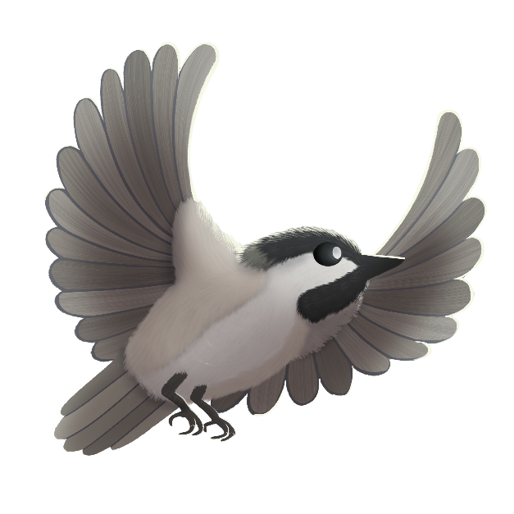
Ganawaabandan agwaajiing!
Look outside!
Biboon ina?
Mazinaakizan!
Scan the QR to hear the song
Is it winter?
Ziigwan ina?
Is it spring?
Niibin ina?
Is it summer?
Dagwaagin ina?
Is it fall?

