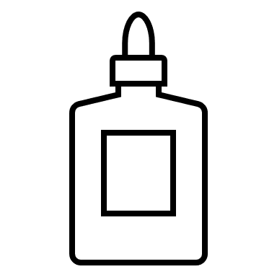

**Giishkizhan Agokiwasan**

|  |  |  |  |
| --- | --- | --- | --- |
| **waabigwan** | **aniibiish** | **gaawanzh** | **ojiibikan** |