**Wegonen apaaboweyaag?**

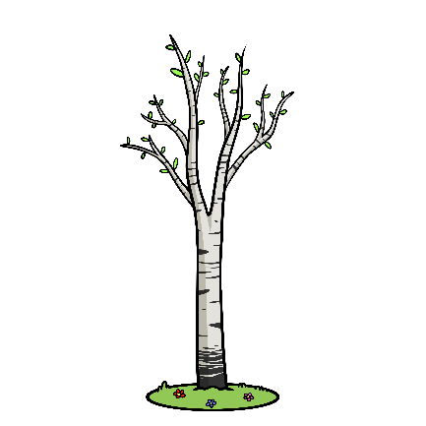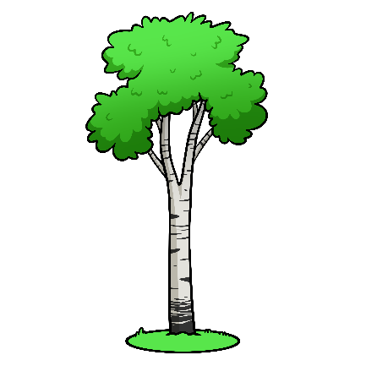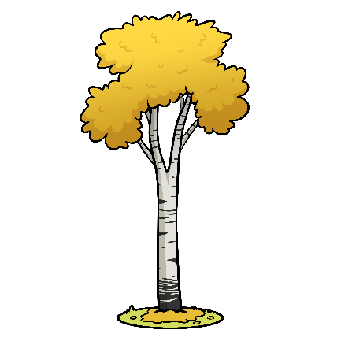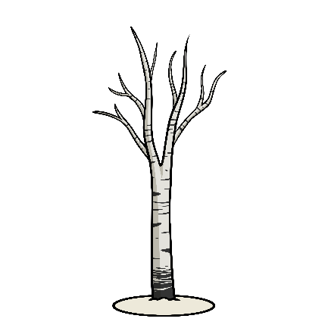

|  |  |  |  |
| --- | --- | --- | --- |
|  |  |  |  |
|  |  |  |  |
|  |  |  |  |
|  |  |  |  |
|  |  |  |  |



**Giishkizhan!**

|  |  |  |  |
| --- | --- | --- | --- |
|  |  |  |  |
|  |  |  |  |
|  |  |  |  |
|  |  |  |  |
|  |  |  |  |

**Answer Key**



|  |  |  |  |
| --- | --- | --- | --- |
|  |  |  |  |
|  |  |  |  |
|  | Beach sand castle Clipart Vector PNG , SVG, EPS, PSD, AI |  |  |
|  |  | Back To School Shopping Png Photos - Transparent Back To School Clipart,  Png Download , Transparent Png Image - PNGitem |  |
|  |  | Duck - Game Management Authority |  |