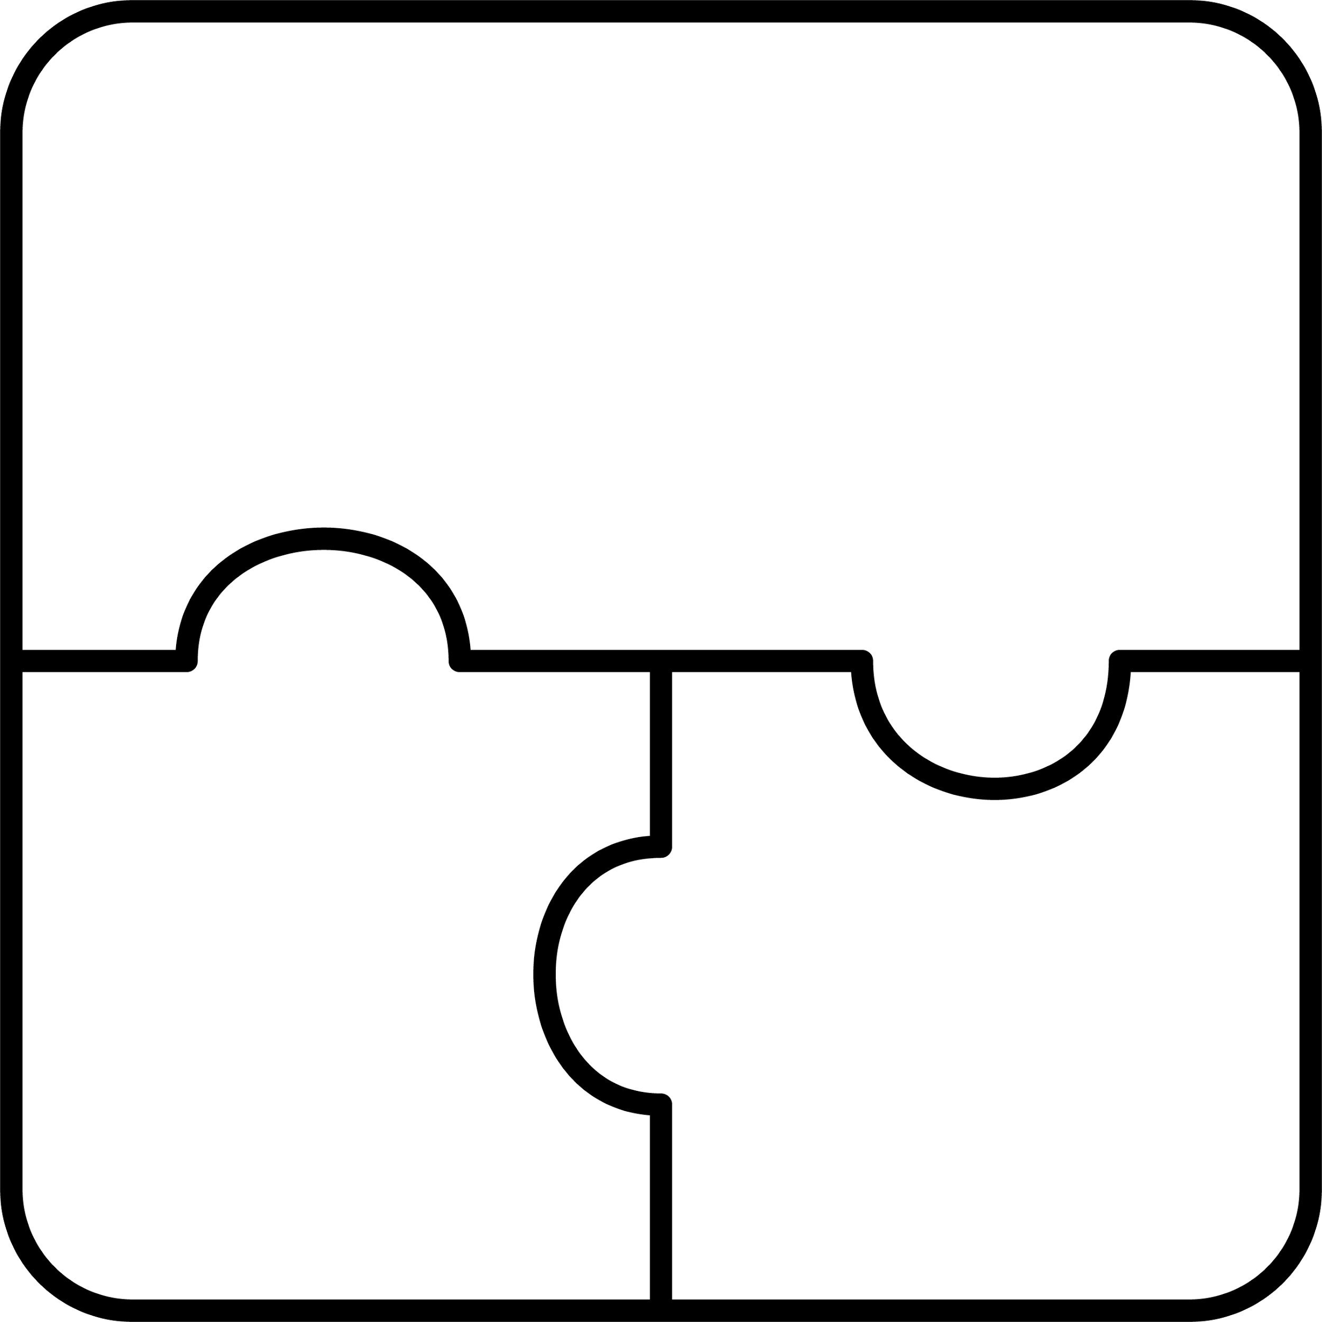

**gijigijigaaneshiinh**

chickadee

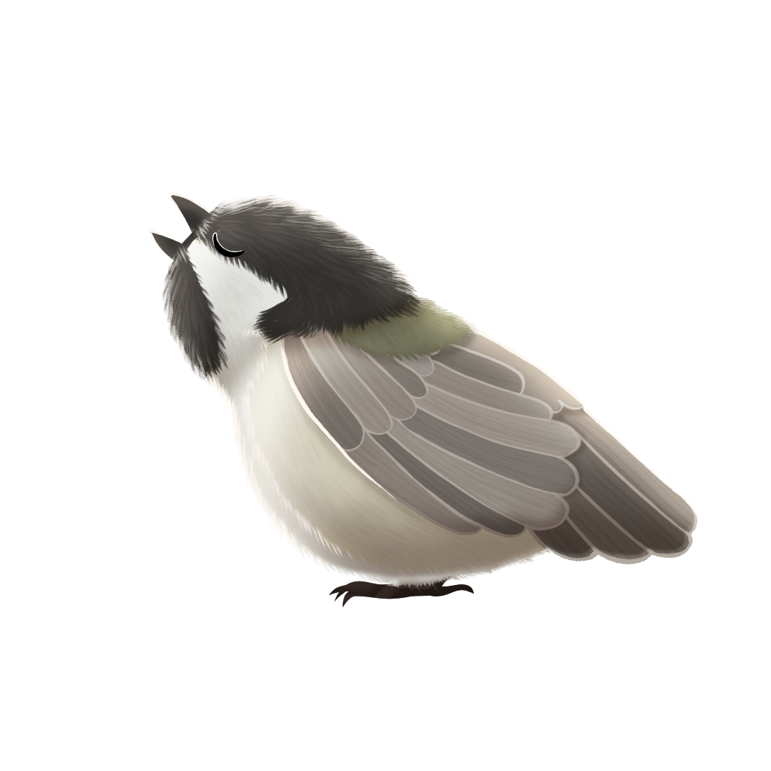

**gi**

**gaa**



**gigizhebaa-wiisiniwin**

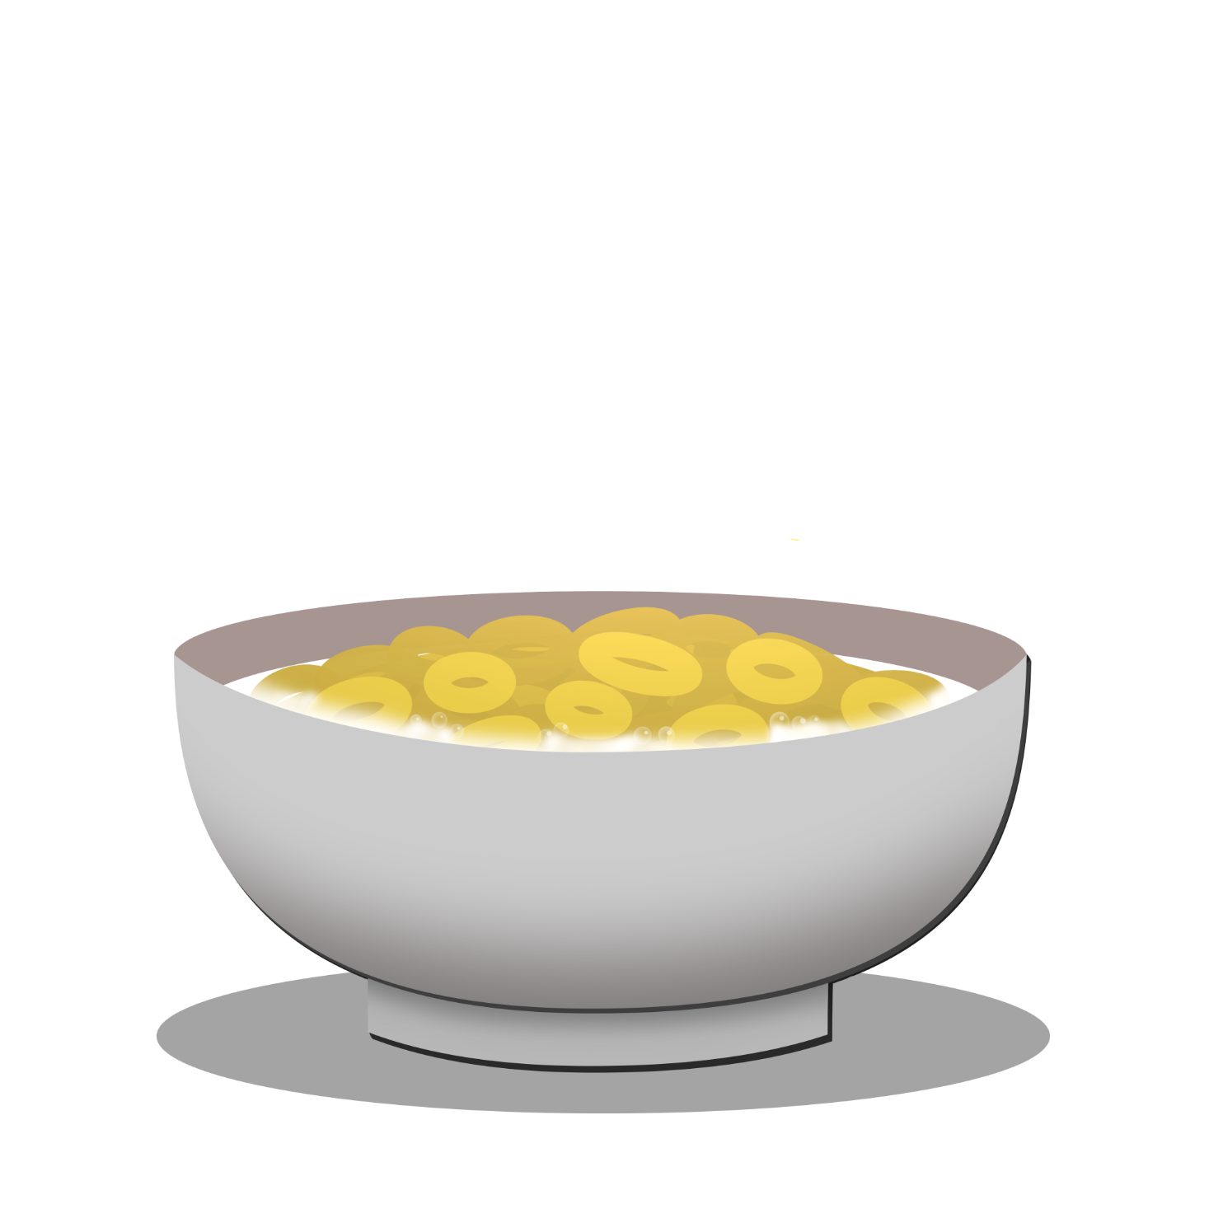

**gi**

breakfast food



**gimiwan**



**gi**

it is raining



**asaakamigoon**

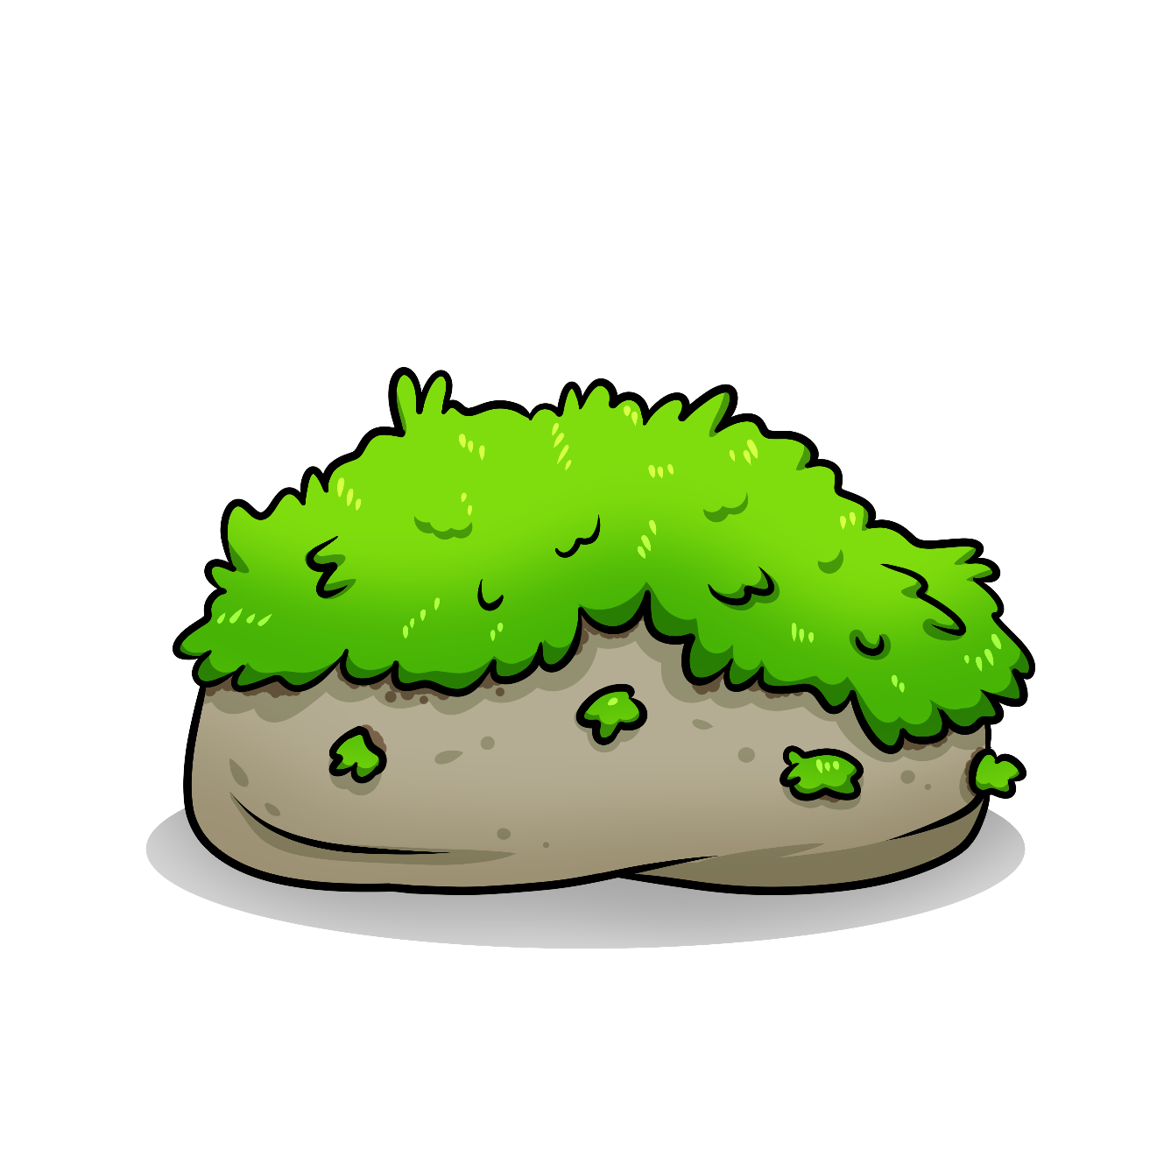

moss

**goo**



**zoogipon**



**gi**

it is snowing