***Gijigijigaaneshiinh onagamotawaan owiijiiwaaganan   
gg gg gg***

*Chickadee sings to their friends gg gg gg*

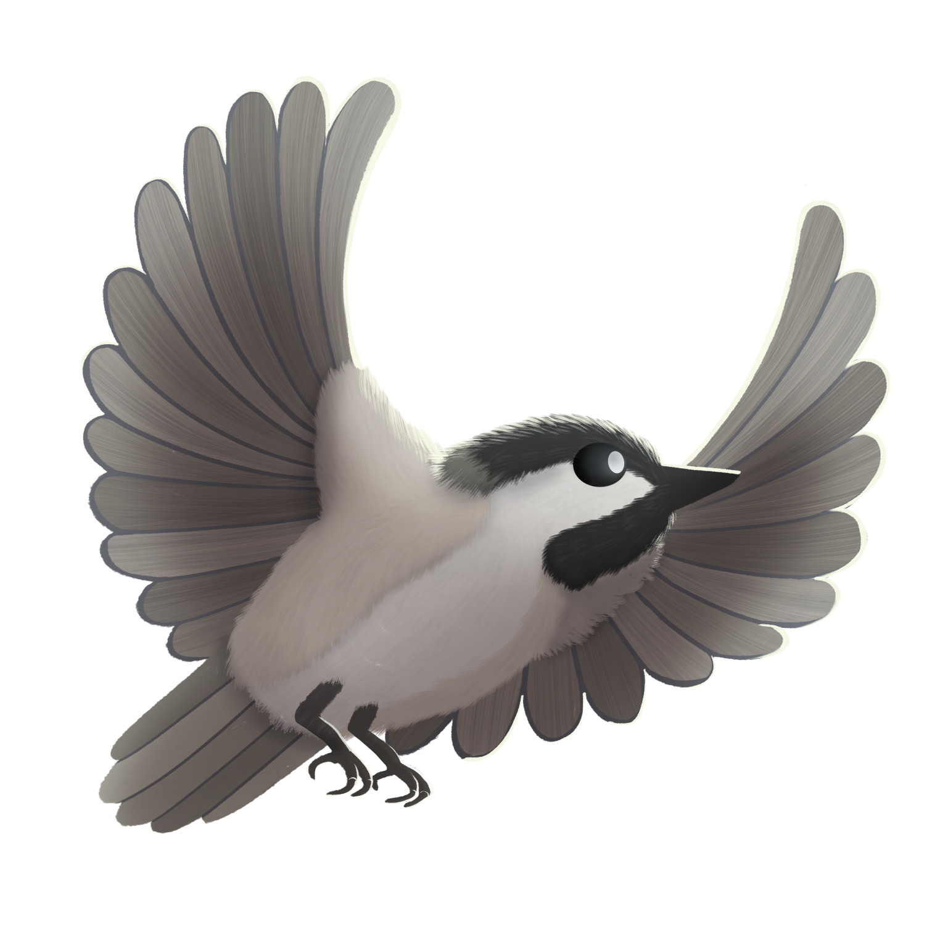

***Gijigijigaaneshiinh onagamotawaan owiijiiwaaganan   
gg gg gg***

*Chickadee sings to their friends gg gg gg*

*nagamo - s/he sings*

*nagamotaw – sing to him/her*

*owiijiiwaagan – his/her friend*

*niwiijiiwaagan – my friend*

*Open mouth and hold tongue down.   
Force sound from back of mouth or throat.*