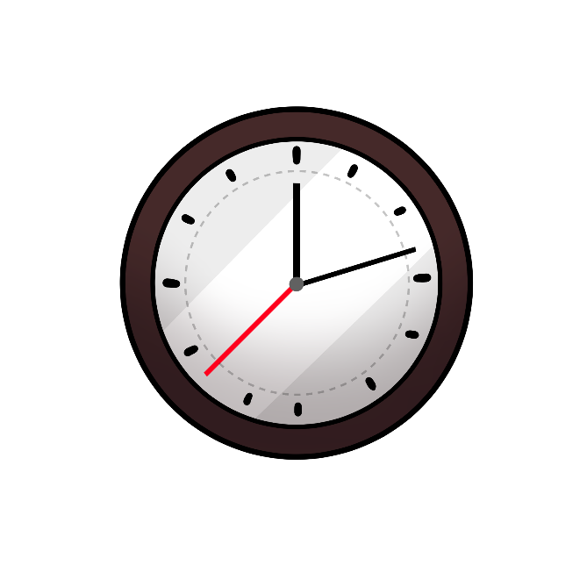

___________________________ indizhinikaaz

**Gigizhebaawagad**

**gemaa Onaagoshin**

|  |  |  |
| --- | --- | --- |
| Ningoshkoz.  Read the event and study the picture. Decide if the event happens  during the morning, night or both and circle your answer.  Colour in the box that matches. | gigizhebaawagad | onaagoshin |
| Nimbagiz. | A picture containing wheel, light, dark  Description automatically generatedgigizhebaawagad | Icon, circle  Description automatically generatedonaagoshin |
| A picture containing text  Description automatically generatedJiigi-boodawaan  ninamadab. | gigizhebaawagad | onaagoshin |
| Nindoonaagoshi-wiisin. | gigizhebaawagad | onaagoshin |
| Ninibaa. | gigizhebaawagad | Icon, circle  Description automatically generatedonaagoshin |
| A person wearing a mask  Description automatically generated with low confidenceNingiziiyaabide’. | gigizhebaawagad | onaagoshin |
| A cartoon of a house  Description automatically generated with medium confidenceNingikinoo’amaagoz. | A picture containing wheel, light, dark  Description automatically generatedgigizhebaawagad | Icon, circle  Description automatically generatedonaagoshin |
| A picture containing text, vector graphics  Description automatically generatedNimbabaamose. | A picture containing wheel, light, dark  Description automatically generatedgigizhebaawagad | onaagoshin |