Aginjibagwesi Nagamowin
Goldfinch Song
To the tune of “Finger Family”

Aginjibagwesi, ozaawigwane
Goldfinch, he has yellow feathers

Anishininaabemo, minwendaagwad
He speaks Anishinaabemowin, it is fun

Ozaawibinesiik, agindaman
Ozaawibinesiik, he counts

Aniibiishan, niinitaam
Many leaves, my turn

Bezhig, Niizh, Niswi, Niiwin
One, two, three, four
Naanan, Ningodwaaswi, Niizhwaaswi
Five, six, seven

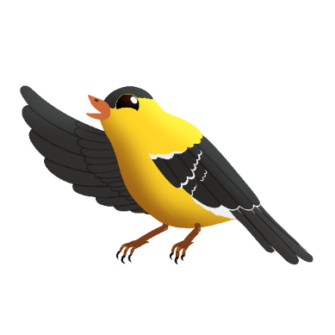
Nishwaaswi, Zhaangaswi, Midaaswi
Eight, nine, ten

Giinitam
Your turn
Mazinaakizan!
Scan the QR to hear the song

