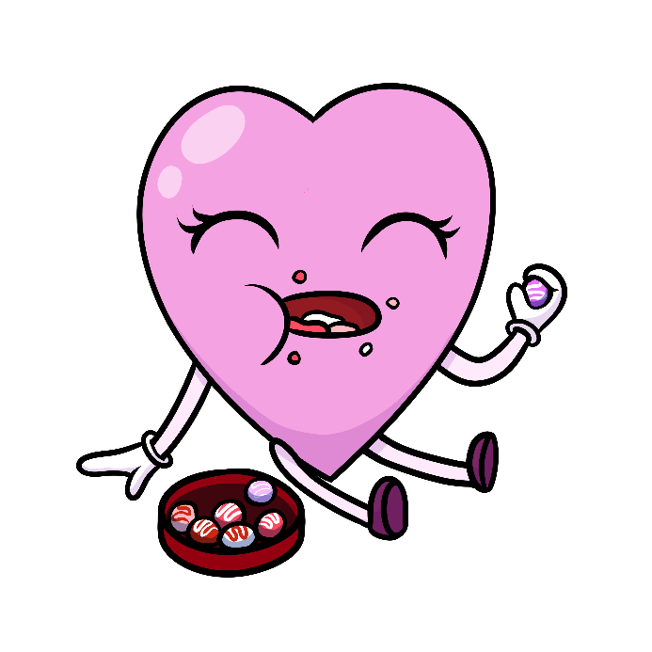
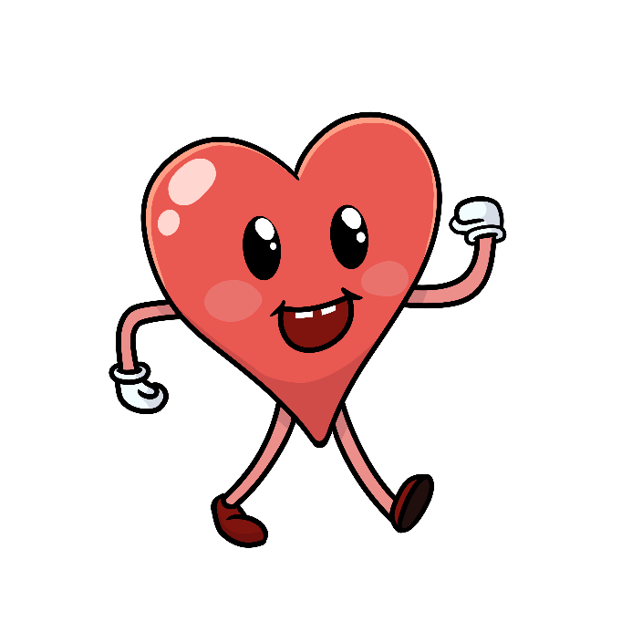
Use these images along with the Naanan Ode’enswag Song. Here are some ideas to create a hands-on activity. Print off this sheet and:
- Glue to felt and let learners explore on a felt board.
- Stick to Velcro patches on a glove for finger play.
- Allow older learners to glue on to popsicle sticks and practice the song.
- Use images on a smart board.

