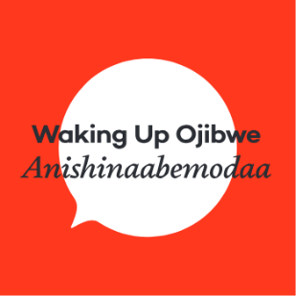
Using This Resource

- Listen to or sing Gizaagi’in Song https://soundcloud.com/ wakingupojibwe/gizaagiin-gizaagi.
- Encourage learners to sing along or shake a rattle or other noise maker.
- Create finger paint artwork on paper and let dry.
- Once dry, cut out heart on Giminwendam Apijii sheet and glue the remaining paper to the painting.

Tips
- For infants, strawberry yogurt can be used or food colouring and yogurt can be mixed
- For a mess-free paint experience, pour paint on small canvas and wrap with plastic/saran wrap
- Older learners can cut out heart and glue on painting to promote independence
- Send home song link or lyrics for others to learn
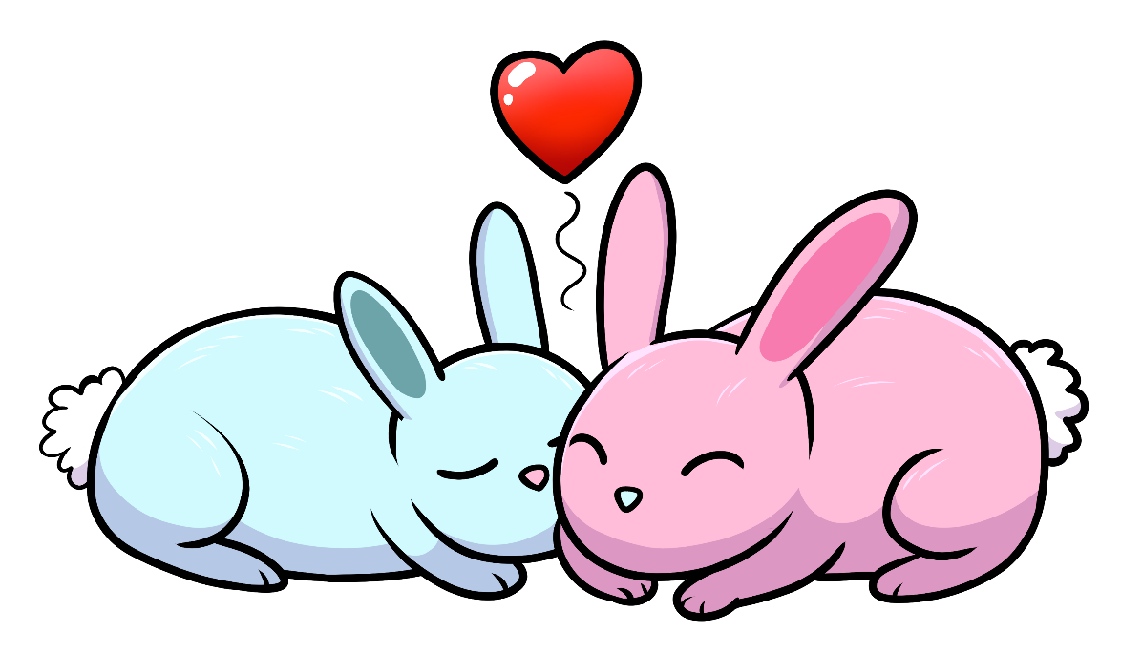

Gizhawenimin aapiji!

