bezhig
1

Aaniin minik?
How many?

Agindaasodaa!
Let’s count!

bezhig
one
1
niizh

2

Aaniin minik?
How many?

Agindaasodaa!
Let’s count!

niizh
two
2

niswi

3

Aaniin minik?
How many?

Agindaasodaa!
Let’s count!

niswi
three
3

niiwin

4

Aaniin minik?
How many?

Agindaasodaa!
Let’s count!

niiwin
four
4

naanan

5

Aaniin minik?
How many?

Agindaasodaa!
Let’s count!

naanan
five
5

ningodwaaswi

6

Aaniin minik?
How many?

Agindaasodaa!
Let’s count!

ningodwaaswi
six
6

niizhwaaswi
7

Aaniin minik?
How many?

Agindaasodaa!
Let’s count!

niizhwaaswi
seven
7

nishwaaswi

8

Aaniin minik?
How many?

Agindaasodaa!
Let’s count!

nishwaaswi
eight
8

zhaangaswi

9

Aaniin minik?
How many?

Agindaasodaa!
Let’s count!

zhaangaswi
nine
9

midaaswi

10

Aaniin minik?
How many?

Agindaasodaa!
Let’s count!

midaaswi
ten
10

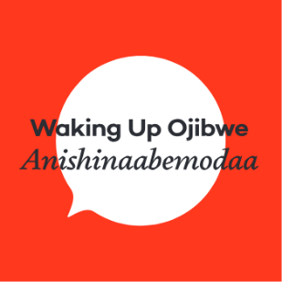
Using This Resource

- Use these heart themed counting cards and listen or sing the Gidagindaasomin Song https://soundcloud.com/ wakingupojibwe/gidagindaasomin
- Tape the cards to the floor or walls in learning environment.
- For younger or beginner language learners yell out a number such as “NAANAN” and have them walk, run or skip to the correct number.

Tips
- Laminate and bring cards outside for an outdoor learning experience
- Set up numbers on floor and play Hopscotch
- For a challenge, yell out a number and add an action such a running or jumping
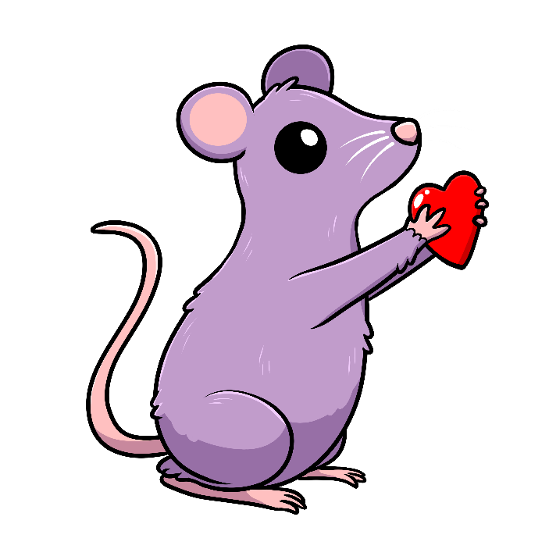
- Post cards in infant rooms to promote numeracy in Anishinaabemowin

