Zhizhoobii’igedaa!
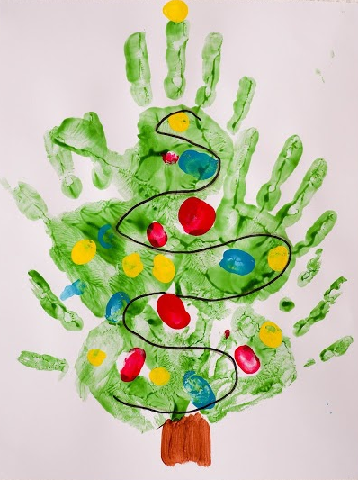

Let’s Paint!

Materials

- Paint - Zhizhoobii’igan
- Paper - Mazina’igan
- Plate - Onaagan
- A cut-out of a star to be used as a stamp, or the student can create one with their fingers.
Be sure to use old clothes, pajamas, or aprons as painting can be fun and messy.
Instructions
- On a white piece of paper, the instructor can draw an outline of a tree as a guide.
- Add brown paint onto a plate and have the child paint the tree trunk or use the side of the hand/palm to make the tree trunk as well. Wash the brown paint off.
- Add some green paint onto a plate. The student can press their hand into it (with the help of an instructor, if needed).
- Start by showing the student how to place the hand and they can begin to create the tree branches as they go up. Wash the green paint off and allow to dry.
- When dry, the students can use their fingertips to paint decorations on their tree.
Vocabulary
Maagonan Press on it
Mitig Tree
Zasegaachigan Decoration
Anang Star
Yellow Ozaawaa
Blue Ozhaawashkwaa
Green Ozhaawashkwaa
Purple Ozhaawashkwaa
Pink Miskoonaagwad
Red Miskwaa
Brown Makade-Ozaawaa
Grey/silver Waabijiiyaa
White Waabishkaa

