Ozhi’ Mitig!
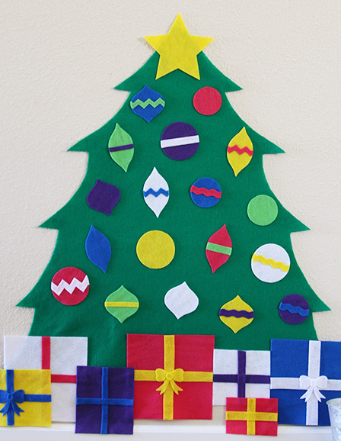
Felt Christmas Tree Activity

Gaa-waawiyeyaag Circle
Bajiishkaag Triangle
Gaakakaag Square
Anang Star
Anangoons Little star
Mitig Tree
Magoshe’iwewin(an) Gift(s)
Zasegaachigan(an) Decoration(s)
Waaskonenjigan(an) Light(s)
Aaniin ezhinikaadeg owe? What is this called?
Aaniin ezhinaagok owe? What does this look like?
Wegonen ishpiming eteg? What goes at the top?
Mitigong atoon. Place it on the tree.
Giminochige! Good job!
This activity is great for young learners to engage with decorating a Christmas tree with soft, safe materials while using Anishinaabemowin. These trees and décor can be fashioned out of felt by anyone, or you can purchase kits online as well.

