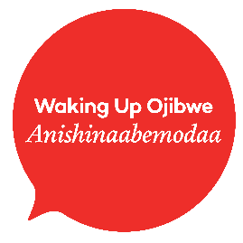
Mikan Niizhwewaan!
Find the pair!
This is a Christmas game of memory with Anishinaabemowin translations. The instructor can print out the cards, mix them up, and lay them faced down in rows.
- When a card is flipped the learner can practice pronouncing the Anishinaabe word with the guidance of the instructor.

- The learner will turn over another card to try find the matching picture. If the card does not match the cards can be read out loud by the instructor or learner, and then turned back over for the next learner to have their turn.

- When all cards have been matched, the person with the highest number of matches wins the game.

Phrases to Use:
Turn it face up Aazhigidinan
Turn another one face up Bezhig miinawaa aazhigidin
Only pick two Niizh eta onaabandan.
Are they the same? Naasaabinaagoziwag ina?
Good job! Giminochige!
Try again! Gojitoon miinawaa!
Your turn! Giinitam!
His/her turn! Wiinitam!
Magoshe’iwe-inini | Magoshe’iwe-inini
Mitig | Mitig
Magoshe’iwewin | Magoshe’iwewin
Magoshe’iwewin | Magoshe’iwewin
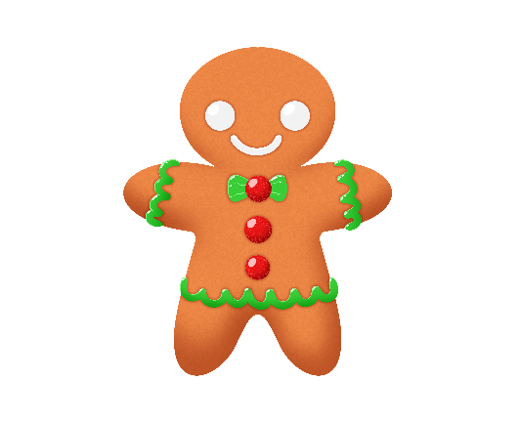  Bakwezhiganiiwininiins | Bakwezhiganiiwininiins
Ziinzibaakwadoons | Ziinzibaakwadoons
Gooniwinini | Gooniwinini
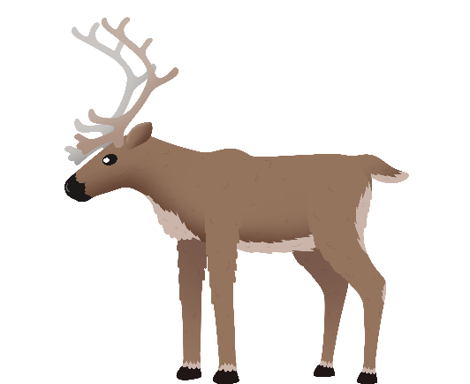  Adik | Adik
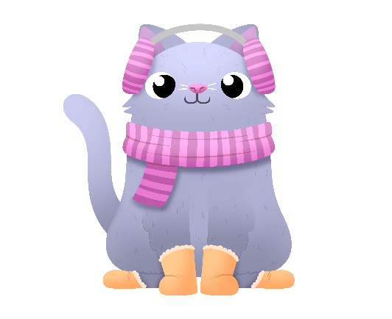  Gaazhagens | Gaazhagens
Bimaadagaakobineshii | Bimaadagaakobineshii
Azhigan | Azhigan
Waaskonenjigan | Waaskonenjigan
Waaskonenjigan | Waaskonenjigan
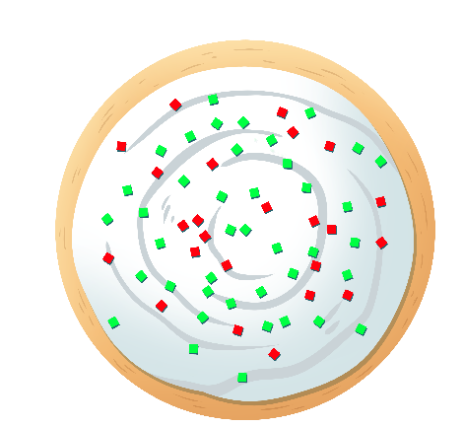  Bakwezhiganens | Bakwezhiganens
Anang | Anang
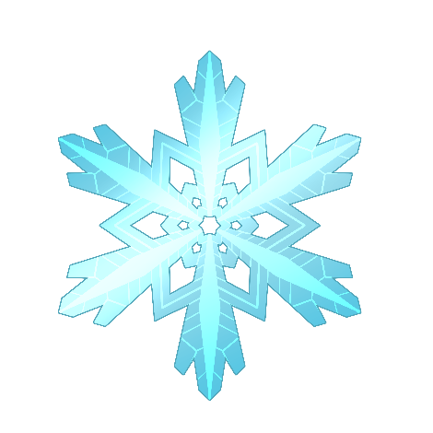  Goonens | Goonens

