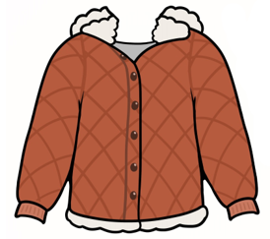
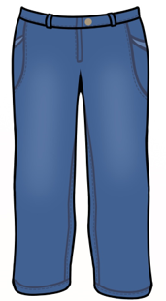
Nimbiisikaan biboone-midaas
Biboone-midaas, Biboone-midaas
Nimbiisikaan biboone-midaas
Niwii-giizhooz

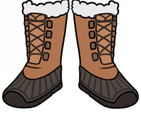
Nimbiisikaan biboonikizin
Biboonikizin, biboonikizin
Nimbiisikaan biboonikizin
Gaawiin ninga-giikajisii

Nimbiisikaan biboonewiwakwaan
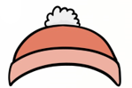
Biboonewiwakwaan, biboonewiwakwaan
Nimbiisikaan biboonewiwakwaan
Niminwendaan gii-biboong

Nimbiisikawaag minjikawanag
Minjikawanag, minjikawanag
Nimbiisikawaag minjikawanag
Izhaadaa agwaajiing
Izhaadaa agwaajiing
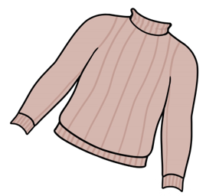
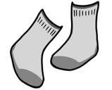

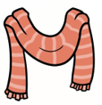
I am putting on my snow pants
Snow pants, snow pants
I am putting on my snow pants
I will be warm

I am putting on my snow boots
Snow boots, snow boots
I am putting on my snow boots
I will not be cold

I am putting on my toque
Toque, toque
I am putting on my toque
I like winter

I am putting on my mitts
Mitts, mitts
I am putting on my mitts
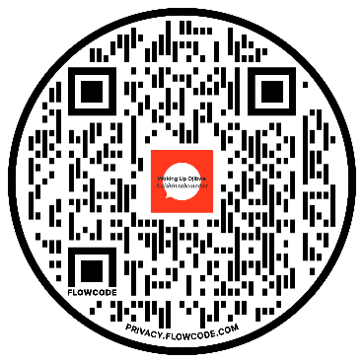
Let’s go outside
Mazinaakizan!
Scan the QR to hear the song
Let’s go outside
