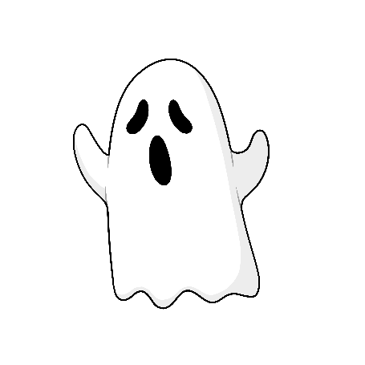

If I saw a ghost

I would scare him too!

I’d hide under my bed

And then shout "BOO!"

**Wegonen Gwetaman?**

What Are You Afraid Of?

**Ozhibii’igen! Draw**

Print out the “Giishpin waabamaag …” resource and hand out to learners. Help learners write on the blank line what they are afraid of. Ask how they would scare it back or how they would act brave. Have them draw their answer.

**Odaminon! Play!**

1. In a circle, choose a learner to start the   
   activity.
2. Ask “Wegonen gwetaman?” and have the child answer in Anishinaabemowin OR   
   repeat their English answer in   
   Anishinaabemowin.
3. After answering, the learner will go under the sheet while the rest of the learners all hold a side of the sheet.
4. The rest of class says the prompt together.
5. At the end of the prompt, learners lift up the sheet and the participant underneath yells boo!
6. Learners can take turns under the blanket, asking each learner what they are scared of.

**Materials Needed:**

This Activity Sheet

**Agwazhaan** Sheet or Blanket

**Giishpin Waabamaag** Sheet

**Ozhibii’igan** Pencil/Markers

**Giishpin waabamaag jiibay**

**Nindaa-zegi’aa!**

**Anaaminibewin nindaagaaz**

**“BOO!” ezhi-biibaagiyaan.**