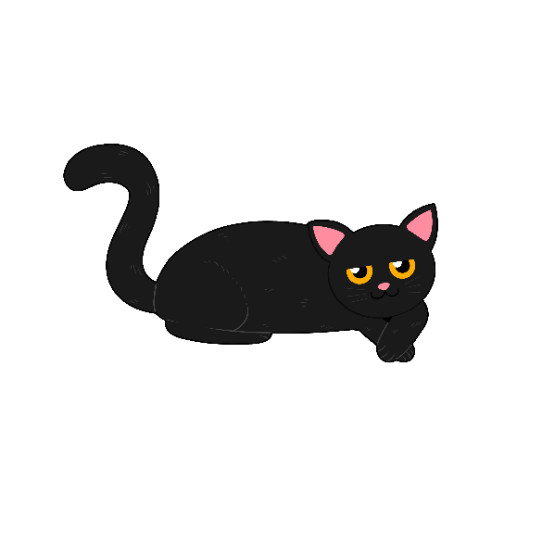

**Okosimaan-Giizhigad - Halloween Sensory Bin**

**How To Make the Sensory Bin**

1. Cook spaghetti noodles only until they start bending in the pot. If you cook the spaghetti fully they will be too mushy to use in the   
   sensory bin.
2. After you have cooked the spaghetti, drain water and pour cold water over the noodles to cool.
3. Add olive oil so spaghetti does not stick   
   together.
4. Place pasta in a Ziploc bag and add liquid watercolour. Seal the bag and shake to coat spaghetti.
5. Let your spaghetti sit out after dying. This will ensure children’s hands do not stain.
6. Put the coloured spaghetti in a bin with   
   spider rings, eyeballs, etc. Add in tongs and scoopers to add in more ways to exercise fine motor skills.

* Fun for toddlers and preschoolers
* Can be made into an immersion centre for older learners
* Sort objects by colour and count them as you go
* Have learners help by dying the spaghetti

**Ikidowinan**

**Asabikeshii(yag)** Spider(s)

**Oshkiinzhig(oon)** Eye(s)

**Ozhaashijiiyaa** It is slimy

**Mikoojiinan _____**

Find _____ (with your fingers)

**Mikoojiin asabikeshii**

Find the spider (with your fingers)

**Mikoojiinan oshkiinzhigoon**

Find the eyes (with your fingers)

**Aaniin ezhinaagozid asabikeshii/apakwaanaanjii?**   
What colour is the bat/spider?

**Aaniin ezhinaagok ozhkiinzhig?** What colour is the eye?