**Zhiishada’iganaakoong babaamisen!**(Fly on a broomstick!)

**Babaamaashinin daabishkoo jiibay!**(Float like a ghost!)





**Babaamooden daabishkoo asabikeshii!**(Crawl like a spider!)

**Daabishkoo**

**gaa-niboo’aadizid inosen!**(Walk like a zombie!)

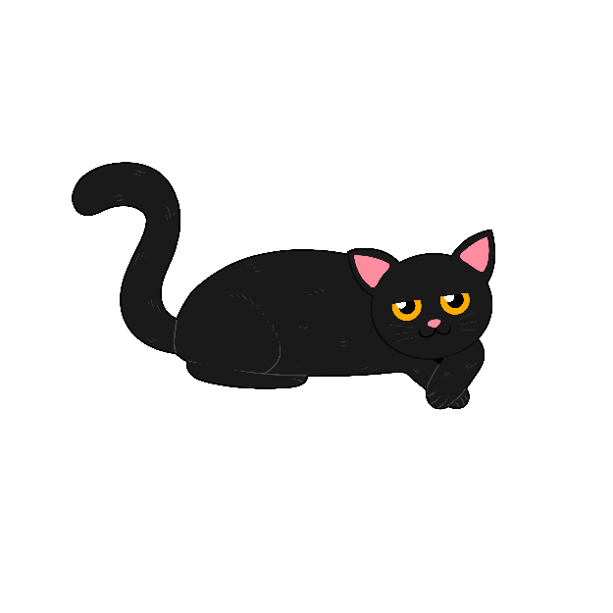

**Mamaajiin daabishkoo gaazhagens!**(Move like a cat!)

**Mamaajiniketaan dabishkoo apakwaanaajii!**(Move your arms like a bat!)

**Baapin daabishkoo awe miskwi gaa-minikwed!**(Laugh like a vampire!)

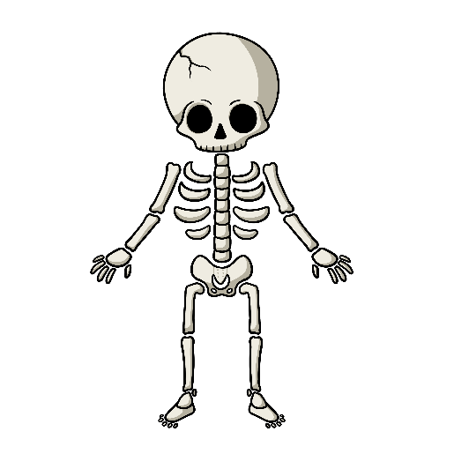

**Niimin daabishkoo**

**Gaa-bizhishigokoganed!**(Dance like a skeleton!)