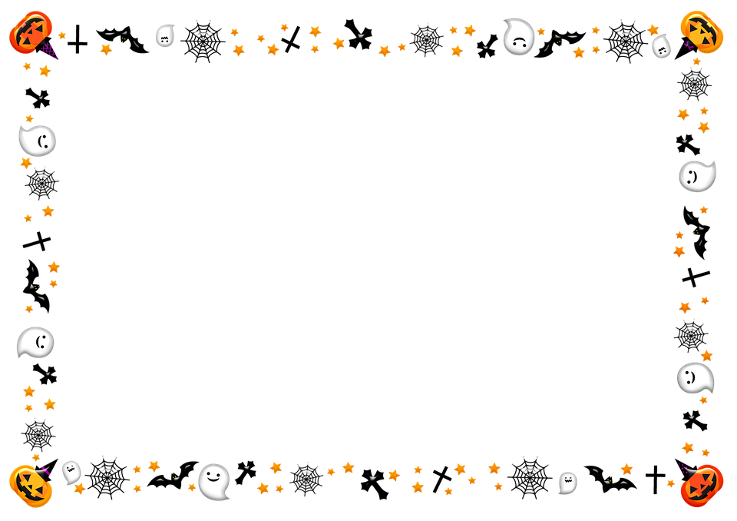

Giishpin waabamaag ______________________________