1  bezhig | 3  niswi | 5  naanan | 7  niizhwaaswi | 9  zhaangaswi
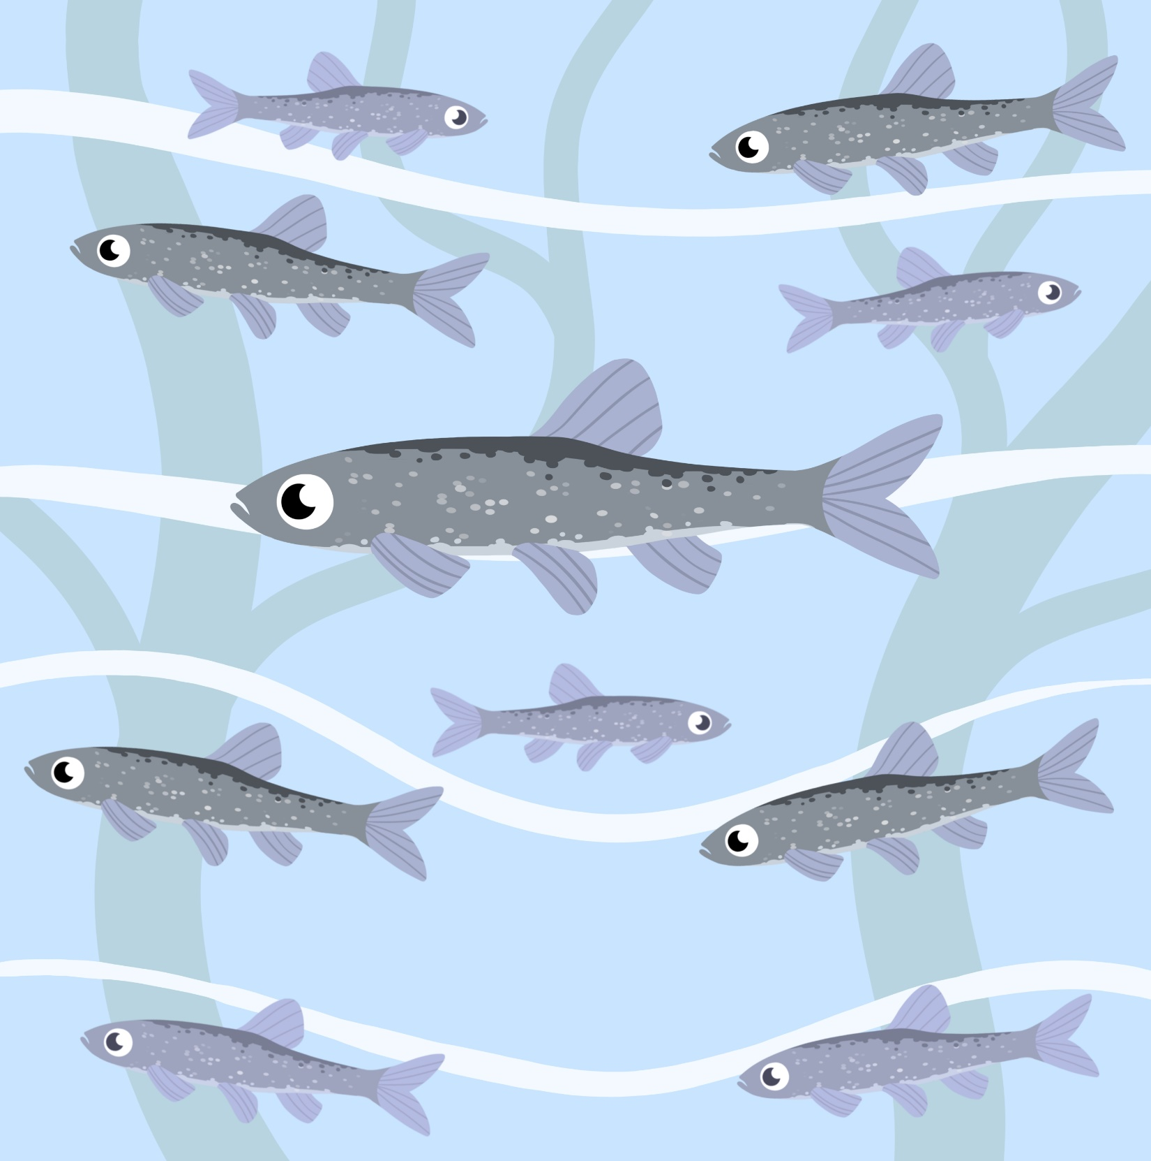

2  niizh | 4  niiwin | 6  ningodwaaswi | 8  niizhwaaswi | 10  midaaswi
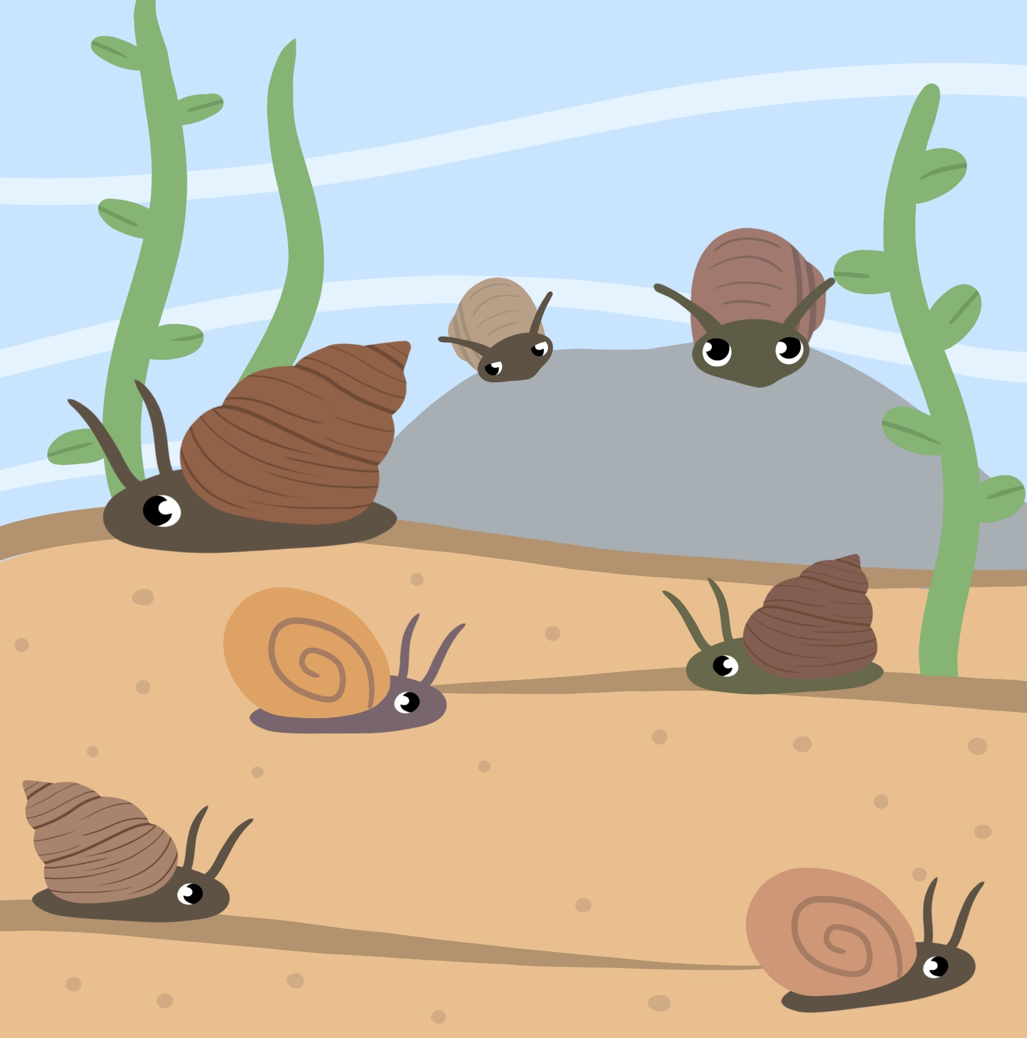

10  midaaswi | 20  niizhtana | 30  nisimidana | 40  niimidana | 50  naanimidana | 60  ningodwaasimidana | 70  niizhwaaswimidana | 80  nishwaaswimidana | 90  zhaagaswimidana | 100  ningodwaak

5  naanan | 10  midaaswi | 15  ashi-naanan | 20  niizhtana | 25  niizhtana-  ashi-naanan | 30  nisimidana | 35  nisimidana-  ashi-naanan | 40  niimidana | 45  niimidana-  ashi-naanan | 50  naanimidana
 |  |  |  |  |  |  |  |  | 