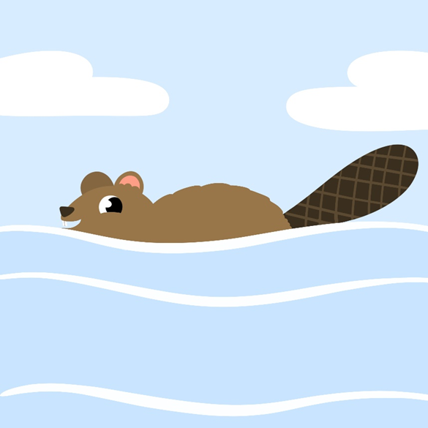
1

Aaniin minik amikwag?
How many beavers?

Agindaasodaa!
Let’s count!

Bezhig
One

Bezhig Amik
One beaver

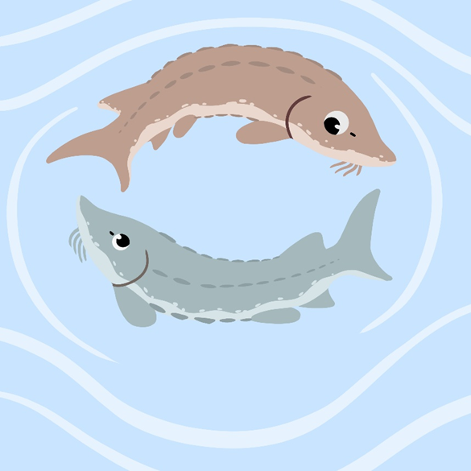
2
Aaniin minik namewag?
How many sturgeon?

Agindaasodaa!
Let’s count!

Niizh
Two

Bezhig name, niizh namewag
One sturgeon, two sturgeon

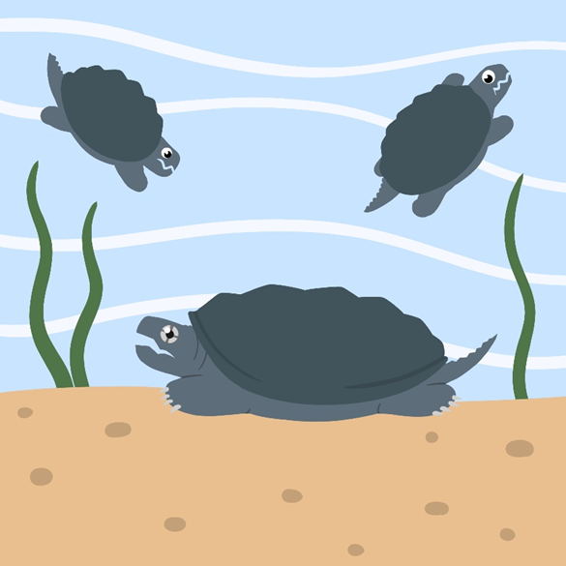
3

Aaniin minik mikinaak?
How many turtles?

Agindaasodaa!
Let’s count!

Niswi
Three

Bezhig mikinaak...niswi mikinaakwag
One turtle...three turtles

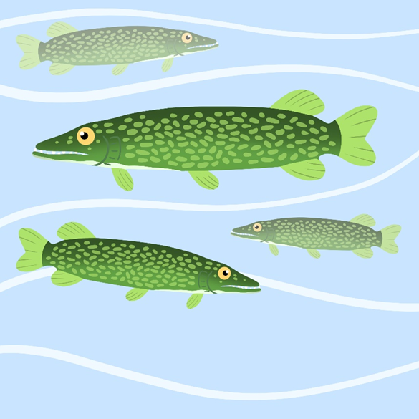
4

Aaniin minik ginoozheg?
How many northern pike?

Agindaasodaa!
Let’s count!

Niiwin
Four

Bezhig ginoozhe...niiwin ginoozheg
One northern pike...niiwin northern pike

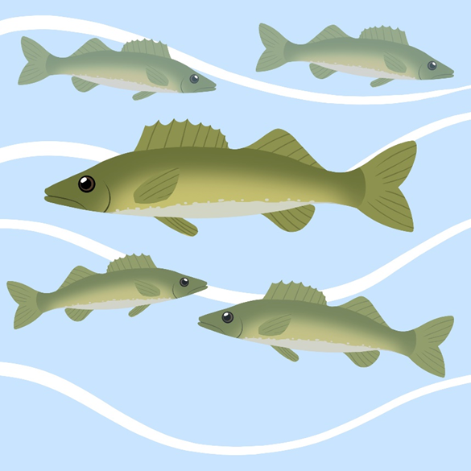
5

Aaniin minik ogaawag?
How many walleye?

Agindaasodaa!
Let’s count!

Naanan
Five

Bezhig ogaa...naanan ogaawag
One walleye...five walleyes

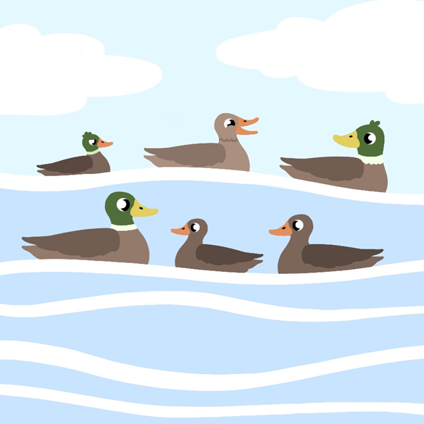
6

Aaniin minik zhiishiibag?
How many ducks?

Agindaasodaa!
Let’s count!

Ningodwaaswi
Six

Bezhig zhiishiib...ningodwaaswi zhiishiibag
One duck...six ducks

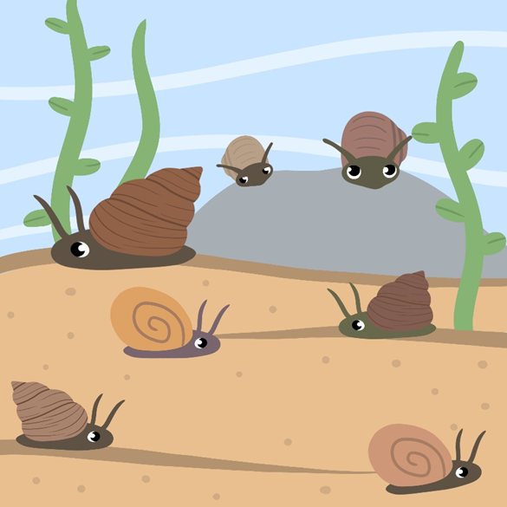
7

Aaniin minik biimiskodisiig?
How many snails?

Agindaasodaa!
Let’s count!

Niizhwaaswi
Seven

Bezhig biimiskodisii...
niizhwaaswi biimiskodisiig
One snail...seven snails

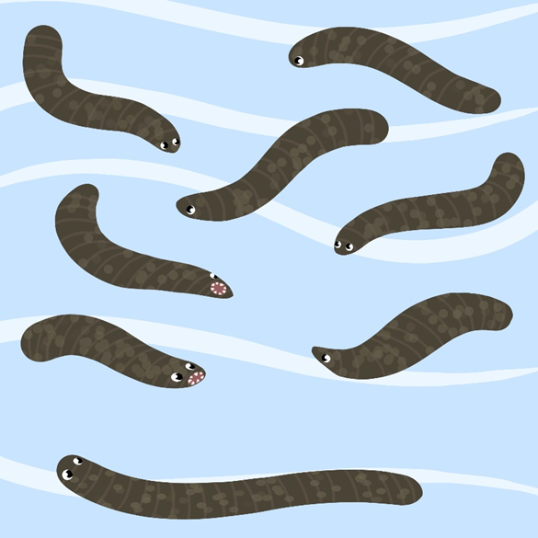
8

Aaniin minik zagaskwayag?
How many leeches?

Agindaasodaa!
Let’s count!

Nishwaaswi
Eight

Bezhig zagaskway...
nishwaaswi zagaskwayag
One leech...eight leeches

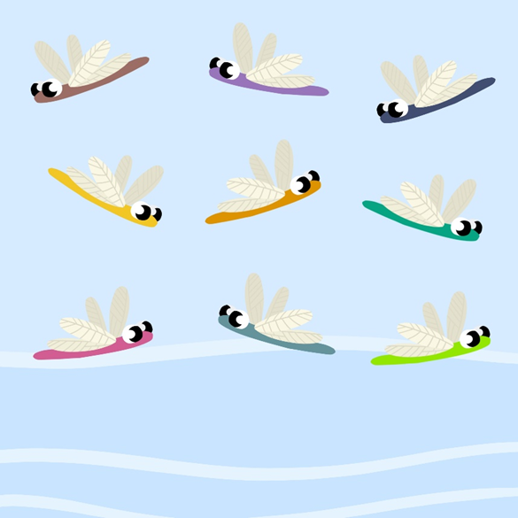
9

Aaniin minik oboodashkwaanishiinhyag?
How many dragonflies?

Agindaasodaa!
Let’s count!

Zhaangaswi
Nine

bezhig oboodashkwaanishiinh…
one dragonfly…
zhaangaswi oboodashkwaanishiinhyag
nine dragonflies

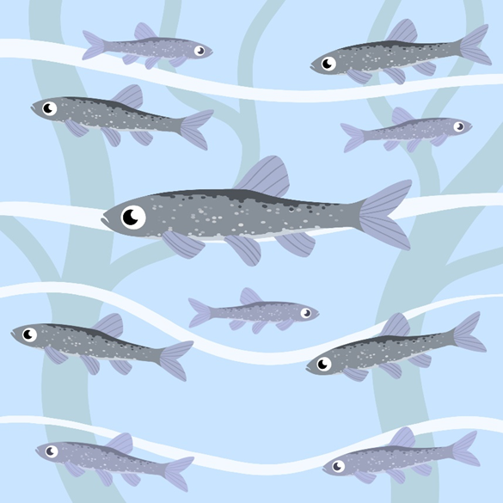
10

Aaniin minik giigoozhensag?
How many minnows?

Agindaasodaa!
Let’s count!

Midaaswi
Ten

bezhig giigoozhens…
one dragonfly…
midaaswi giigoozhensag
ten dragonflies

