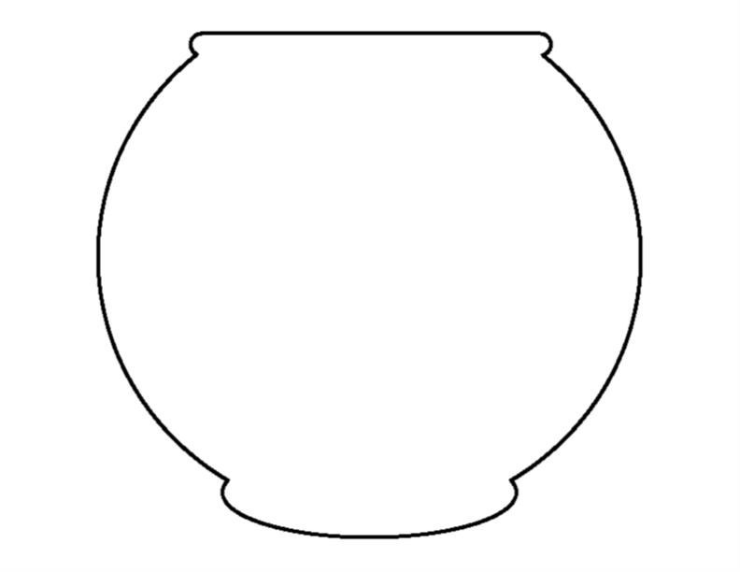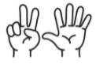

**1**

**2**

**3**

**4**

**5**

**6**

**7**

**8**

**9**

**10**

BEZHIG

NIIZH

NISWI

NIIWIN

NAANAN

NINGODWAASWI

NIIZHWAASWI

NISHWAASWI

ZHAANGASWI

MIDAASWI