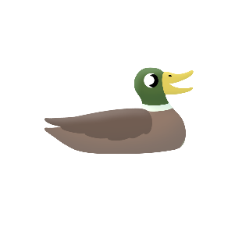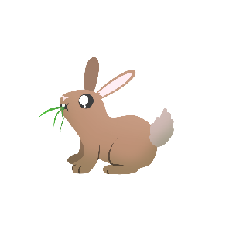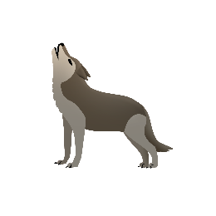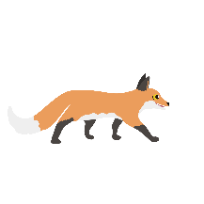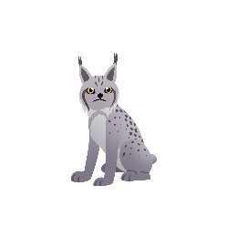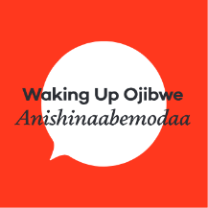

5

4

3

2

1

___________________________ nindizhinkaaz

**GIIZHKIZHAN**

**AGOKIWASAN**

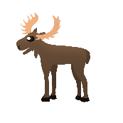

10

9

8

7

6

___________________________ nindizhinkaaz

**GIIZHKIZHAN**

**AGOKIWASAN**