Aaniin endashiwaad ayaa’aag gaa-daawaad imaa endaayan?
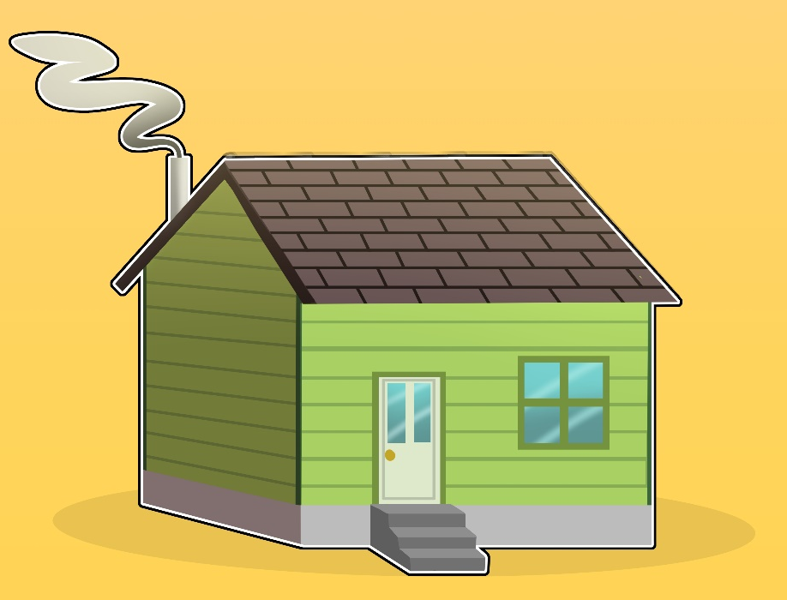
(How many people live in your house?)

Niizhiwag aya'aag daawaad imaa endaayaan.
Two people live in my house.

(Change the number to reflect i.e.
Niswiwag aya'aag daawaad imaa endaayaan.)

10
midaaswi
9
zhaangaswi
8
nishwaaswi
7
niizhwaaswi
6
ningodwaaswi
5
naanan
4
niiwin
3
niswi
2
niizh
1
bezhig
0
gaawiin gegoo
Wiinzowinan:
Aaniin minik eyaawadwaa bami’aagansag?
(How many pets do you have?)
Gaawiin awiya nindayaawaasiig bima’aagaansag.
I don't have any pets.
Bezhig nindayaawaa bima’aagaans.
I have one pet.
Niizhiwag bima’aagaansag eyaawagwaa.
I have two pets.
Bezhig animosh nindayaawaa.
I have one dog.
Bezhig gaazhagens nindayaawaa.
I have one cat.
Niizh nindayaawaag animoshag.
I have two dogs.
Niizh nindayaawaag gaazhagensag.
I have two cats.

(change the number for number of pets/cats/dogs)

10
midaaswi
9
zhaangaswi
8
nishwaaswi
7
niizhwaaswi
6
ningodwaaswi
5
naanan
4
niiwin
3
niswi
2
niizh
1
bezhig
0
gaawiin gegoo
Wiinzowinan:
Aaniin minik daso-diba’igan gaa-nibaayan dibikong?
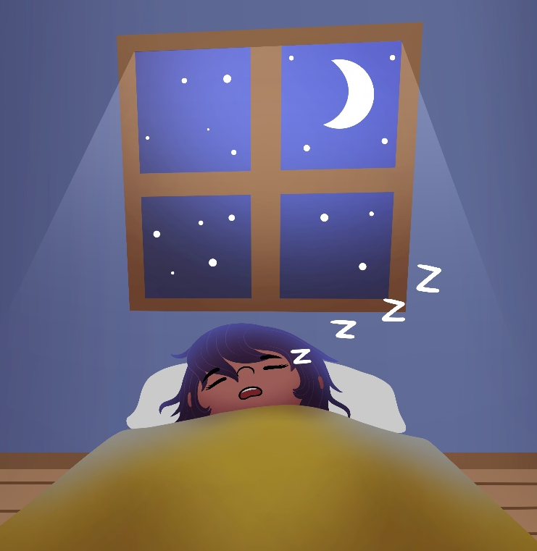
(How many hours did you sleep last night?)
Ningodwaaso-diba’igan ningii-nibaa dibikong.
I slept for six hour last night.
(Change number for hours slept)

Ambegish geyaabi nibaayaambaan.
I wish I slept more.

Wiiba ningii-nibaa. I went to sleep early.
Wiikaa ningii-nibaa. I went to sleep late.

Wiiba ningii-goshkoz zhebaa.
I woke up early this morning.
Wiika ningii-goshkoz zhebaa.
I woke up late this morning.

10
midaaswi
9
zhaangaswi
8
nishwaaswi
7
niizhwaaswi
6
ningodwaaswi
5
naanan
4
niiwin
3
niswi
2
niizh
1
bezhig
0
gaawiin gegoo
Wiinzowinan:
Aaniin ezhinaagozid mishiimin menwenimad?
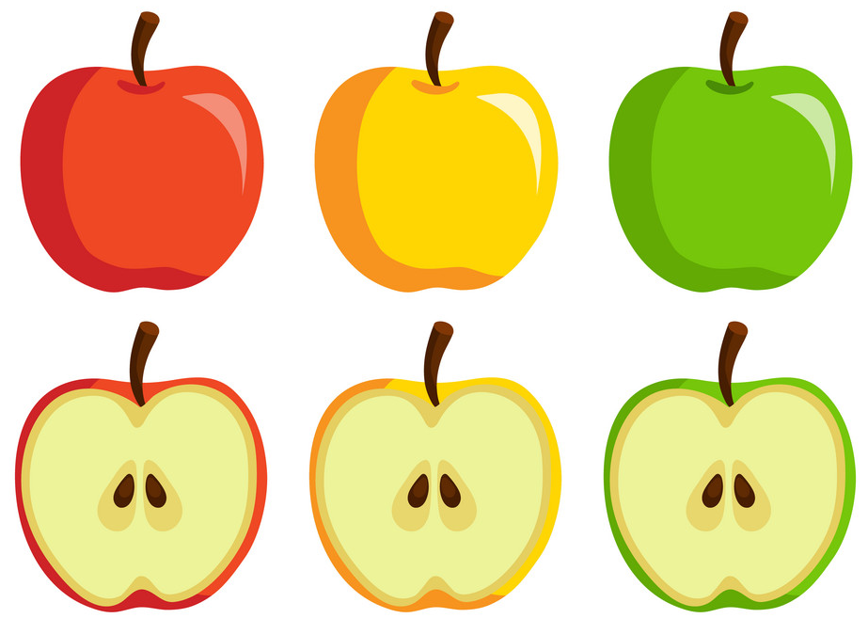
(What colour apple do you like?)
Aaniin endashiwaad aya’aag gaa-miskozid minwenimaad mishiimanag?
How many people like red apples?
Aaniin endashiwaad aya’aag gaa-ozaawizid minwenimaad mishiimanag?
How many people like yellow apples?
Aaniin endashiwaad aya’aag gaa-ozhaawashkozid minwenimaad mishiimanag?
How many people like green apples?
Agindaasodaa!
Let’s count!

10
midaaswi
9
zhaangaswi
8
nishwaaswi
7
niizhwaaswi
6
ningodwaaswi
5
naanan
4
niiwin
3
niswi
2
niizh
1
bezhig
0
gaawiin gegoo
Daabishkoo: | gaa-miskozid | gaa-ozaawizid | gaa-ozhaawashkozid

