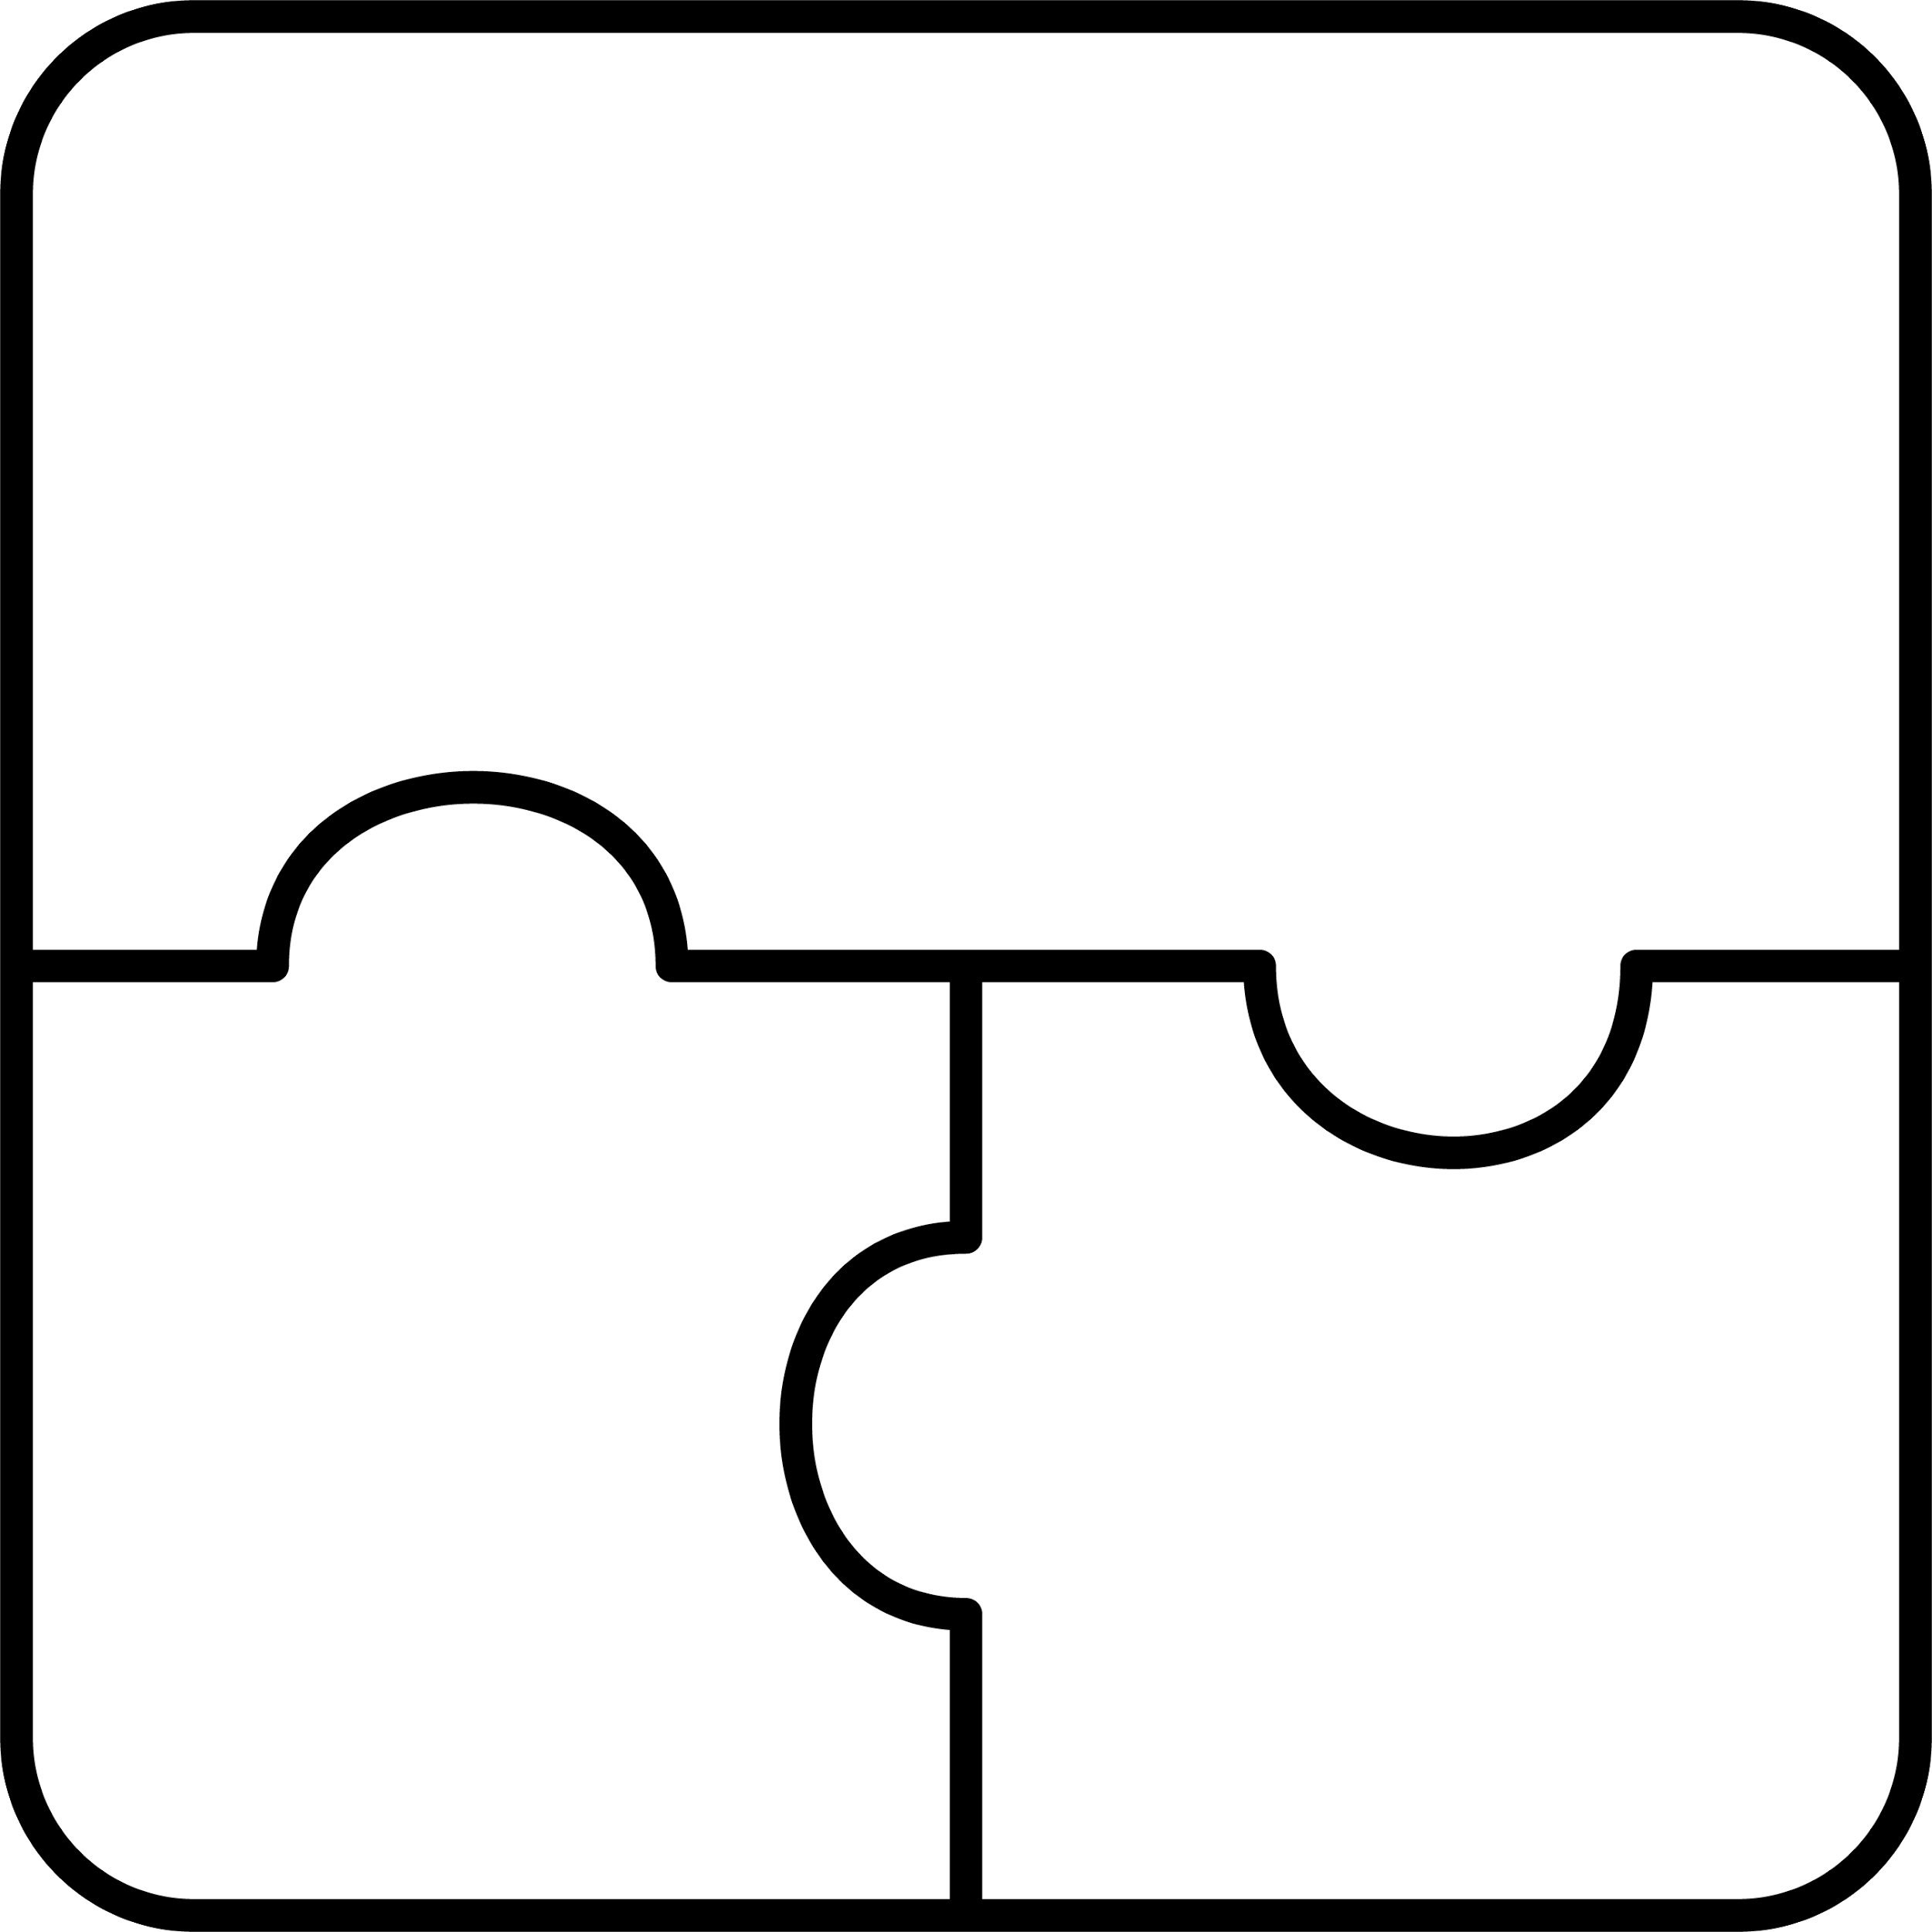

**migizi**

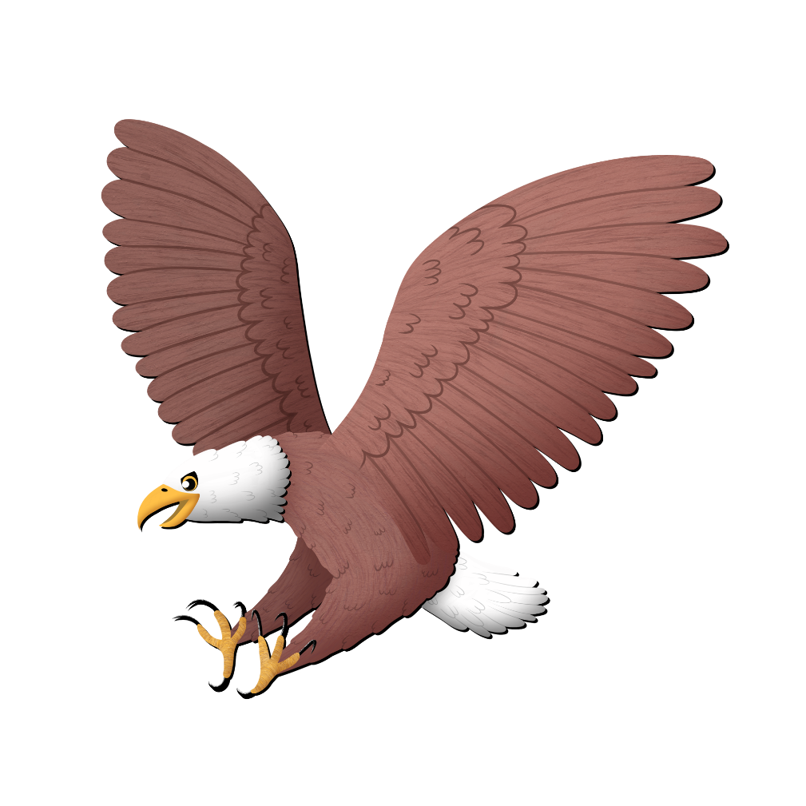

bald eagle

**zi**



**wazison**

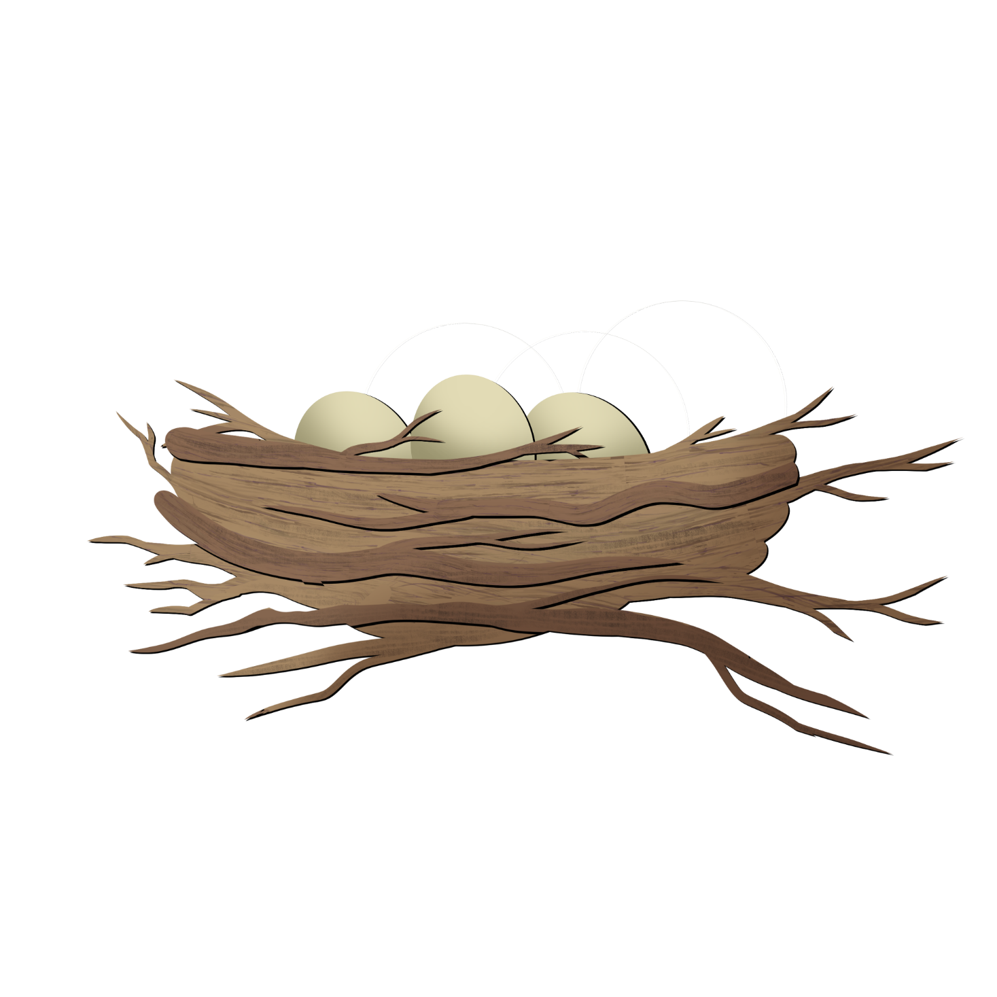

nest

**zi**



**bizaan**

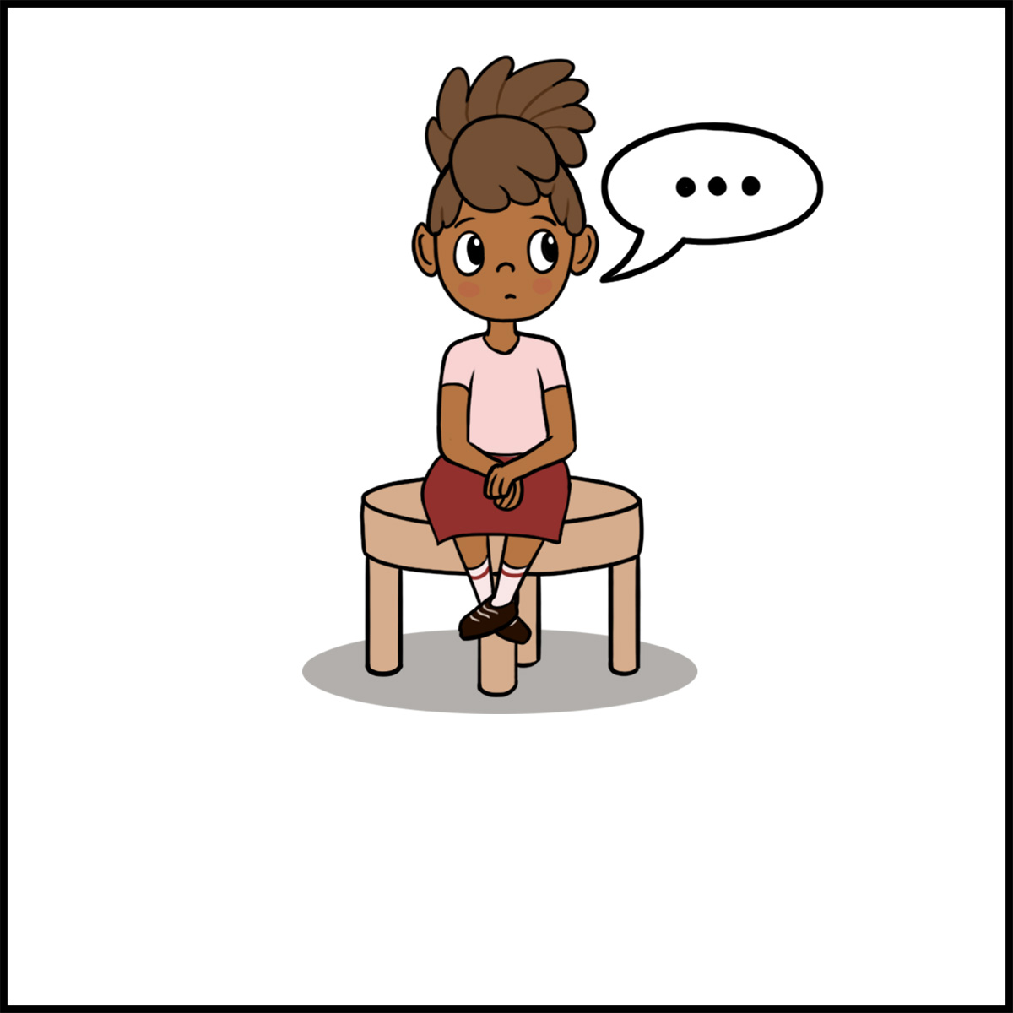

s/he is   
quiet

**zaa**



**zhoomingweni**

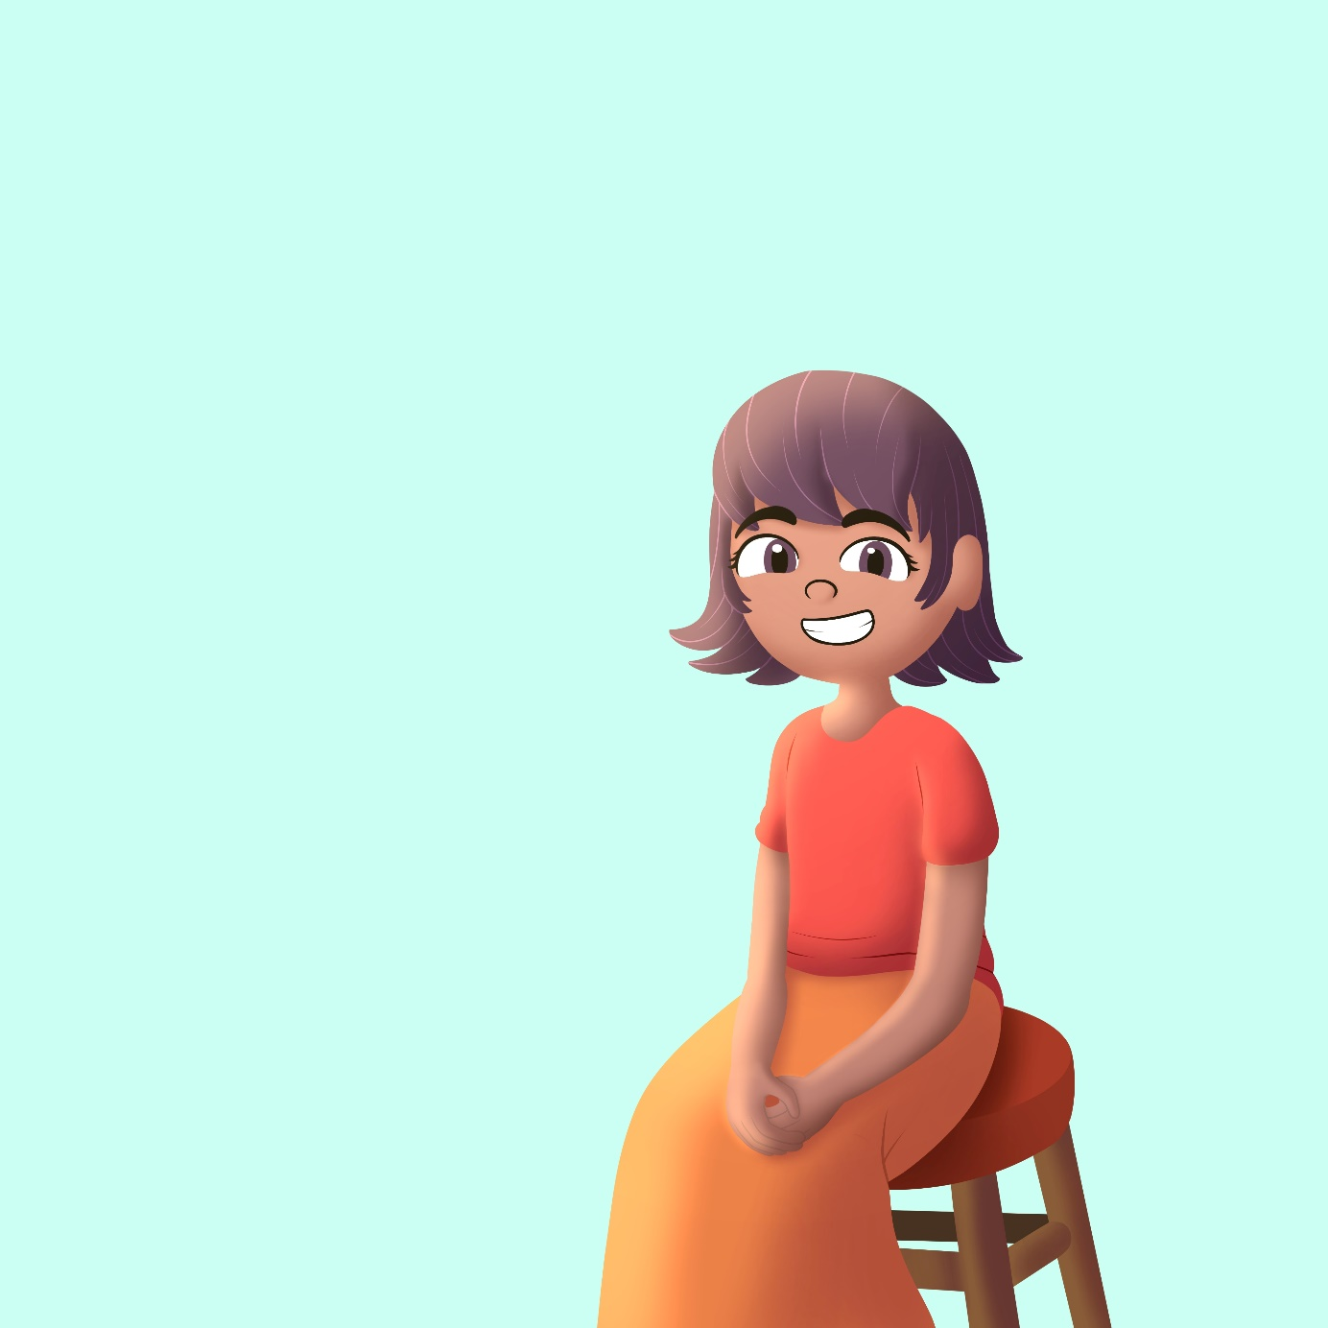

**zhoo**

s/he   
smiles



**zaagaate**



sun is shining

**zaa**