Migizi babaamise ishpiming zz zz zz
Eagle flies in the sky zz zz zz

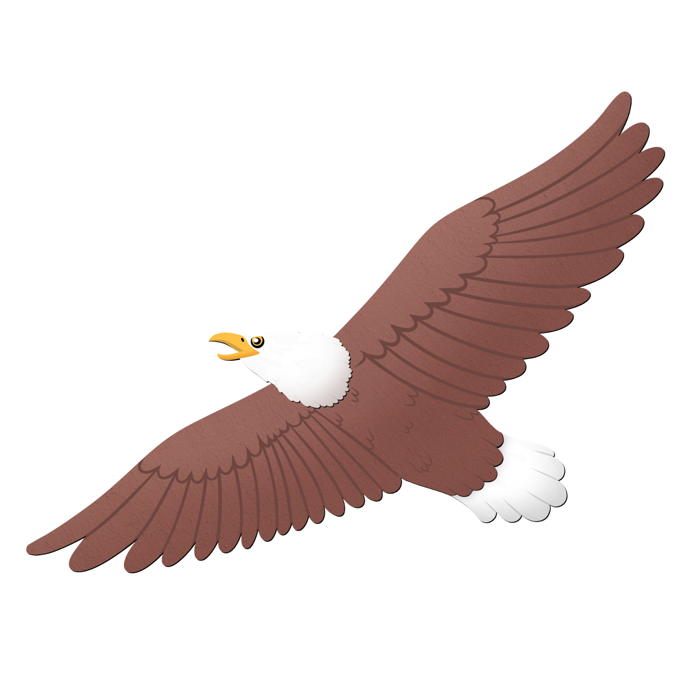

Migizi babaamise ishpiming zz zz zz
Eagle flies in the sky zz zz zz

babaamise – s/he flies about
nandawaabam - look for, search for h/
ishpiming - in the sky

Teeth together, mouth open slightly. Hum and vibrate sound through your teeth.

