Migizi Nagamowin
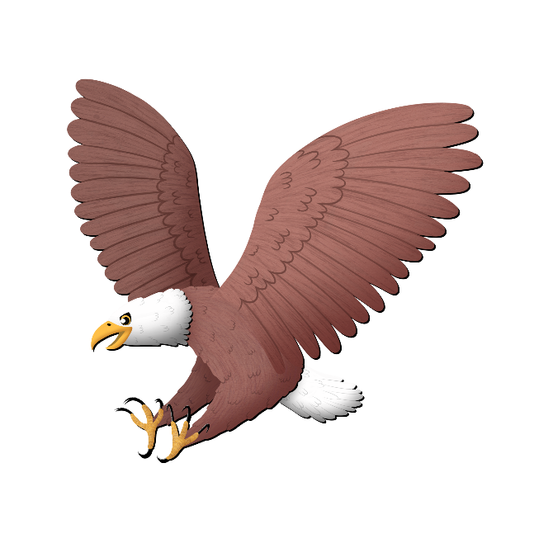
(To the tune of “Family Finger”)

Mino gigizheb
(Good Morning)

Niin Migizi
(I’m an eagle)

Ninzaagitoon bimiseyaan
(I love to fly)

Ambe bimisedaa ishpiming
(Come let’s fly in the sky)

Aabajitoon giningwiiganan
(Use your wings)

Niwaabamaag awesiinyag
(I see animals)

Awegonen waabandaman?
(What do you see?)

