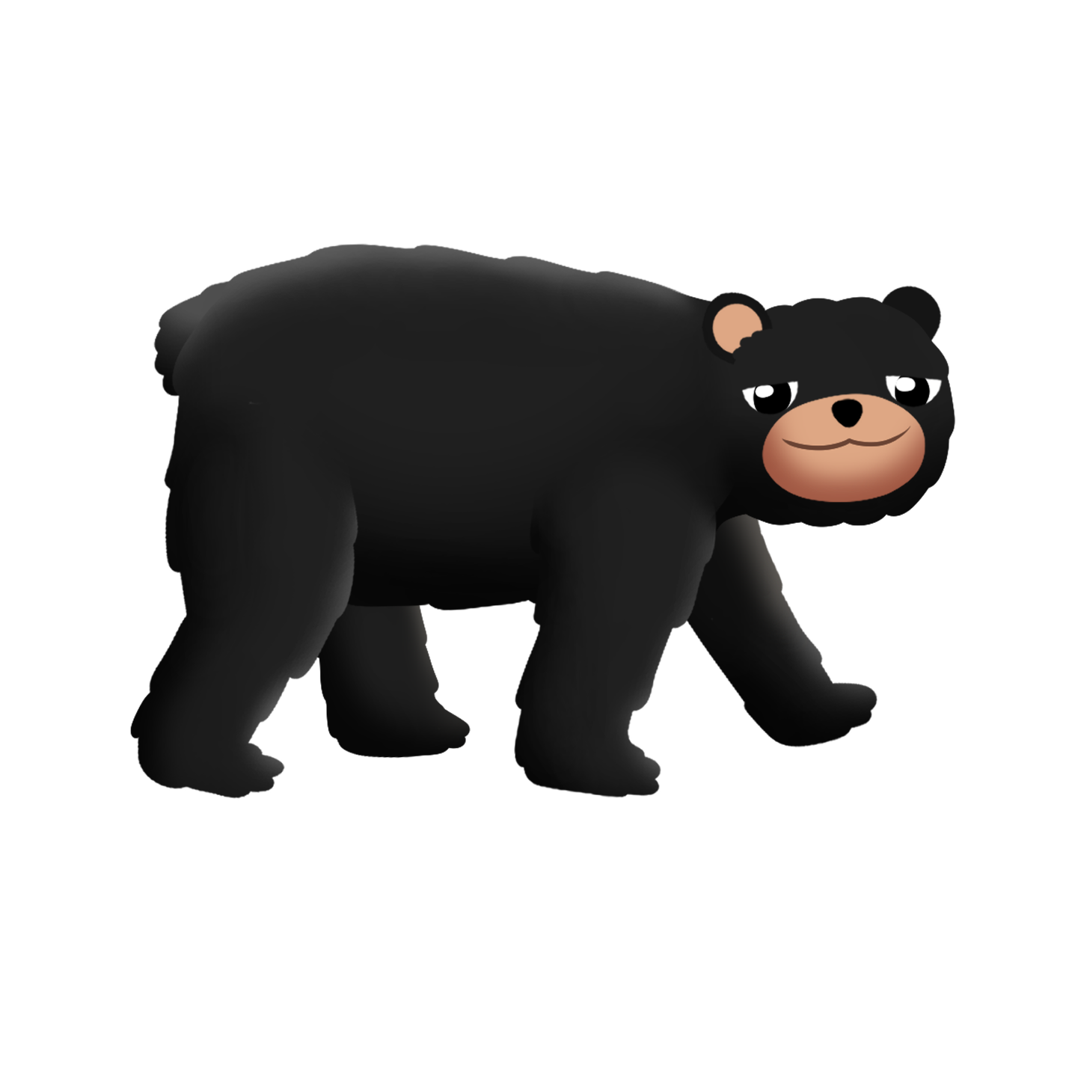

***Makwa omiijinan miinan   
mm mm mm***

*Makwa eats blueberries   
mm mm mm*

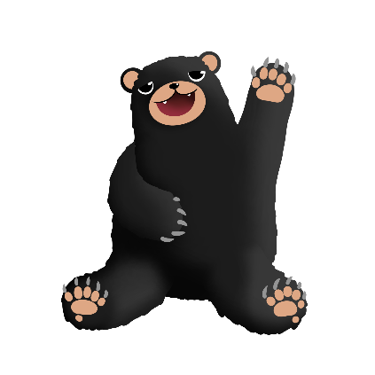

***Makwa omiijinan miinan mm mm mm***

*Makwa eats blueberries mm mm mm*

noondeskade - s/he is hungry

miijin – eat it

miinan - blueberries

Push lips together and hum/vibrate mouth.