ONINGWIIGANAAWAG

GAAWIIN ONINGWIIGANAASIIWAAG

NINGODWAASOGAADEWAG

NISHWAASOGAADEWAG

**THEY HAVE 8 LEGS**

**THEY HAVE 6 LEGS**

**THEY HAVE WINGS**

**THEY DO NOT HAVE WINGS**

**Leaf Sorting Activity**

Print, laminate and cut sheets 1 through 10. Use the labels in the blue boxes to determine how you want learners to sort the bugs. Print off multiple leaves to make more difficult for older learners. Practice counting in Anishinaabemowin when done sorting. Use the Anishinaabemowin phrases and questions in the Makwa guide to engage learners in the language.

**THEY ARE WHITE**

OZAAWIZIWAG

**THEY ARE RED**

MISKOZIWAG

MAKADE-OZHAAWASHKOZIWAG

**THEY ARE BLUE**

OZHAAWASHKOZIWAG

**THEY ARE BLUE**

MAKADEWIZIWAG

WAABIJIIZIWAG

WAABISHKIZIWAG

**THEY ARE YELLOW**

**THEY ARE GREY**

**THEY ARE PURPLE**

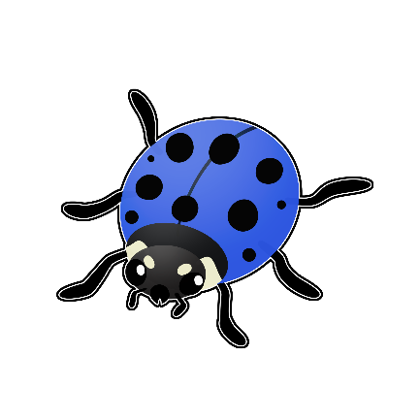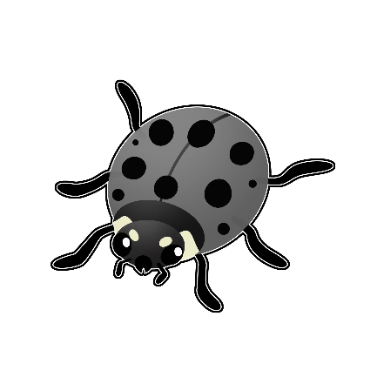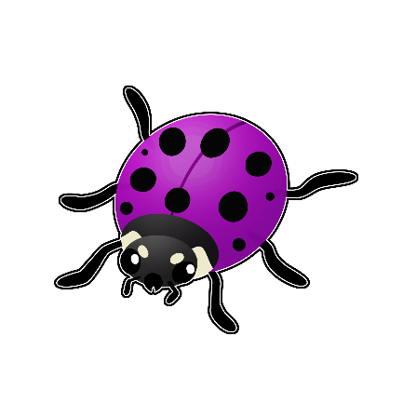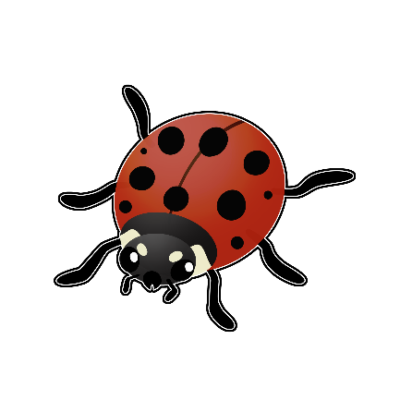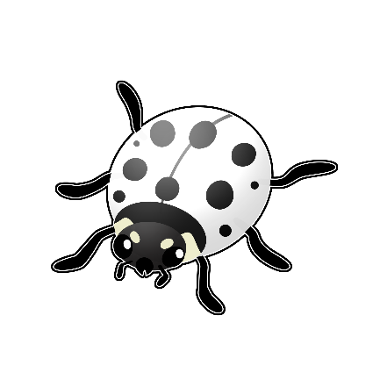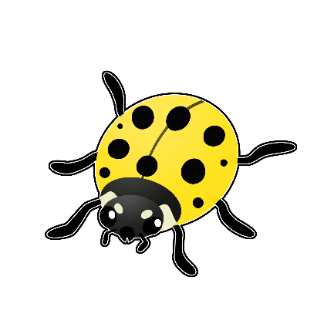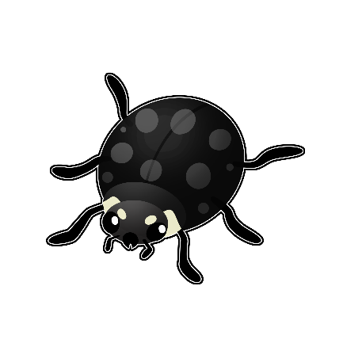

IKWEMANIDOOSHAG

**Ladybugs**

Animate

ikwemanidoosh (singular)

OR

manoominimanidoosh (singular)

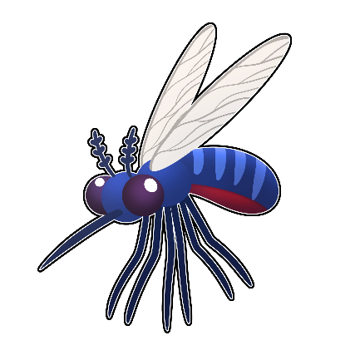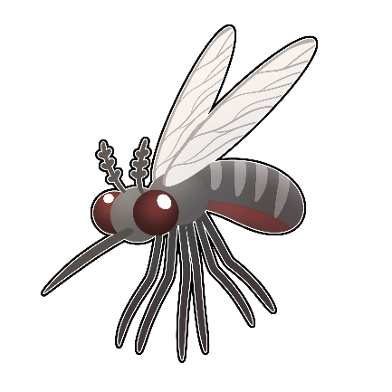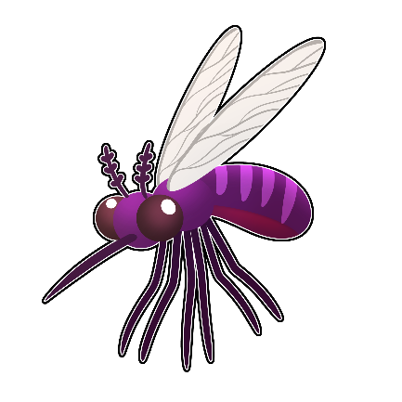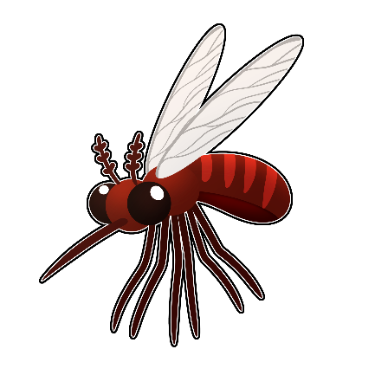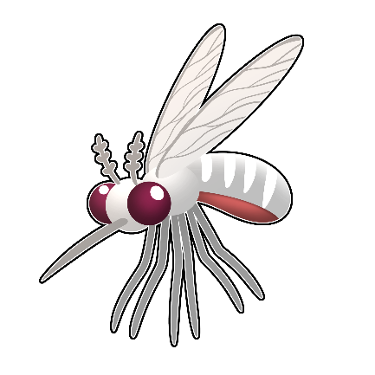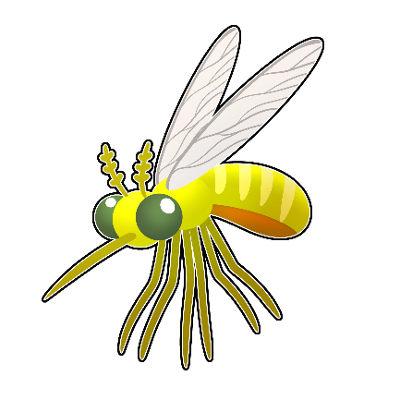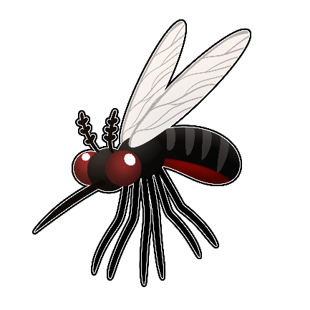

ZAAGIMEG

**Mosquitoes**

Animate

Zaagime (singular)

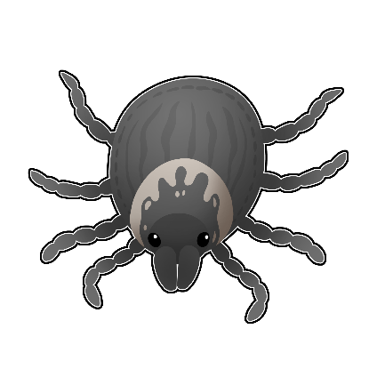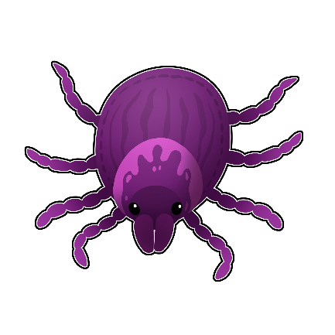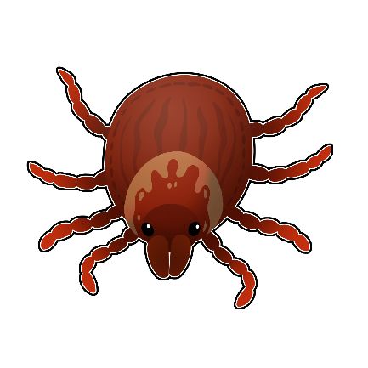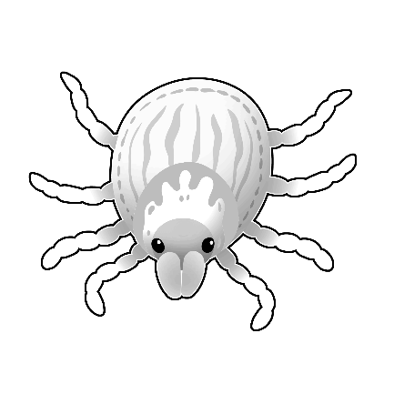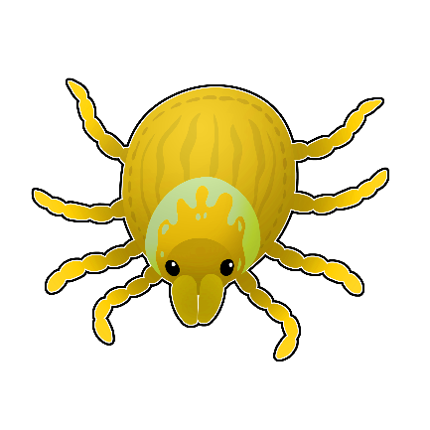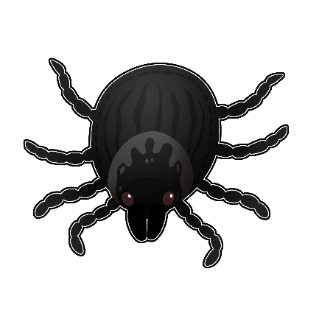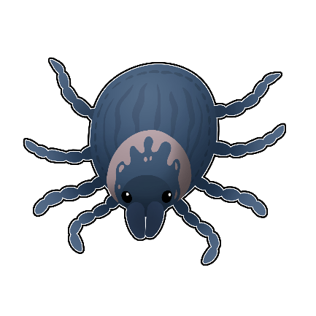

EZIGAAG

**Woodticks**

Animate

Ezigaa (singular)

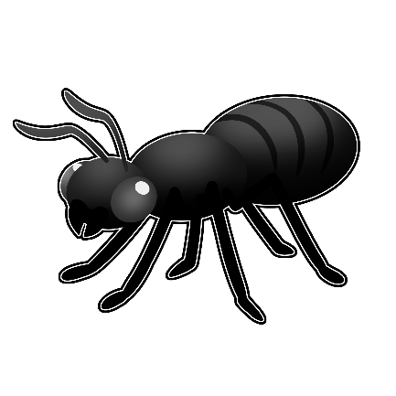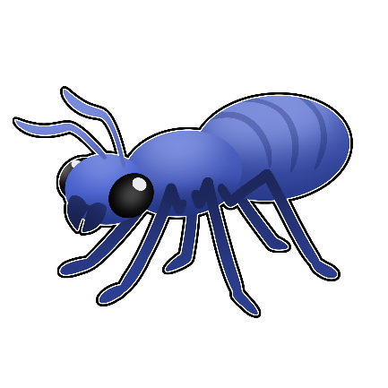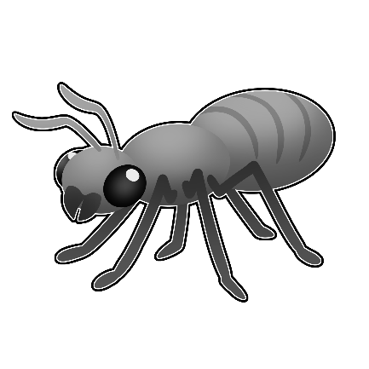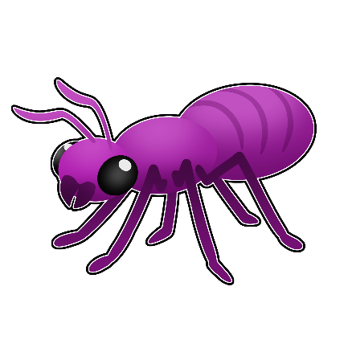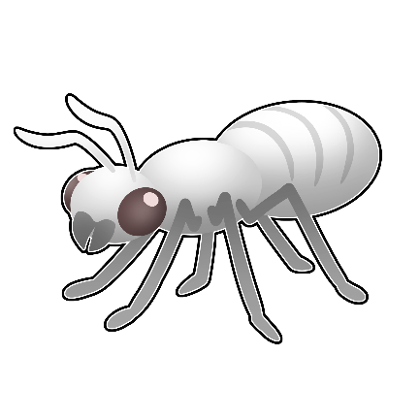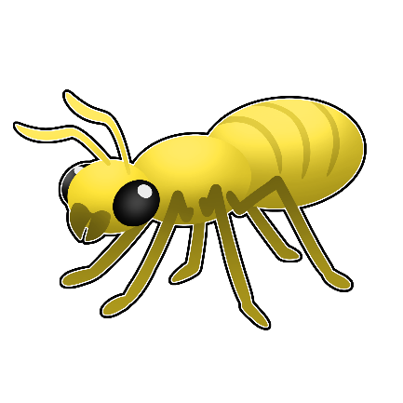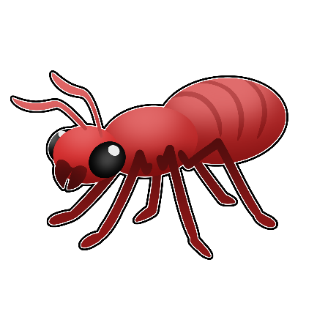

ENIGOONSAG

**Ants**

Animate

Enigoons (singular)

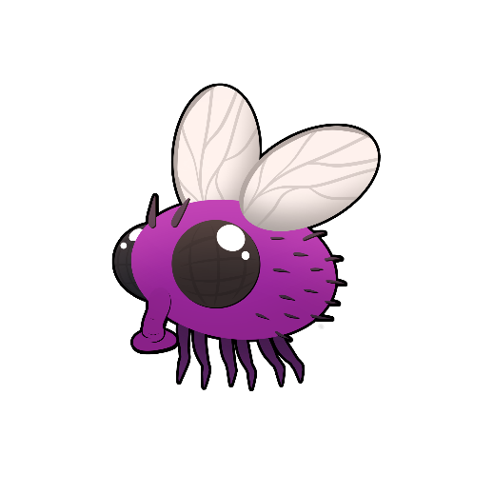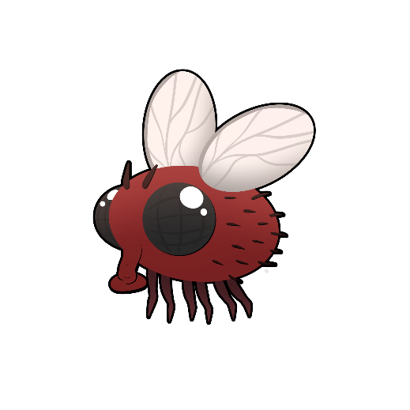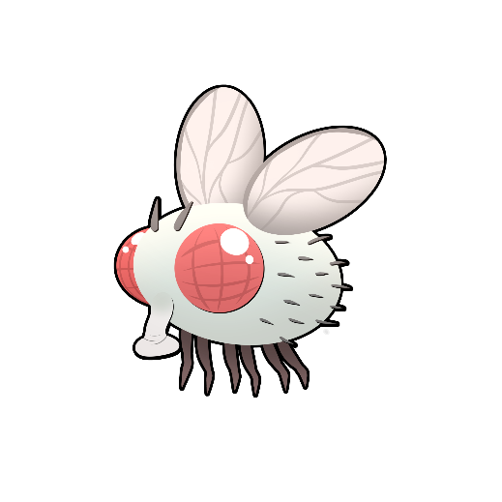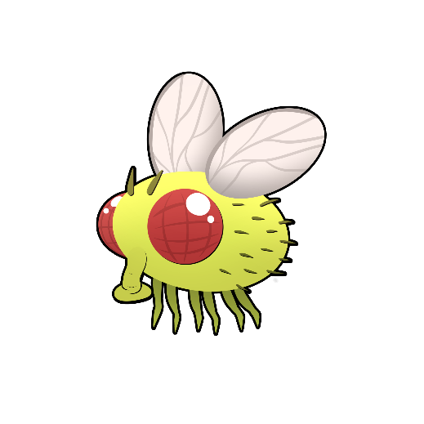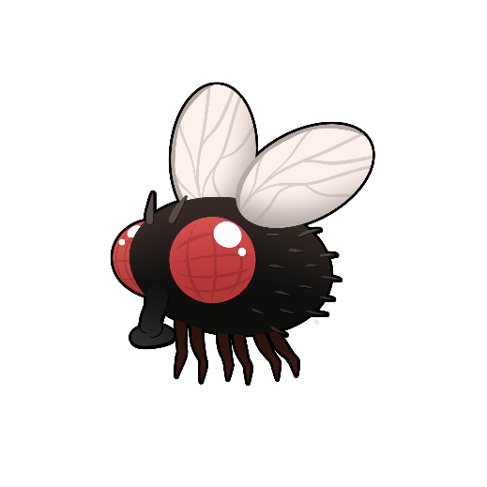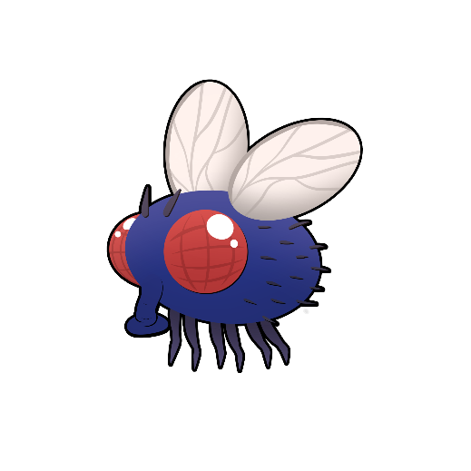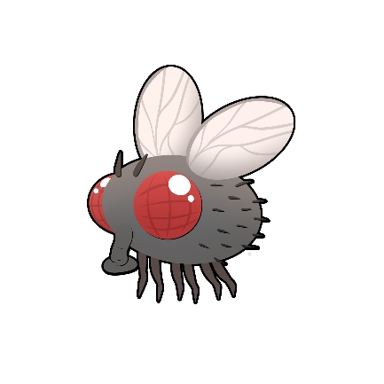

**OOJIINSAG**

**Flies**

Animate

Oojiins (singular)

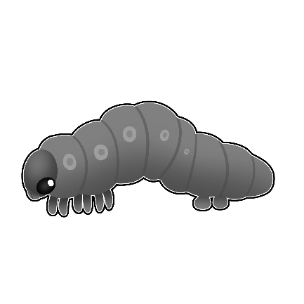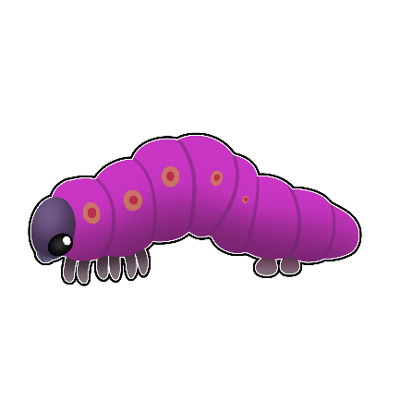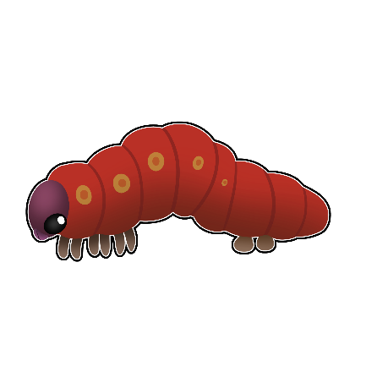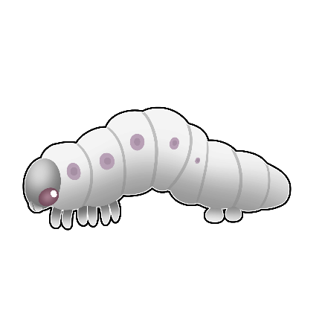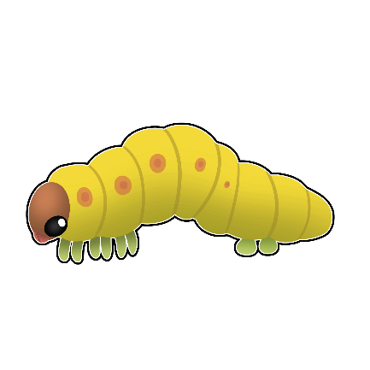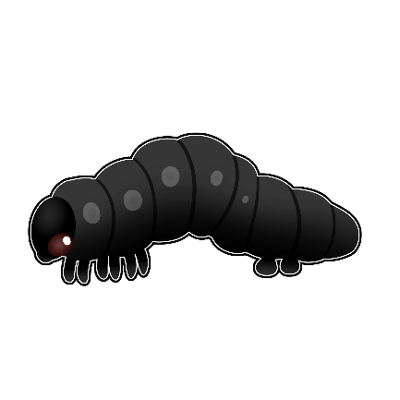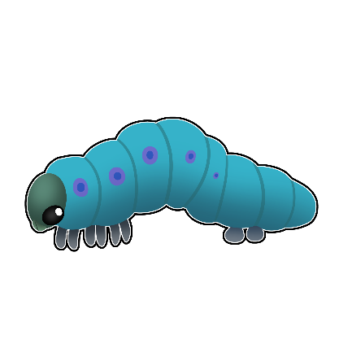

AMOOBAGWESIWAG

**Armyworms**

Animate

Amoobagwesi (singular)

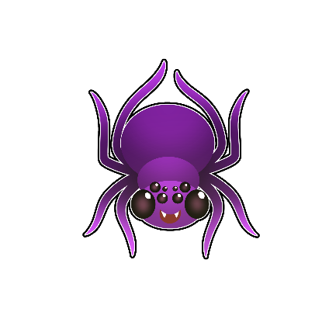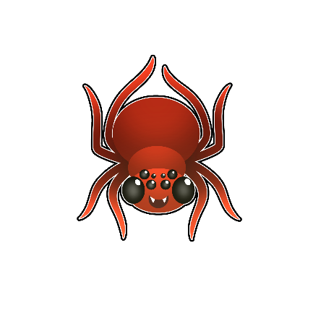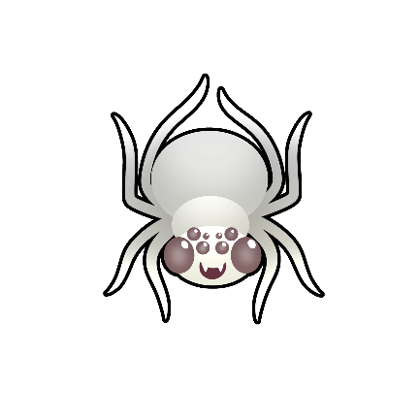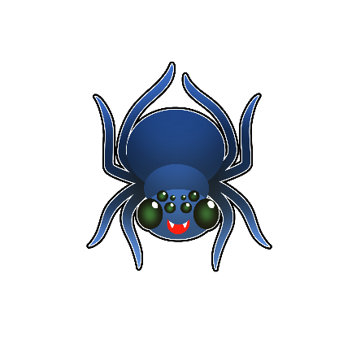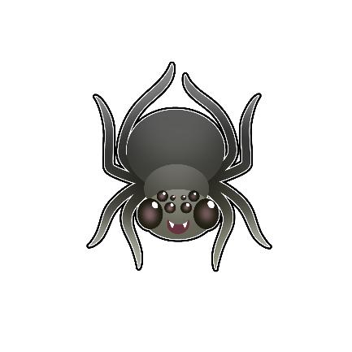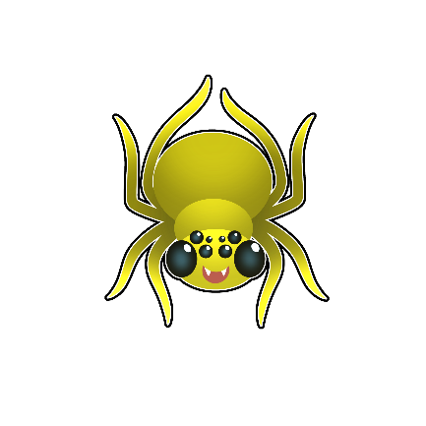

ASABIKESHIINHYAG

**Spiders**

Animate

Asabikeshiinh (singular)



**Manidooshag   
Chart Sorting**

**1. Print and cut out bugs and next page (page 12).**

**2. Place white versions of bugs along left hand side.**

**3. Cut out coloured circles to right and place along top.**

**4. Have children match colours to bugs in chart.**

**5. Use fewer colours or fewer bugs to start or for younger learners.**

**6. Instructors can apply Velcro to backs of bugs and on chart to keep in place or to practice fine motor skills.**

|  |  |  |  |  |
| --- | --- | --- | --- | --- |
|  |  |  |  |  |
|  |  |  |  |  |
|  |  |  |  |  |
|  |  |  |  |  |
|  |  |  |  |  |

|  |  |  |  |  |
| --- | --- | --- | --- | --- |
|  |  |  |  |  |
|  |  |  |  |  |
|  |  |  |  |  |
|  |  |  |  |  |
|  |  |  |  |  |