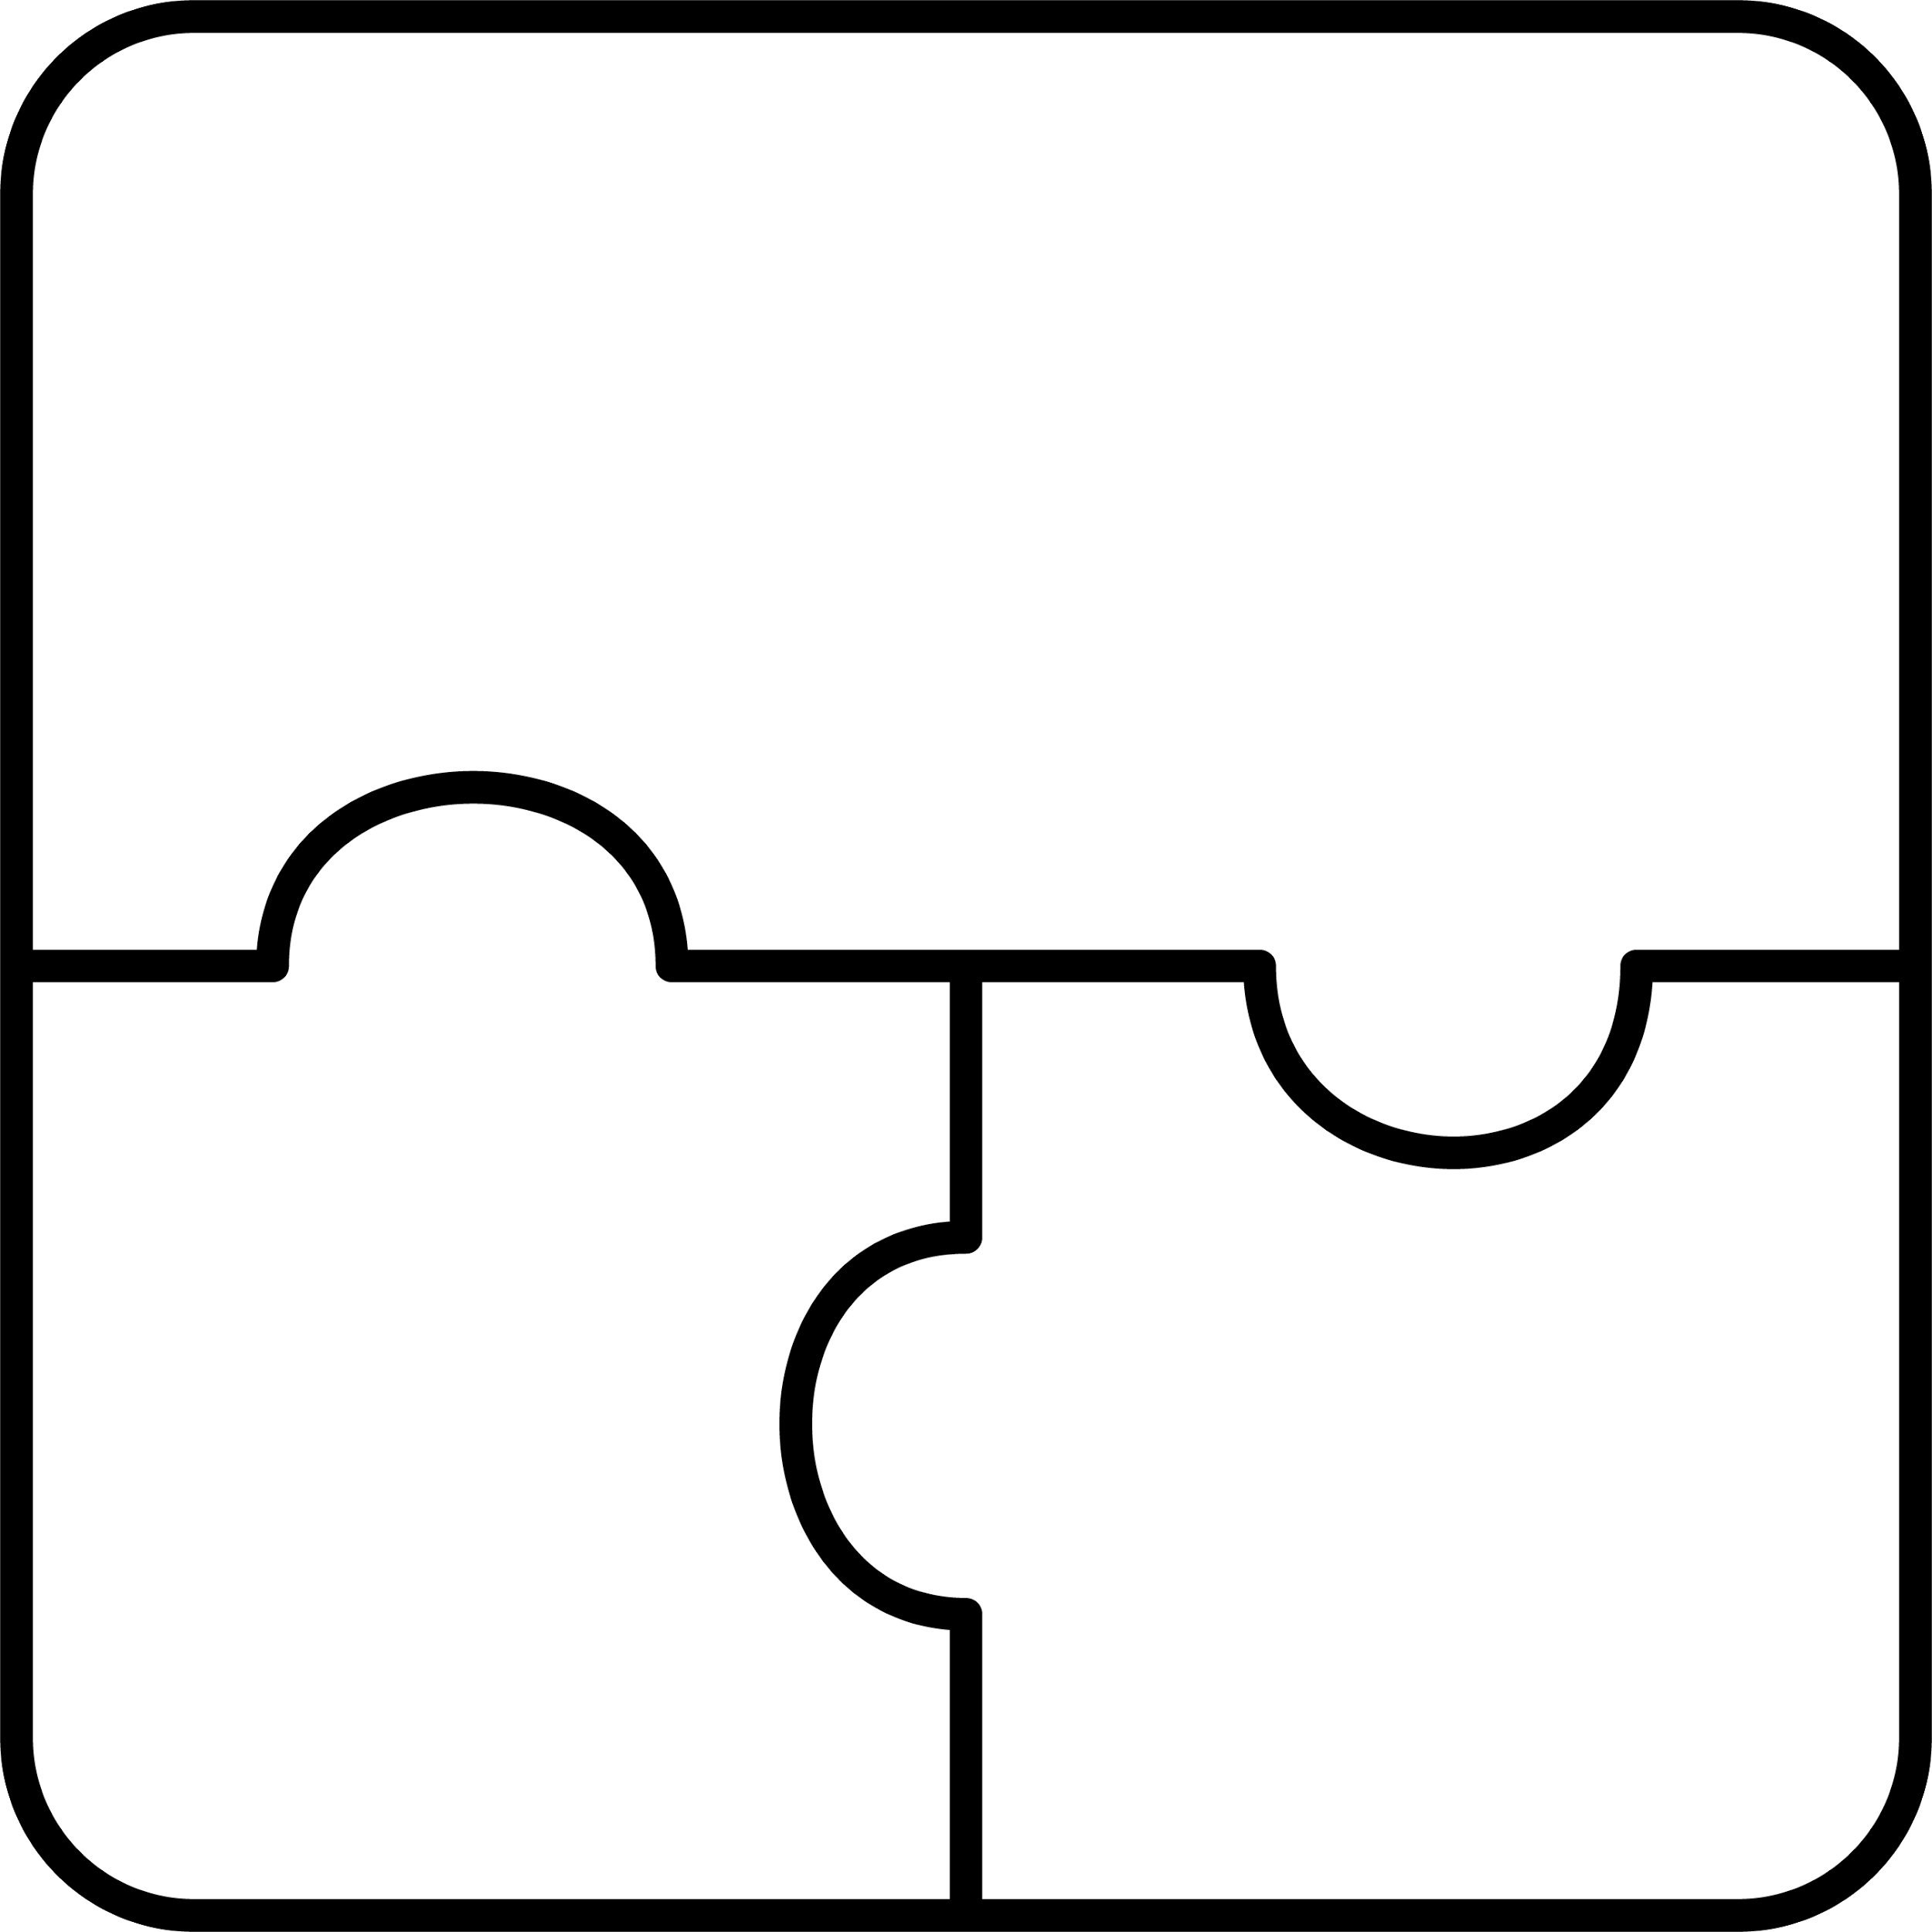

**aginjibagwesi**

goldfinch

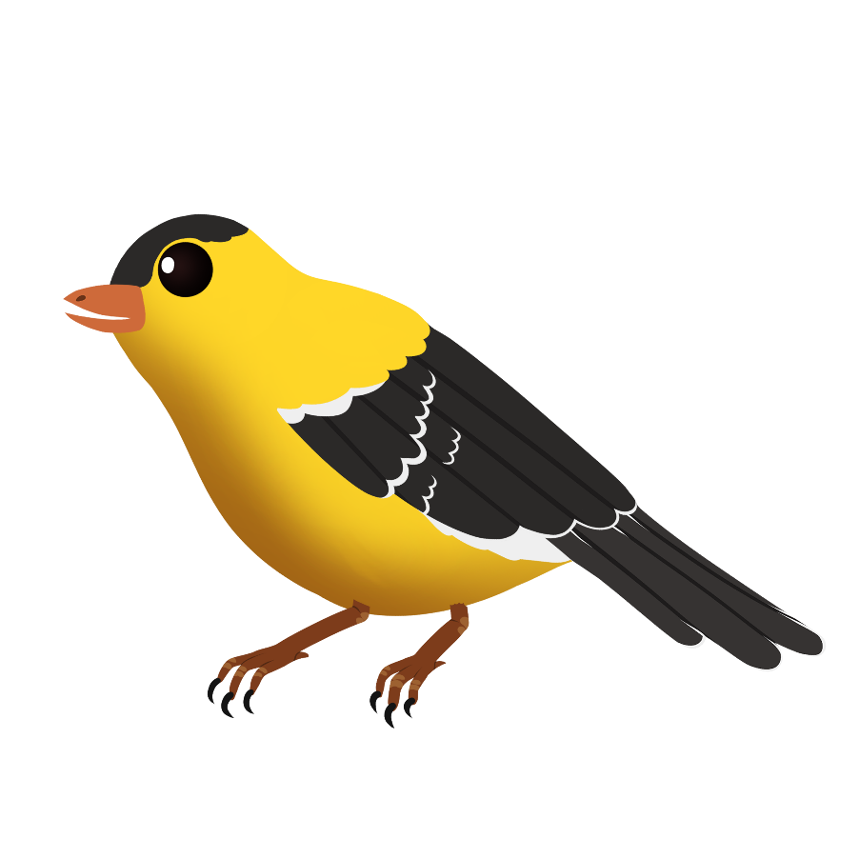

**ba**



**boozhoo**

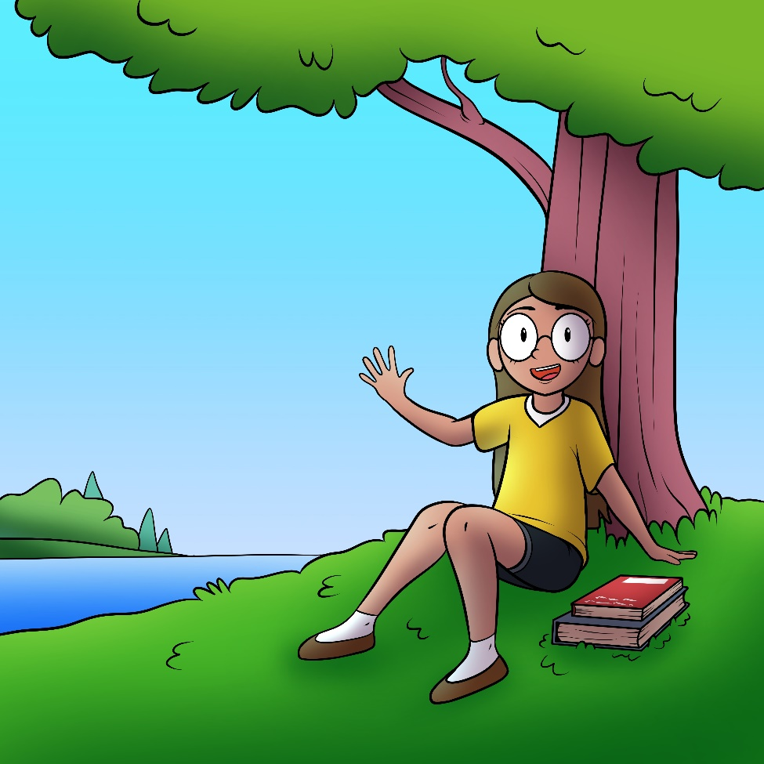

**boo**

hello



**aniibiishan**

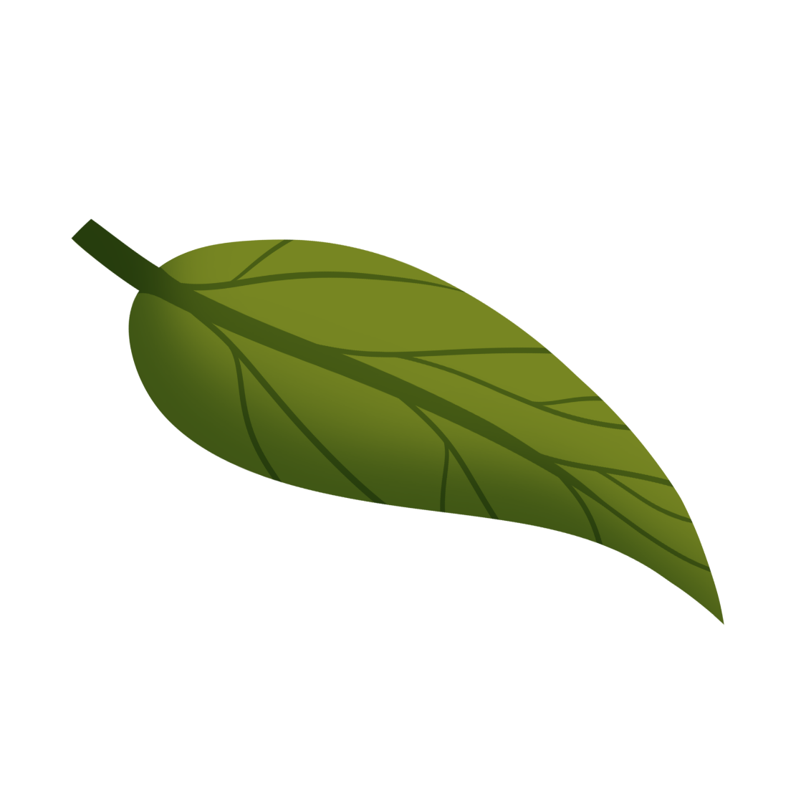

**bii**

leaf



**gaa-bagaki-ozaawegin**



yellow   
cloth

**ba**



**bezhig**

**1**

one

**be**