***Aginjibagwesi okoonzh omiijinan miinikaanan buh buh***

*Aginjibagwesi pecks at the seeds buh buh*

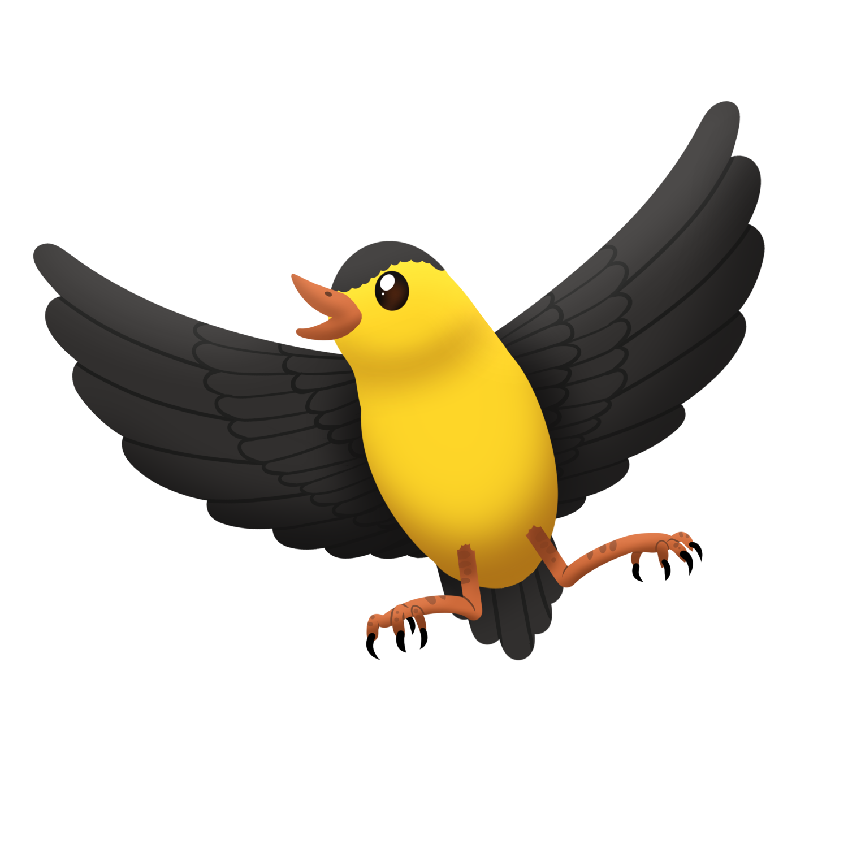

***Aginjibagwesi okoonzh omiijinan miinikaanan buh buh***

*Aginjibagwesi pecks at the seeds buh buh*

*noondeskade - s/he is hungry*

*miijin - eat it*

*miinikaan(an) - seed(s)*

*Puff out your cheeks a release air when   
making the buh sound.*