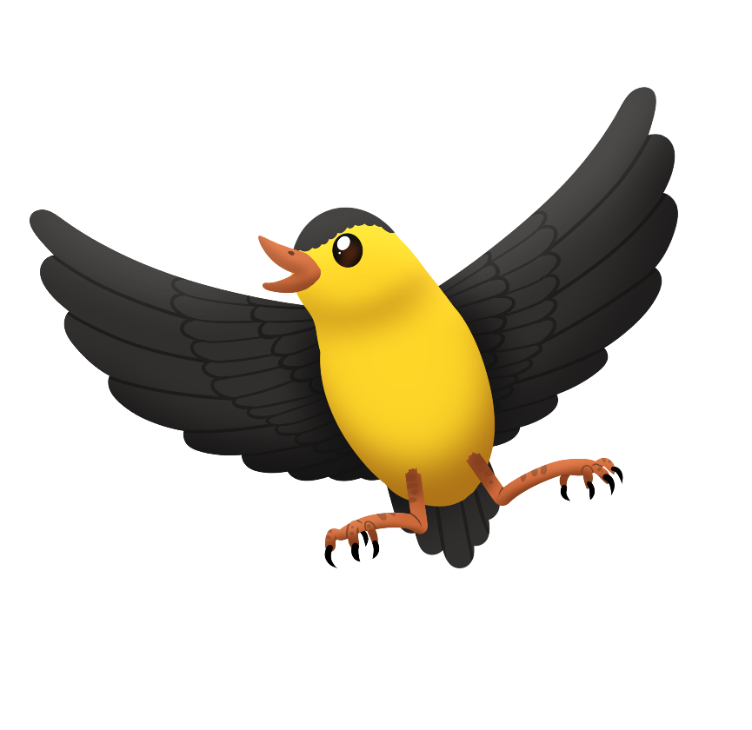

**Aginjibagwesi pecks at the seeds buh buh**

**Aginjibagwesi okoonzh omiijinan   
miinikaanan buh buh**

Boozhoo! Ozaawibinesiik indizhinkaaz.

(Hello! My name is Ozaawibinesiik.)

Aginjibagwesi indigoo.

(I am called a Goldfinch.)

Odaminodaa dash nanda-gikendandaa

ji-anishinaabemowin!

(Let’s play and learn Anishinaabemowin!)

Please visit www.wakingupojibwe.ca for the Aginjibagwesi book, Read With Me Video, resource guides, and other materials to use with Aginjibagwesi. Document your families’ weekend adventure with Ozaawibinesiik by taking photos or drawing pictures, then submit them to your child’s teacher. Miigwech!

Your child wants to ____________________________ with you and Ozaawibinesiik.

Use the **buh buh** sound at home. Point it out in conversation and practice saying it by puffing out your cheeks and letting out air when making the sound.