Aginjibagwesi Nagamowin
(To the tune of “Finger Family”)

Aginjibagwesi, ozaawigwane
Goldfinch, he has yellow weathers

Anishininaabemo, minwendaagwad
He speaks Anishinaabemowin, it is fun

Ozaawibinesiik, agindaman
Ozaawibinesiik, he counts

Aniibiishan, niinitaam
Many leaves, my turn

Bezhig, Niizh, Niswi, Niiwin
One, two, three, four
Naanan, Ningodwaaswi, Niizhwaaswi
Five, six, seven
Nishwaaswi, Zhaangaswi, Midaaswi
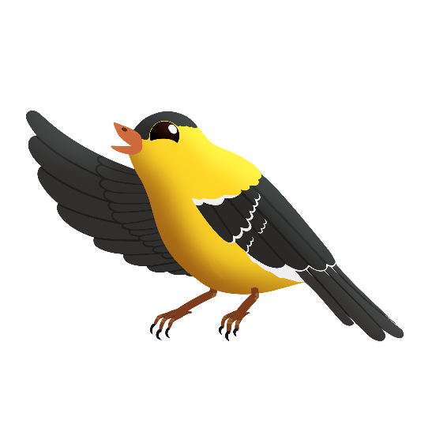
Eight, nine, ten

Giinitam
Your turn

